Crystal Structure Report for A. Velian
by Paige M Gannon & Werner Kaminsky
Sample Submitted by
Sebastian Krajewski
ID – SMK_166X-ray Crystallography Laboratory
University of Washington
28. July 2026

Data Collection started: 3/16/2022
Documentation finished: 3/18/2022

Data backup accessibly through http:
URL: http://cad4.cpac.washington.edu/structures

W.Kaminsky: tel. (206) 543 7585
(x-ray lab): tel. (206) 543 0210
Email: kaminsky@chem.washington.edu

Understanding crystallographic information is not trivial. If you discuss a structure in a publication, please let the crystallographers proof-read the final draft of that manuscript before you submit it.
For many structures it is true that crystallography is an intellectual performance (like synthesis or elucidation of mechanisms) and not a routine job. In these cases, particularly when the structures contribute significantly to the content of the publication, the crystallographers should be co-authors. Do not think this is not necessary because you pay for structures.
A brown needle, measuring 0.26 x 0.07 x 0.07 mm³ was mounted on a loop with oil. Data was collected at -173ºC on a Bruker APEX II single crystal X-ray diffractometer, Mo-radiation, equipped with a Miracol X-ray optical collimator.

Crystal-to-detector distance was 40 mm and exposure time was 10 seconds per frame for all sets. The scan width was 0.5º. Data collection was 99.9% complete to 25º in ϑ. A total of 28446 reflections were collected covering the indices, -39<=h<=39, -19<=k<=19, -40<=l<=40. 14529 reflections were symmetry independent and the R_{int} = 0.0353 indicated that the data was excellent. Indexing and unit cell refinement indicated a C-centered monoclinic lattice. The space group was found to be C2/c (No. 15).

The data was integrated and scaled using SAINT, SADABS within the APEX2 software package by Bruker.

Solution by direct methods (SHELXT or SIR97) produced a complete heavy atom phasing model consistent with the proposed structure. The structure was completed by difference Fourier synthesis with SHELXL., Scattering factors are from Waasmair and Kirfel. Hydrogen atoms were placed in geometrically idealised positions and constrained to ride on their parent atoms with C---H distances in the range 0.95-1.00 Angstrom. Isotropic thermal parameters U_{eq} were fixed such that they were 1.2U_{eq} of their parent atom Ueq for CH's and 1.5U_{eq} of their parent atom U_{eq} in case of methyl groups. All non-hydrogen atoms were refined anisotropically by full-matrix least-squares.

The asymmetric unit contains a half complex. 3 DMF solvent molecules hydrogen bond to the 3 hydroxyls of the half complex and a 4th DMF fills space. The complex is completed by the inversion symmetry of the space group.

Almost all moieties of the structure appear disordered.

The structure is of high quality and ready for publication. Table 1 summarizes the data collection details. Figure 1 shows an ORTEP of the asymmetric unit.

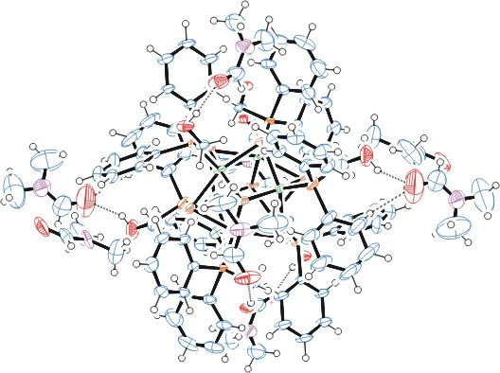
Figure 1. ORTEP of the expanded molecule with thermal ellipsoids at the 50% probability level. Disorder omitted for clarity.

Table 1: Crystallographic data for the structures provided.
Empirical formula C102 H134 Co6 N8 O14 P6 Se8
Formula weight 2867.24
Temperature 100(2) K
Wavelength 0.71073 Å
Crystal system Monoclinic
Space group C 2/c
Unit cell dimensions a = 29.2699(12) Å α= 90°.
b = 14.6169(5) Å β= 115.714(2)°.
c = 30.0860(18) Å γ = 90°.
Volume 11597.2(9) Å3
Z 4
Density (calculated) 1.642 Mg/m3
Absorption coefficient 3.493 mm-1
F(000) 5752
Crystal size 0.260 x 0.070 x 0.070 mm3
Theta range for data collection 1.502 to 28.401°.
Index ranges -39<=h<=39, -19<=k<=19, -40<=l<=40
Reflections collected 28446
Independent reflections 14529 [R(int) = 0.0353]
Completeness to theta = 25.000° 99.9 %
Refinement method Full-matrix least-squares on F2
Data / restraints / parameters 14529 / 1515 / 795
Goodness-of-fit on F2 1.104
Final R indices [I>2sigma(I)] R1 = 0.0616, wR2 = 0.1303
R indices (all data) R1 = 0.0951, wR2 = 0.1445
Largest diff. peak and hole 1.889 and -1.573 e.Å-3

Bruker (2007) APEX2 (Version 2.1-4), SAINT (version 7.34A), SADABS (version 2007/4), BrukerAXS Inc, Madison, Wisconsin, USA.
Sheldrick GM. (2015) SHELXT - Integrated space-group and crystal-structure determination. Acta Cryst. A71, 3-8.
(a) Altomare A, Burla C, Camalli M, Cascarano G L, Giacovazzo C, Guagliardi A, Moliterni AGG, Polidori G, Spagna R. (1999) SIR97: a new tool for crystal structure determination and refinement Journal of Applied Crystallography, 32, 115-119. (b) Altomare A, Cascarano G L, Giacovazzo C, Guagliardi A. (1993) Completion and refinement of crystal structures with SIR 92. Journal of Applied Crystallography, 26, 343-350.
’Sheldrick : A short history of SHELX . Acta Cryst. (2008), A64, 112-122
Mackay, S.; Edwards, C.; Henderson, A.; Gilmore, C.; Stewart, N.; Shankland, K.; Donald, A. (1997) MaXus: a computer program for the solution and refinement of crystal structures from diffraction data. University of Glasgow, Scotland,.
Waasmaier, D.; Kirfel, A. (1995) New Analytical Scattering Factor Functions for Free Atoms and Ions. Acta Crystallographica A., 51, 416-430.
Farrugia LJ. (1997) Ortep-3 for Windows. Journal of Applied Crystallography, 30, 565

