Crystal Structure Report for A. Velian
by Sebastian Krajewski
& Werner Kaminsky
Sample Submitted by
Sebastian Krajewski
ID – SMK394
X-ray Crystallography Laboratory
University of Washington
31. July 2026

Data Collection started: 11/9/2022
Documentation finished: 11//15/2022

Data backup accessibly through http:
URL: http://cad4.cpac.washington.edu/structures

W.Kaminsky: tel. (206) 543 7585
(x-ray lab): tel. (206) 543 0210
Email: kaminsky@chem.washington.edu

Understanding crystallographic information is not trivial. If you discuss a structure in a publication, please let the crystallographers proof-read the final draft of that manuscript before you submit it.
For many structures it is true that crystallography is an intellectual performance (like synthesis or elucidation of mechanisms) and not a routine job. In these cases, particularly when the structures contribute significantly to the content of the publication, the crystallographers should be co-authors. Do not think this is not necessary because you pay for structures.
An irregularily shaped black crystal, measuring 0.30 x 0.15 x 0.15 mm³ was mounted on a loop with oil. Data was collected at -173ºC on a Bruker APEX II single crystal X-ray diffractometer, Mo-radiation, equipped with a Miracol X-ray optical collimator.

Crystal-to-detector distance was 40 mm and exposure time was 120 seconds per frame for all sets. The scan width was 1º.

Due to massive toluene disorder filling a large volume portion of the unit cell, the crystal appeared 'hot' with elevated solvent displacement parameters. As a result, as for crystals measured at elevated temperatures, intensities vanished beyond a resolution of 1.2.

Data collection covered the indices, -12<=h<=12, -17<=k<=17, -20<=l<=20. 9165 reflections were symmetry independent with R_{int} = 0.0663. Indexing and unit cell refinement indicated a triclinic lattice. The space group was found to be P‾1 (No. 2).

The data was integrated and scaled using SAINT, SADABS within the APEX2 software package by Bruker.

The contribution of disordered solvent to the diffraction pattern was removed with SQUEEZE

Solution by direct methods (SHELXT or SIR97) produced a complete heavy atom phasing model consistent with the proposed structure. The structure was completed by difference Fourier synthesis with SHELXL. Scattering factors are from Waasmair and Kirfel. Hydrogen atoms were placed in geometrically idealised positions and constrained to ride on their parent atoms with C---H distances in the range 0.95-1.00 Angstrom. Isotropic thermal parameters U_{eq} were fixed such that they were 1.2U_{eq} of their parent atom Ueq for CH's and 1.5U_{eq} of their parent atom U_{eq} in case of methyl groups. All non-hydrogen atoms were refined anisotropically by full-matrix least-squares.

The structure is of lower quality and new data should be taken if intended for publication. Table 1 summarizes the data collection details. Figure 1 shows an ORTEP of the asymmetric unit.

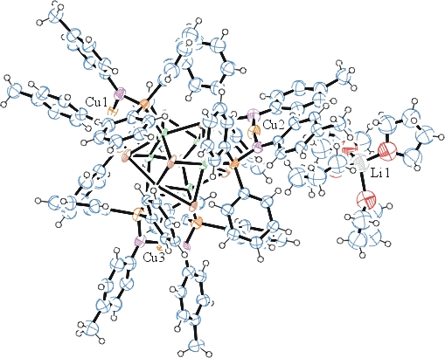
Figure 1. ORTEP of the structure with thermal ellipsoids at the 50% probability level.

Table 1: Crystallographic data for the structures provided.
Empirical formula C130 H134 Co6 Cu3 Li N6 O4 P6 Se8
Formula weight 3213.06
Temperature 100(2) K
Wavelength 0.71073 Å
Crystal system Triclinic
Space group P -1
Unit cell dimensions a = 15.1850(14) Å α= 93.919(6)°.
b = 20.5588(19) Å β= 98.921(6)°.
c = 25.133(3) Å γ = 98.907(5)°.
Volume 7623.3(13) Å3
Z 2
Density (calculated) 1.400 Mg/m3
Absorption coefficient 3.063 mm-1
F(000) 3204
Crystal size 0.300 x 0.150 x 0.150 mm3
Theta range for data collection 1.007 to 17.225°.
Index ranges -12<=h<=12, -17<=k<=17, -20<=l<=20
Reflections collected 18305
Independent reflections 9165 [R(int) = 0.0663]
Completeness to theta = 17.225° 99.2 %
Refinement method Full-matrix least-squares on F2
Data / restraints / parameters 9165 / 2279 / 1267
Goodness-of-fit on F2 1.009
Final R indices [I>2sigma(I)] R1 = 0.1727, wR2 = 0.3701
R indices (all data) R1 = 0.2366, wR2 = 0.4212
Largest diff. peak and hole 2.765 and -2.148 e.Å-3

Bruker (2007) APEX2 (Version 2.1-4), SAINT (version 7.34A), SADABS (version 2007/4), BrukerAXS Inc, Madison, Wisconsin, USA.
(a) A. Spek, J. Appl. Cryst. (2003), 36, 7-13; (b) P. van der Sluis & A. L. Spek, Acta Cryst. (1990). A46, 194-201. (c) Spek, A. L. (2009). Acta. Cryst. D65, 148-155.
(a) Sheldrick GM. (2008) A short history of SHELX. Acta Cryst. A64, 112-122. (b) Sheldrick GM. (2015) SHELXT - Integrated space-group and crystal-structure determination. Acta Cryst. A71, 3-8.
(a) Altomare A, Burla C, Camalli M, Cascarano G L, Giacovazzo C, Guagliardi A, Moliterni AGG, Polidori G, Spagna R. (1999) SIR97: a new tool for crystal structure determination and refinement Journal of Applied Crystallography, 32, 115-119. (b) Altomare A, Cascarano G L, Giacovazzo C, Guagliardi A. (1993) Completion and refinement of crystal structures with SIR 92. Journal of Applied Crystallography, 26, 343-350.
(a) Sheldrick GM. (1997) SHELXL-97, Program for the Refinement of Crystal Structures. University of Göttingen, Germany. (b) Sheldrick GM. (2015) Crystal structure refinement with SHELXL. Acta Cryst. C71, 3–8
Waasmaier, D.; Kirfel, A. (1995) New Analytical Scattering Factor Functions for Free Atoms and Ions. Acta Crystallographica A., 51, 416-430.
Farrugia LJ. (1997) Ortep-3 for Windows. Journal of Applied Crystallography, 30, 565

