Crystal Structure Report for A. Velian
by Werner Kaminsky
Sample Submitted by
Sebastian Krajewski
ID – SMK404
X-ray Crystallography Laboratory
University of Washington
28. July 2026

Data Collection started: 12/5/2022
Documentation finished: 12/12/2022

Data backup accessibly through http:
URL: http://cad4.cpac.washington.edu/structures

W.Kaminsky: tel. (206) 543 7585
(x-ray lab): tel. (206) 543 0210
Email: kaminsky@chem.washington.edu

Understanding crystallographic information is not trivial. If you discuss a structure in a publication, please let the crystallographers proof-read the final draft of that manuscript before you submit it.
For many structures it is true that crystallography is an intellectual performance (like synthesis or elucidation of mechanisms) and not a routine job. In these cases, particularly when the structures contribute significantly to the content of the publication, the crystallographers should be co-authors. Do not think this is not necessary because you pay for structures.
A brown plate, measuring 0.200 x 0.090 x 0.020 mm³ was mounted on a loop with oil. Data was collected at -173ºC on a Bruker APEX II single crystal X-ray diffractometer, Mo-radiation, equipped with a Miracol X-ray optical collimator.

Crystal-to-detector distance was 40 mm and exposure time was 90 seconds per frame for all sets. The scan width was 0.6º. Data collection was 97.9% complete to 25º in ϑ. A total of 50961 reflections were collected covering the indices, -19<=h<=19, -36<=k<=36, 0<=l<=37. 26743 reflections were symmetry independent and the R_{int} = 0.1429 indicated that the data was acceptable. Indexing and unit cell refinement indicated a chiral primitive orthorhombic lattice. The space group was found to be P 2₁ 2₁ 2₁ (No. 19).

The data appeared twinned (CELL_NOW) and after dual-domain integration (SAINT, SADABS within the APEX2 software package by Bruker) the data was merged in P1 utilizing twinabs. The two twin domains contribute roughly at a ratio of 2:1.

Solution by direct methods (SHELXT or SIR97) produced a complete heavy atom phasing model consistent with the proposed structure. The structure was completed by difference Fourier synthesis with SHELXL., Scattering factors are from Waasmair and Kirfel. Hydrogen atoms were placed in geometrically idealised positions and constrained to ride on their parent atoms with C---H distances in the range 0.95-1.00 Angstrom. Isotropic thermal parameters U_{eq} were fixed such that they were 1.2U_{eq} of their parent atom Ueq for CH's and 1.5U_{eq} of their parent atom U_{eq} in case of methyl groups. All non-hydrogen atoms were refined anisotropically by full-matrix least-squares.

The Cu containing cluster is accompanied by Li⁺(THF)4 and some additional solvent, the contribution of which to the diffraction pattern being removed with SQUEEZE

To stabilize displacement parameters, DELU and ISOR commands were utilized to include all nitrogen, carbon, oxygen and the lithium and additionally phosphorous for DELU. A few protons needed separating with anti-bump restraints. The Li-O distances were set to be similar. 45 bad reflections were omitted.

‘SAME’ restraints between unit similar to N1 P1 C1 > C19 and also between the THF in addition to AFEX 66 loops were implemented to improve the C-C bond accuracy.

The structure is of high quality and ready for publication. Table 1 summarizes the data collection details. Figure 1 shows an ORTEP of the asymmetric unit.

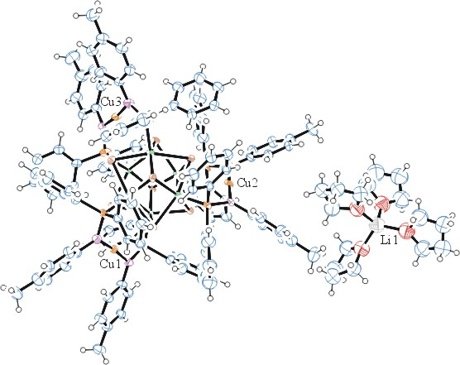
Figure 1. ORTEP of the structure with thermal ellipsoids at the 50% probability level.

Table 1: Crystallographic data for the structures provided.
Empirical formula C130 H134 Co6 Cu3 Li N6 O4 P6 Se8
Formula weight 3213.06
Temperature 100(2) K
Wavelength 0.71073 Å
Crystal system Orthorhombic
Space group P 2₁ 2₁ 2₁
Unit cell dimensions a = 15.2726(11) Å α= 90°.
b = 29.4371(18) Å β= 90°.
c = 30.338(2) Å γ = 90°.
Volume 13639.4(16) Å3
Z 4
Density (calculated) 1.565 Mg/m3
Absorption coefficient 3.424 mm-1
F(000) 6408
Crystal size 0.200 x 0.090 x 0.020 mm3
Theta range for data collection 1.342 to 26.373°.
Index ranges -19<=h<=19, -36<=k<=36, 0<=l<=37
Reflections collected 50961
Independent reflections 26743 [R(int) = 0.1429]
Completeness to theta = 25.000° 97.9 %
Refinement method Full-matrix least-squares on F2
Data / restraints / parameters 26743 / 2180 / 1266
Goodness-of-fit on F2 1.038
Final R indices [I>2sigma(I)] R1 = 0.1002, wR2 = 0.2102
R indices (all data) R1 = 0.1776, wR2 = 0.2289
Absolute structure parameter 0.08(2)
Largest diff. peak and hole 1.787 and -1.236 e.Å-3

Sheldrick, G. M. (2005). CELL_NOW. University of Goettingen, Germany.
Bruker (2007) APEX2 (Version 2.1-4), SAINT (version 7.34A), SADABS (version 2007/4), BrukerAXS Inc, Madison, Wisconsin, USA.
Sheldrick, G. M. (2007). TWINABS. University of Goettingen, Germany.
Sheldrick GM. (2015) SHELXT - Integrated space-group and crystal-structure determination. Acta Cryst. A71, 3-8.
(a) Altomare A, Burla C, Camalli M, Cascarano G L, Giacovazzo C, Guagliardi A, Moliterni AGG, Polidori G, Spagna R. (1999) SIR97: a new tool for crystal structure determination and refinement Journal of Applied Crystallography, 32, 115-119. (b) Altomare A, Cascarano G L, Giacovazzo C, Guagliardi A. (1993) Completion and refinement of crystal structures with SIR 92. Journal of Applied Crystallography, 26, 343-350.
’Sheldrick : A short history of SHELX . Acta Cryst. (2008), A64, 112-122
Mackay, S.; Edwards, C.; Henderson, A.; Gilmore, C.; Stewart, N.; Shankland, K.; Donald, A. (1997) MaXus: a computer program for the solution and refinement of crystal structures from diffraction data. University of Glasgow, Scotland,.
Waasmaier, D.; Kirfel, A. (1995) New Analytical Scattering Factor Functions for Free Atoms and Ions. Acta Crystallographica A., 51, 416-430.
(a) A. Spek, J. Appl. Cryst. (2003), 36, 7-13; (b) P. van der Sluis & A. L. Spek, Acta Cryst. (1990). A46, 194-201. (c) Spek, A. L. (2009). Acta. Cryst. D65, 148-155.
Farrugia LJ. (1997) Ortep-3 for Windows. Journal of Applied Crystallography, 30, 565

