Crystal Structure Report for A. Velian
by Werner Kaminsky
Sample Submitted by
Sebastian Krajewski
ID – SMK509
X-ray Crystallography Laboratory
University of Washington
31. July 2026

Data Collection started: 8/8/2023
Documentation finished: 8/21/2023

Data backup accessibly through http:
URL: http://cad4.cpac.washington.edu/structures

W.Kaminsky: tel. (206) 543 7585
(x-ray lab): tel. (206) 543 0210
Email: kaminsky@chem.washington.edu

Understanding crystallographic information is not trivial. If you discuss a structure in a publication, please let the crystallographers proof-read the final draft of that manuscript before you submit it.
For many structures it is true that crystallography is an intellectual performance (like synthesis or elucidation of mechanisms) and not a routine job. In these cases, particularly when the structures contribute significantly to the content of the publication, the crystallographers should be co-authors. Do not think this is not necessary because you pay for structures.
A black block, measuring 0.33 x 0.15 x 0.07 mm³ was mounted on a loop with oil. Data was collected at -173ºC on a Bruker APEX II single crystal X-ray diffractometer, Mo-radiation, equipped with a Miracol X-ray optical collimator.

Crystal-to-detector distance was 45 mm and exposure time was 20 seconds per frame for all sets. The scan width was 0.5º. Data collection was 100% complete to 25º in ϑ. A total of 289414 reflections were collected covering the indices, -40<=h<=40, -38<=k<=38, -33<=l<=33. 100053 reflections were symmetry independent and the R_{int} = 0.1439 indicated that the data was a challange. Indexing and unit cell refinement indicated an orthorhombic lattice. The space group was found to be A b a 2 (No. 41).

The data was integrated and scaled using SAINT, SADABS within the APEX2 software package by Bruker.

The data appeared merohedrally twinned via 180 degrees about [1 0 0] and a hklf5 file was created from within WinGX.

The contribution of disordered THF solvent to the diffraction pattern was removed with SQUEEZE

Solution by direct methods (SHELXT or SIR97) produced a complete heavy atom phasing model consistent with the proposed structure. The structure was completed by difference Fourier synthesis with SHELXL. Scattering factors are from Waasmair and Kirfel. Hydrogen atoms were placed in geometrically idealised positions and constrained to ride on their parent atoms with C---H distances in the range 0.95-1.00 Angstrom. Isotropic thermal parameters U_{eq} were fixed such that they were 1.2U_{eq} of their parent atom Ueq for CH's and 1.5U_{eq} of their parent atom U_{eq} in case of methyl groups. All non-hydrogen atoms were refined anisotropically by full-matrix least-squares.

The structure solved as enantiopure twin whereby the twin fraction of 180 degree rotation about the c-axis was refined to 20(4)%. The lower data quality made it necessary to stabilize the displacement parameters of carbon and nitrogen using ISOR restraints, and together with phosphorous link them along bonds via DELU. ONE Toluene was straightened out with a FLAT card. All phenyls are optimized and the ph2PNtol ligands are linked via SAME. The butanes of the but4N cation were linked with SAME as well.

The structure is of high quality and ready for publication. Table 1 summarizes the data collection details. Figure 1 shows an ORTEP of the asymmetric unit.

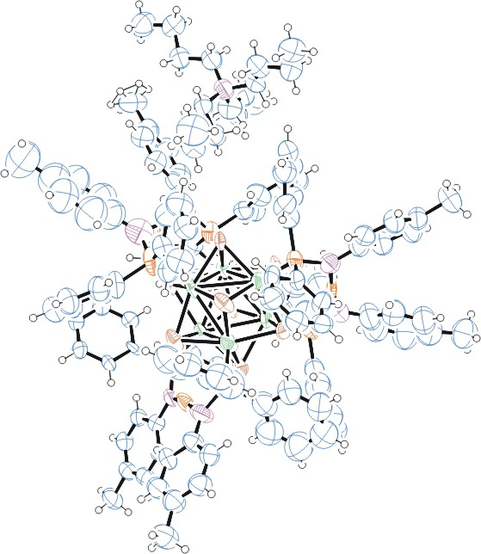
Figure 1. ORTEP of the structure with thermal ellipsoids at the 50% probability level.

Table 1: Crystallographic data for the structures provided.
Empirical formula C130 H138 Co6 Cu3 N7 P6 Se8
Formula weight 3160.17
Temperature 100(2) K
Wavelength 0.71073 Å
Crystal system Orthorhombic
Space group A b a 2
Unit cell dimensions a = 33.937(4) Å α= 90°.
b = 32.775(4) Å β= 90°.
c = 27.995(3) Å γ = 90°.
Volume 31138(6) Å3
Z 8
Density (calculated) 1.348 Mg/m3
Absorption coefficient 2.997 mm-1
F(000) 12624
Crystal size 0.330 x 0.150 x 0.070 mm3
Theta range for data collection 1.129 to 25.027°.
Index ranges -40<=h<=40, -38<=k<=38, -33<=l<=33
Reflections collected 100053
Independent reflections 100053 [R(int) = 0.1439]
Completeness to theta = 25.027° 100.0 %
Refinement method Full-matrix least-squares on F2
Data / restraints / parameters 100053 / 2015 / 1231
Goodness-of-fit on F2 1.062
Final R indices [I>2sigma(I)] R1 = 0.1511, wR2 = 0.2785
R indices (all data) R1 = 0.3130, wR2 = 0.3326
Absolute structure parameter -0.032(9)
Largest diff. peak and hole 2.366 and -1.363 e.Å-3

Bruker (2007) APEX2 (Version 2.1-4), SAINT (version 7.34A), SADABS (version 2007/4), BrukerAXS Inc, Madison, Wisconsin, USA.
Farrugia, L. J. (1999). J. Appl. Cryst. 32, 837-838.
(a) A. Spek, J. Appl. Cryst. (2003), 36, 7-13; (b) P. van der Sluis & A. L. Spek, Acta Cryst. (1990). A46, 194-201. (c) Spek, A. L. (2009). Acta. Cryst. D65, 148-155.
(a) Sheldrick GM. (2008) A short history of SHELX. Acta Cryst. A64, 112-122. (b) Sheldrick GM. (2015) SHELXT - Integrated space-group and crystal-structure determination. Acta Cryst. A71, 3-8.
(a) Altomare A, Burla C, Camalli M, Cascarano G L, Giacovazzo C, Guagliardi A, Moliterni AGG, Polidori G, Spagna R. (1999) SIR97: a new tool for crystal structure determination and refinement Journal of Applied Crystallography, 32, 115-119. (b) Altomare A, Cascarano G L, Giacovazzo C, Guagliardi A. (1993) Completion and refinement of crystal structures with SIR 92. Journal of Applied Crystallography, 26, 343-350.
(a) Sheldrick GM. (1997) SHELXL-97, Program for the Refinement of Crystal Structures. University of Göttingen, Germany. (b) Sheldrick GM. (2015) Crystal structure refinement with SHELXL. Acta Cryst. C71, 3–8
Waasmaier, D.; Kirfel, A. (1995) New Analytical Scattering Factor Functions for Free Atoms and Ions. Acta Crystallographica A., 51, 416-430.
Farrugia LJ. (1997) Ortep-3 for Windows. Journal of Applied Crystallography, 30, 565

