Crystal Structure Report for D. Reed
by Sebastian Krajewski & Werner Kaminsky
Sample Submitted by Spencer Smith
ID – SPS_3_6_10
X-ray Crystallography Laboratory
University of Washington
30. July 2026

Data Collection started: 8/4/2023
Documentation finished: 8/8/2023

Data backup accessibly through http:
URL: http://cad4.cpac.washington.edu/structures

W.Kaminsky: tel. (206) 543 7585
(x-ray lab): tel. (206) 543 0210
Email: kaminsky@chem.washington.edu

Understanding crystallographic information is not trivial. If you discuss a structure in a publication, please let the crystallographers proof-read the final draft of that manuscript before you submit it.
For many structures it is true that crystallography is an intellectual performance (like synthesis or elucidation of mechanisms) and not a routine job. In these cases, particularly when the structures contribute significantly to the content of the publication, the crystallographers should be co-authors. Do not think this is not necessary because you pay for structures.
A green needle, measuring 0.20 x 0.02 x 0.02 mm³ was mounted on a loop with oil. Data was collected at -173ºC on a Bruker APEX II single crystal X-ray diffractometer, Mo-radiation, equipped with a Miracol X-ray optical collimator.

Crystal-to-detector distance was xx mm and exposure time was 30 seconds per frame for all sets. The scan width was 0.5º. Data collection was 99.9% complete to 25º in ϑ. A total of 33313 reflections were collected covering the indices, -17<=h<=17, -19<=k<=19, -26<=l<=26. 16800 reflections were symmetry independent and the R_{int} = 0.0841 indicated that the data was of appropriate quality (0.07). Indexing and unit cell refinement indicated a triclinic lattice. The space group was found to be P‾1 (No. 2).

The data was integrated and scaled using SAINT, SADABS within the APEX2 software package by Bruker.

Solution by direct methods (SHELXT or SIR97) produced a complete heavy atom phasing model consistent with the proposed structure. The structure was completed by difference Fourier synthesis with SHELXL. Scattering factors are from Waasmair and Kirfel. Hydrogen atoms were placed in geometrically idealised positions and constrained to ride on their parent atoms with C---H distances in the range 0.95-1.00 Angstrom. Isotropic thermal parameters U_{eq} were fixed such that they were 1.2U_{eq} of their parent atom Ueq for CH's and 1.5U_{eq} of their parent atom U_{eq} in case of methyl groups. All non-hydrogen atoms were refined anisotropically by full-matrix least-squares.

The structure contains in addition to the Cu2-(C7 H4 S O5)4 complex, where two DMF solvents coordinate with the copper atoms, several more DMF solvents, of which one is disordered over a special position, filling voids between the complex. One NO3 anion is hydrogen-bonding to a C(NH2)3 cations, and one (Ch3CH3)2NH2 cation plus three potassiom ions balance charges, but no kitchen sink was found.

The structure is of high quality and ready for publication. Table 1 summarizes the data collection details. Figure 1 shows an ORTEP of the asymmetric unit.

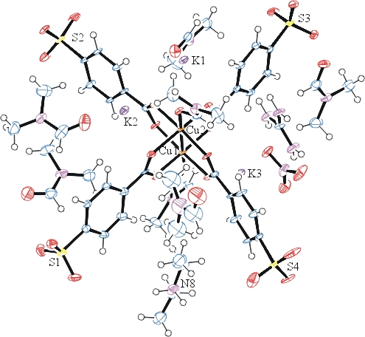
Figure 1. ORTEP of the structure with thermal ellipsoids at the 50% probability level. Disorder omitted for clarity.

Table 1: Crystallographic data for the structures provided.
Empirical formula C105 H159 Cu4 K6 N23 O59 S8
Formula weight 3432.78
Temperature 100(2) K
Wavelength 0.71073 Å
Crystal system Triclinic
Space group P -1
Unit cell dimensions a = 13.1102(7) Å α= 105.812(3)°.
b = 15.3144(9) Å β= 103.344(3)°.
c = 20.4996(12) Å γ = 104.314(3)°.
Volume 3635.6(4) Å3
Z 1
Density (calculated) 1.568 Mg/m3
Absorption coefficient 0.961 mm-1
F(000) 1780
Crystal size 0.200 x 0.020 x 0.020 mm3
Theta range for data collection 1.090 to 27.660°.
Index ranges -17<=h<=17, -19<=k<=19, -26<=l<=26
Reflections collected 33313
Independent reflections 16800 [R(int) = 0.0841]
Completeness to theta = 25.242° 99.9 %
Refinement method Full-matrix least-squares on F2
Data / restraints / parameters 16800 / 170 / 937
Goodness-of-fit on F2 0.902
Final R indices [I>2sigma(I)] R1 = 0.0542, wR2 = 0.1085
R indices (all data) R1 = 0.1231, wR2 = 0.1261
Extinction coefficient 0.00183(17)
Largest diff. peak and hole 1.985 and -0.930 e.Å-3

Bruker (2007) APEX2 (Version 2.1-4), SAINT (version 7.34A), SADABS (version 2007/4), BrukerAXS Inc, Madison, Wisconsin, USA.
(a) Sheldrick GM. (2008) A short history of SHELX. Acta Cryst. A64, 112-122. (b) Sheldrick GM. (2015) SHELXT - Integrated space-group and crystal-structure determination. Acta Cryst. A71, 3-8.
(a) Altomare A, Burla C, Camalli M, Cascarano G L, Giacovazzo C, Guagliardi A, Moliterni AGG, Polidori G, Spagna R. (1999) SIR97: a new tool for crystal structure determination and refinement Journal of Applied Crystallography, 32, 115-119. (b) Altomare A, Cascarano G L, Giacovazzo C, Guagliardi A. (1993) Completion and refinement of crystal structures with SIR 92. Journal of Applied Crystallography, 26, 343-350.
(a) Sheldrick GM. (1997) SHELXL-97, Program for the Refinement of Crystal Structures. University of Göttingen, Germany. (b) Sheldrick GM. (2015) Crystal structure refinement with SHELXL. Acta Cryst. C71, 3–8
Waasmaier, D.; Kirfel, A. (1995) New Analytical Scattering Factor Functions for Free Atoms and Ions. Acta Crystallographica A., 51, 416-430.
Farrugia LJ. (1997) Ortep-3 for Windows. Journal of Applied Crystallography, 30, 565

