Crystal Structure Report for D. Xiao
by Sebastian Krajewski and
Werner Kaminsky
Sample Submitted by Sophie Song
ID – SS_6205_2
X-ray Crystallography Laboratory
University of Washington
28. July 2026

Data Collection started: 11/20/2024
Documentation finished: 2/25/2025

Data backup accessibly through http:
URL: http://cad4.cpac.washington.edu/structures

W.Kaminsky: tel. (206) 543 7585
(x-ray lab): tel. (206) 543 0210
Email: kaminsky@chem.washington.edu

Understanding crystallographic information is not trivial. If you discuss a structure in a publication, please let the crystallographers proof-read the final draft of that manuscript before you submit it.
For many structures it is true that crystallography is an intellectual performance (like synthesis or elucidation of mechanisms) and not a routine job. In these cases, particularly when the structures contribute significantly to the content of the publication, the crystallographers should be co-authors. Do not think this is not necessary because you pay for structures.
A colorless needle, measuring 0.15 x 0.07 x 0.05 mm³ was mounted on a loop with oil. Data was collected at -173ºC on a Bruker APEX II single crystal X-ray diffractometer, Mo-radiation, equipped with a Miracol X-ray optical collimator.

Crystal-to-detector distance was 45 mm and exposure time was 30 seconds per frame for all sets. The scan width was 0.5º. Data collection was 99.4% complete to 25º in ϑ. A total of 43168 merged reflections were collected covering the indices, -28<=h<=28, -60<=k<=60, -27<=l<=27. 21718 reflections were symmetry independent and the R_{int} = 0.0456 indicated that the data was of good quality. Indexing and unit cell refinement indicated a C-centered monoclinic lattice. The space group was found to be C 2/c (No.15).

The data was integrated and scaled using SAINT, SADABS within the APEX2 software package by Bruker.

Solution by direct methods (SHELXT or SIR97) produced a complete heavy atom phasing model consistent with the proposed structure. The structure was completed by difference Fourier synthesis with SHELXL. Scattering factors are from Waasmair and Kirfel. Hydrogen atoms were placed in geometrically idealised positions and constrained to ride on their parent atoms with C---H distances in the range 0.95-1.00 Angstrom. Isotropic thermal parameters U_{eq} were fixed such that they were 1.2U_{eq} of their parent atom Ueq for CH's and 1.5U_{eq} of their parent atom U_{eq} in case of methyl groups. All non-hydrogen atoms were refined anisotropically by full-matrix least-squares.

The structure exhibits full-molecule disorder. Part of the Cu-metallorganic framework is partially overlapping with solvent, similar the PF6 anions. Thus, although most of the disordered solvent’s contribution to the diffraction pattern was removed with SQUEEZE, some remaining electron density from the overlap zones raise the refinement R1 number. (Refined electrons [F(000)]: 8592, squeezed electrons: 2792).

The structure is of moderate quality but publishable. Table 1 summarizes the data collection details. Figure 1 shows an ORTEP of the asymmetric unit.

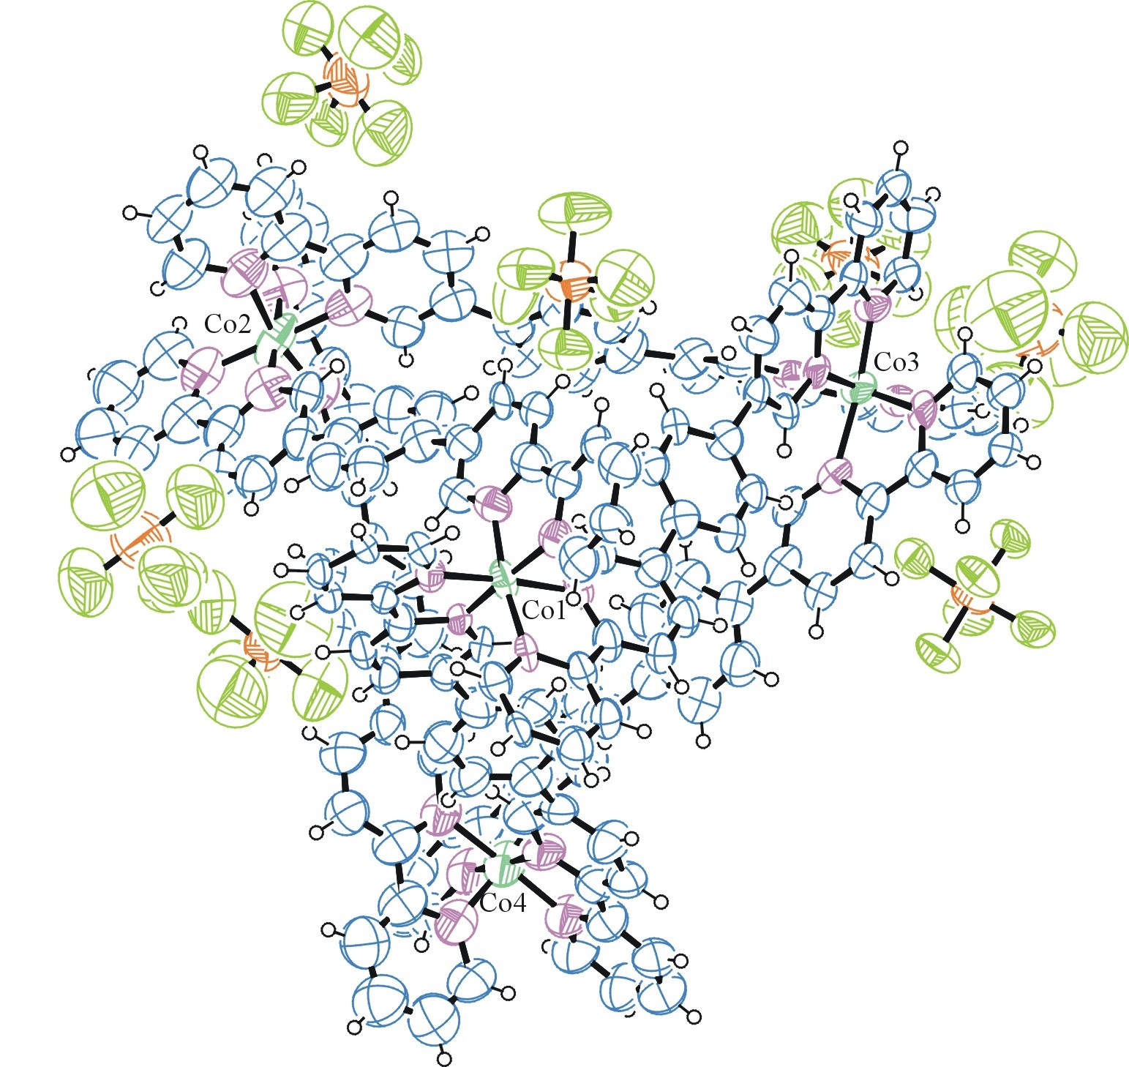
Figure 1. ORTEP of the structure with thermal ellipsoids at the 50% probability level. Only PF6 anions from the asymmetric unit are shown (a total of 12 per MOF).
Disorder omitted for clarity.

Table 1: Crystallographic data for the structures provided.
Empirical formula C156 H108 Co4 F72 N24 P12
Formula weight 4294.02
Temperature 100(2) K
Wavelength 0.71073 Å
Crystal system Monoclinic
Space group C 2/c
Unit cell dimensions a = 24.131(4) Å α= 90°.
b = 50.857(9) Å β= 118.993(9)°.
c = 23.001(4) Å γ = 90°.
Volume 24690(8) Å3
Z 4
Density (calculated) 1.155 Mg/m3
Absorption coefficient 0.437 mm-1
F(000) 8592
Crystal size 0.150 x 0.070 x 0.050 mm3
Theta range for data collection 1.045 to 25.027°.
Index ranges -28<=h<=28, -60<=k<=60, -27<=l<=27
Reflections collected 43168
Independent reflections 21718 [R(int) = 0.0456]
Completeness to theta = 25.027° 99.4 %
Refinement method Full-matrix least-squares on F2
Data / restraints / parameters 21718 / 5026 / 2026
Goodness-of-fit on F2 1.057
Final R indices [I>2sigma(I)] R1 = 0.1799, wR2 = 0.3251
R indices (all data) R1 = 0.2715, wR2 = 0.3802
Extinction coefficient 0.00044(3)
Largest diff. peak and hole 0.979 and -1.069 e.Å-3

Bruker (2007) APEX2 (Version 2.1-4), SAINT (version 7.34A), SADABS (version 2007/4), BrukerAXS Inc, Madison, Wisconsin, USA.
(a) Sheldrick GM. (2008) A short history of SHELX. Acta Cryst. A64, 112-122. (b) Sheldrick GM. (2015) SHELXT - Integrated space-group and crystal-structure determination. Acta Cryst. A71, 3-8.
(a) Altomare A, Burla C, Camalli M, Cascarano G L, Giacovazzo C, Guagliardi A, Moliterni AGG, Polidori G, Spagna R. (1999) SIR97: a new tool for crystal structure determination and refinement Journal of Applied Crystallography, 32, 115-119. (b) Altomare A, Cascarano G L, Giacovazzo C, Guagliardi A. (1993) Completion and refinement of crystal structures with SIR 92. Journal of Applied Crystallography, 26, 343-350.
(a) Sheldrick GM. (1997) SHELXL-97, Program for the Refinement of Crystal Structures. University of Göttingen, Germany. (b) Sheldrick GM. (2015) Crystal structure refinement with SHELXL. Acta Cryst. C71, 3–8
Waasmaier, D.; Kirfel, A. (1995) New Analytical Scattering Factor Functions for Free Atoms and Ions. Acta Crystallographica A., 51, 416-430.
(a) A. Spek, J. Appl. Cryst. (2003), 36, 7-13; (b) P. van der Sluis & A. L. Spek, Acta Cryst. (1990). A46, 194-201. (c) Spek, A. L. (2009). Acta. Cryst. D65, 148-155.
Farrugia LJ. (1997) Ortep-3 for Windows. Journal of Applied Crystallography, 30, 565

