Crystal Structure Report for K Goldberg
by Sarah Flowers & Werner Kaminsky
Sample Submitted by Timothy Brewster
ID – TB_2_140
X-ray Crystallography Laboratory
University of Washington
29. July 2026

Data Collection started: 01/08/15
Documentation finished: 01/16/15

Data backup accessibly through http:
URL: http://cad4.cpac.washington.edu/structures

W.Kaminsky: tel. (206) 543 7585
(x-ray lab): tel. (206) 543 0210
Email: kaminsky@chem.washington.edu

Understanding crystallographic information is not trivial. If you discuss a structure in a publication, please let the crystallographers proof-read the final draft of that manuscript before you submit it.
For many structures it is true that crystallography is an intellectual performance (like synthesis or elucidation of mechanisms) and not a routine job. In these cases, particularly when the structures contribute significantly to the content of the publication, the crystallographers should be co-authors. Do not think this is not necessary because you pay for structures. Even I have to pay for my own structures for my research.
A yellow prism, measuring 0.30 x 0.15 x 0.05 mm³ was mounted on a loop with oil. Data was collected at -183ºC on a Bruker APEX II single crystal X-ray diffractometer, Mo-radiation.

Crystal-to-detector distance was 40 mm and exposure time was 5 seconds per frame for all sets. The scan width was 0.5º. Data collection was 98.4% complete to 25º in ϑ. A total of 88363 reflections were collected covering the indices, h = -16 to 16, k = -17 to 17, l = -231 to 23. 13065 reflections were symmetry independent and the R_{int} = 0.0601 indicated that the data was good. Indexing and unit cell refinement indicated a primitive triclinic lattice. The space group was found to be P‾1 (No.14).

The data was integrated and scaled using SAINT, SADABS within the APEX2 software package by Bruker.

Solution by direct methods (SHELXS, SIR97) produced a complete heavy atom phasing model consistent with the proposed structure. The structure was completed by difference Fourier synthesis with SHELXL97., Scattering factors are from Waasmair and Kirfel. Hydrogen atoms were placed in geometrically idealised positions and constrained to ride on their parent atoms with C---H distances in the range 0.95-1.00 Angstrom. Isotropic thermal parameters U_{eq} were fixed such that they were 1.2U_{eq} of their parent atom Ueq for CH's and 1.5U_{eq} of their parent atom U_{eq} in case of methyl groups. All non-hydrogen atoms were refined anisotropically by full-matrix least-squares.

Chaotically disordered CH₂Cl₂ solvent was first considered for refinement, but then it proved a better solution to involve
SQUEEZE for removal of solvent contribution to the scattering intensities. Several CF3 groups in vicinity of the solvent are rotationally disordered. This structure is very similar to that od TB_2_138.

The structure is of high quality and ready for publication. Table 1 summarizes the data collection details. Figure 1 shows an ORTEP of the asymmetric unit.

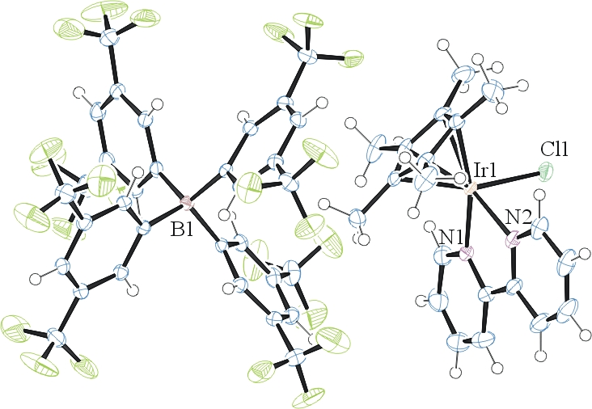

Figure 1. ORTEP of the structure with thermal ellipsoids at the 50% probability level. Disorder and solvent omitted for clarity.

Table 1: Crystallographic data for the structures provided.
Empirical formula C52 H35 B Cl F24 N2 Rh
Formula weight 1292.99
Temperature 90(2) K
Wavelength 0.71073 Å
Crystal system Triclinic
Space group P -1
Unit cell dimensions a = 12.4565(11) Å α= 73.727(5)°.
b = 13.2830(12) Å β= 81.600(5)°.
c = 17.6332(17) Å γ = 74.304(5)°.
Volume 2688.5(4) Å3
Z 2
Density (calculated) 1.597 Mg/m3
Absorption coefficient 0.489 mm-1
F(000) 1288
Crystal size 0.30 x 0.15 x 0.05 mm3
Theta range for data collection 2.01 to 28.39°.
Index ranges -16<=h<=16, -17<=k<=17, -23<=l<=23
Reflections collected 88363
Independent reflections 13065 [R(int) = 0.0601]
Completeness to theta = 25.00° 98.4 %
Max. and min. transmission 0.9760 and 0.8672
Refinement method Full-matrix least-squares on F2
Data / restraints / parameters 13065 / 255 / 900
Goodness-of-fit on F2 1.072
Final R indices [I>2sigma(I)] R1 = 0.0430, wR2 = 0.0892
R indices (all data) R1 = 0.0611, wR2 = 0.0946
Largest diff. peak and hole 0.645 and -0.654 e.Å-3

Bruker (2007) APEX2 (Version 2.1-4), SAINT (version 7.34A), SADABS (version 2007/4), BrukerAXS Inc, Madison, Wisconsin, USA.
(a) Altomare A, Burla C, Camalli M, Cascarano G L, Giacovazzo C, Guagliardi A, Moliterni AGG, Polidori G, Spagna R. (1999) SIR97: a new tool for crystal structure determination and refinement Journal of Applied Crystallography, 32, 115-119. (b) Altomare A, Cascarano G L, Giacovazzo C, Guagliardi A. (1993) Completion and refinement of crystal structures with SIR 92. Journal of Applied Crystallography, 26, 343-350.
Sheldrick GM. (1997) SHELXL-97, Program for the Refinement of Crystal Structures. University of Göttingen, Germany.
Mackay, S.; Edwards, C.; Henderson, A.; Gilmore, C.; Stewart, N.; Shankland, K.; Donald, A. (1997) MaXus: a computer program for the solution and refinement of crystal structures from diffraction data. University of Glasgow, Scotland,.
Waasmaier, D.; Kirfel, A. (1995) New Analytical Scattering Factor Functions for Free Atoms and Ions. Acta Crystallographica A., 51, 416-430.
A. Spek, J. Appl. Cryst. (2003), 36, 7-13; P. van der Sluis & A. L. Spek, Acta Cryst. (1990). A46, 194-201.
Farrugia LJ. (1997) Ortep-3 for Windows. Journal of Applied Crystallography, 30, 565

