Crystal Structure Report for K Goldberg
by Werner Kaminsky
Sample Submitted by Timothy Brewster
ID – TB_2_141
X-ray Crystallography Laboratory
University of Washington
31. July 2026

Data Collection started: 1/12/2015
Documentation finished: 1/23/2015

Data backup accessibly through http:
URL: http://cad4.cpac.washington.edu/structures

W.Kaminsky: tel. (206) 543 7585
(x-ray lab): tel. (206) 543 0210
Email: kaminsky@chem.washington.edu

Understanding crystallographic information is not trivial. If you discuss a structure in a publication, please let the crystallographers proof-read the final draft of that manuscript before you submit it.
For many structures it is true that crystallography is an intellectual performance (like synthesis or elucidation of mechanisms) and not a routine job. In these cases, particularly when the structures contribute significantly to the content of the publication, the crystallographers should be co-authors. Do not think this is not necessary because you pay for structures. Even I have to pay for my own structures for my research.
An orange prism, measuring 0.45 x 0.40 x 0.37 mm³ was mounted on a loop with oil. Data was collected at 21ºC on a Nonius Kappa CCD FR590 single crystal X-ray diffractometer, Mo-radiation.

Crystal-to-detector distance was 30 mm and exposure time was 60 seconds per degree for all sets. The scan width was 1º. Data collection was 99.8% complete 25º in ϑ. A total of 23089 merged reflections were collected covering the indices, h = -15 to 16, k = -18 to 19, l = -21 to 20. 13944 reflections were symmetry independent and the R_{int} = 0.0372 indicated that the data was brilliant. Indexing and unit cell refinement indicated a triclinic P lattice. The space group was found to be P‾1 (No.2).

The data was integrated and scaled using hkl-SCALEPACK. This program applies a multiplicative correction factor (S) to the observed intensities (I) and has the following form:

S is calculated from the scale and the B factor determined for each frame and is then applied to I to give the corrected intensity (I_{corr}).

Solution by direct methods (SHELXS, SIR97) produced a complete heavy atom phasing model consistent with the proposed structure. The structure was completed by difference Fourier synthesis with SHELXL97., Scattering factors are from Waasmair and Kirfel. Hydrogen atoms were placed in geometrically idealised positions and constrained to ride on their parent atoms with C---H distances in the range 0.95-1.00 Angstrom. Isotropic thermal parameters U_{eq} were fixed such that they were 1.2U_{eq} of their parent atom Ueq for CH's and 1.5U_{eq} of their parent atom U_{eq} in case of methyl groups. All non-hydrogen atoms were refined anisotropically by full-matrix least-squares.

The data were taken at 294K because upon cooling the material undergoes a structural phase transition. Delayed recovery to its original clear room-temperature structure is observed after removal of sample from the cold stream, where opaqueness vanishes within a few minutes. Likely, this is a order-disorder case of reversible structural phasetransition where disordered TP* and several CF3 moieties on BArF order into at least two orientations in a different unit cell and symmetry, details pending.

The structure is of high quality and ready for publication. Table 1 summarizes the data collection details. Figure 1 shows an ORTEP of the asymmetric unit.

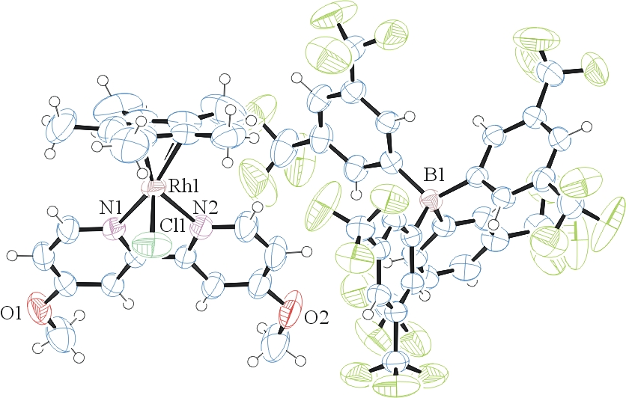

Figure 1. ORTEP of the structure with thermal ellipsoids at the 50% probability level. Disorder omitted for clarity.

Table 1: Crystallographic data for the structures provided.
Empirical formula C54 H39 B Cl F24 N2 O2 Rh
Formula weight 1353.04
Temperature 294(2) K
Wavelength 0.71073 Å
Crystal system Triclinic
Space group P -1
Unit cell dimensions a = 12.6380(2) Å α= 80.517(1)°.
b = 14.6131(2) Å β= 78.680(1)°.
c = 16.1084(3) Å γ = 83.540(1)°.
Volume 2867.27(8) Å3
Z 2
Density (calculated) 1.567 Mg/m3
Absorption coefficient 0.465 mm-1
F(000) 1352
Crystal size 0.45 x 0.40 x 0.37 mm3
Theta range for data collection 2.26 to 28.33°.
Index ranges -15<=h<=16, -18<=k<=19, -21<=l<=20
Reflections collected 23089
Independent reflections 13944 [R(int) = 0.0372]
Completeness to theta = 25.00° 99.8 %
Max. and min. transmission 0.8469 and 0.8182
Refinement method Full-matrix least-squares on F2
Data / restraints / parameters 13944 / 140 / 978
Goodness-of-fit on F2 1.037
Final R indices [I>2sigma(I)] R1 = 0.0527, wR2 = 0.1351
R indices (all data) R1 = 0.0961, wR2 = 0.1599
Largest diff. peak and hole 0.545 and -0.845 e.Å-3

Otwinowsky, Z.; Minor, W. In: Methods in Enzymology; Carter, C. W., Jr., Sweet, R. M., Eds.; Academic Press: New York, 1997, 276, 307-326.
(a) Altomare, A.; Burla, C.; Camalli M.; Cascarano L.; Giacovazzo C.; Guagliardi A.; Moliterni A.G.G.; Polidori G.; Spagna R. J. Appl. Cryst. 1999, 32, 115-119; (b) Altomare, A., Cascarano, G., Giacovazzo, C., Guagliardi, A., J. Appl. Cryst. 1993, 26, 343.
Sheldrick, G. M. SHELXL-97: Program for the Refinement of Crystal Structures 1997 University of Gottingen, Germany.
Mackay, S.; Edwards, C.; Henderson, A.; Gilmore, C.; Stewart, N.; Shankland, K.; Donald, A.; MaXus: a computer program for the solution and refinement of crystal structures from diffraction data. University of Glasgow, Scotland, 1997.
Waasmaier, D.; Kirfel, A. Acta Crystallogr. A. 1995, 51, 416.
Farrugia, L. J. Appl. Cryst. 1997, 30, 565

