Crystal Structure Report for D. Xiao
by Sebastian Krajewski & Werner Kaminsky
Sample Submitted by Ashe Kamin
ID – TC_252_TCE_hept
X-ray Crystallography Laboratory
University of Washington
29. July 2026

Data Collection started: 5/15/2023
Documentation finished: 5/23/2023

Data backup accessibly through http:
URL: http://cad4.cpac.washington.edu/structures

W.Kaminsky: tel. (206) 543 7585
(x-ray lab): tel. (206) 543 0210
Email: kaminsky@chem.washington.edu

Understanding crystallographic information is not trivial. If you discuss a structure in a publication, please let the crystallographers proof-read the final draft of that manuscript before you submit it.
For many structures it is true that crystallography is an intellectual performance (like synthesis or elucidation of mechanisms) and not a routine job. In these cases, particularly when the structures contribute significantly to the content of the publication, the crystallographers should be co-authors. Do not think this is not necessary because you pay for structures.
A colorless needle, measuring 0.47 x 0.09 x 0.04 mm³ was mounted on a loop with oil. Data was collected at -173ºC on a Bruker APEX II single crystal X-ray diffractometer, Mo-radiation, equipped with a Miracol X-ray optical collimator.

Crystal-to-detector distance was 40 mm and exposure time was 60 seconds per frame for all sets. The scan width was 0.5º. Data collection was 96.2% complete to 25º in ϑ. A total of 18303 reflections were collected covering the indices, -23<=h<=23, -10<=k<=9, -25<=l<=25. 5763 reflections were symmetry independent and the R_{int} = 0.1321 reflects the high mosaicity of the sample (average 0.07). Indexing and unit cell refinement indicated a primitive monoclinic lattice. The space group was found to be P 2₁/c (No.14).

The data was integrated and scaled using SAINT, SADABS within the APEX2 software package by Bruker.

Solution by direct methods (SHELXT or SIR97) produced a complete heavy atom phasing model consistent with the proposed structure. The structure was completed by difference Fourier synthesis with SHELXL. Scattering factors are from Waasmair and Kirfel. Hydrogen atoms were placed in geometrically idealised positions and constrained to ride on their parent atoms with C---H distances in the range 0.95-1.00 Angstrom. Isotropic thermal parameters U_{eq} were fixed such that they were 1.2U_{eq} of their parent atom Ueq for CH's and 1.5U_{eq} of their parent atom U_{eq} in case of methyl groups. All non-hydrogen atoms were refined anisotropically by full-matrix least-squares.

After careful selection of integration parameters through trial and error, a good data set was found that solved the structure. The contribution of disordered trichloroethylene to the diffraction pattern was removed with SQUEEZE.
Half of the ‘loop’ is symmetry independent and the other half is reproduced through inversion symmetry. The tetrafluorophenyl is disordered with a phenyl, thus there are only 4 fluorines per loop.

The structure is of high quality and ready for publication. Table 1 summarizes the data collection details. Figure 1 shows an ORTEP of the asymmetric unit.

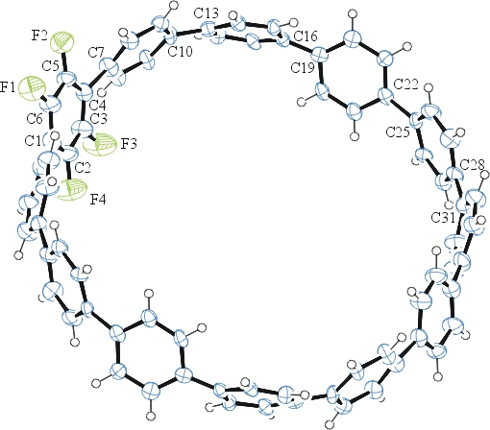
Figure 1. ORTEP of the structure with thermal ellipsoids at the 50% probability level. Disorder and solvent omitted for clarity.

Table 1: Crystallographic data for the structures provided.
Empirical formula C72 H44 F4
Formula weight 985.07
Temperature 100(2) K
Wavelength 0.71073 Å
Crystal system Monoclinic
Space group P 21/c
Unit cell dimensions a = 19.630(8) Å α= 90°.
b = 8.355(4) Å β= 108.19(3)°.
c = 21.036(12) Å γ = 90°.
Volume 3278(3) Å3
Z 2
Density (calculated) 0.998 Mg/m3
Absorption coefficient 0.065 mm-1
F(000) 1024
Crystal size 0.470 x 0.090 x 0.040 mm3
Theta range for data collection 2.038 to 25.348°.
Index ranges -23<=h<=23, -10<=k<=9, -25<=l<=25
Reflections collected 18303
Independent reflections 5763 [R(int) = 0.1321]
Completeness to theta = 25.242° 96.2 %
Refinement method Full-matrix least-squares on F2
Data / restraints / parameters 5763 / 180 / 361
Goodness-of-fit on F2 1.018
Final R indices [I>2sigma(I)] R1 = 0.1296, wR2 = 0.2415
R indices (all data) R1 = 0.2174, wR2 = 0.2807
Largest diff. peak and hole 0.388 and -0.354 e.Å-3

Bruker (2007) APEX2 (Version 2.1-4), SAINT (version 7.34A), SADABS (version 2007/4), BrukerAXS Inc, Madison, Wisconsin, USA.
(a) Sheldrick GM. (2008) A short history of SHELX. Acta Cryst. A64, 112-122. (b) Sheldrick GM. (2015) SHELXT - Integrated space-group and crystal-structure determination. Acta Cryst. A71, 3-8.
(a) Altomare A, Burla C, Camalli M, Cascarano G L, Giacovazzo C, Guagliardi A, Moliterni AGG, Polidori G, Spagna R. (1999) SIR97: a new tool for crystal structure determination and refinement Journal of Applied Crystallography, 32, 115-119. (b) Altomare A, Cascarano G L, Giacovazzo C, Guagliardi A. (1993) Completion and refinement of crystal structures with SIR 92. Journal of Applied Crystallography, 26, 343-350.
(a) Sheldrick GM. (1997) SHELXL-97, Program for the Refinement of Crystal Structures. University of Göttingen, Germany. (b) Sheldrick GM. (2015) Crystal structure refinement with SHELXL. Acta Cryst. C71, 3–8
Waasmaier, D.; Kirfel, A. (1995) New Analytical Scattering Factor Functions for Free Atoms and Ions. Acta Crystallographica A., 51, 416-430.
(a) A. Spek, J. Appl. Cryst. (2003), 36, 7-13; (b) P. van der Sluis & A. L. Spek, Acta Cryst. (1990). A46, 194-201. (c) Spek, A. L. (2009). Acta. Cryst. D65, 148-155.
Farrugia LJ. (1997) Ortep-3 for Windows. Journal of Applied Crystallography, 30, 565

