Crystal Structure Report for K. Goldberg
by Sarah Flowers and Werner Kaminsky
Sample Submitted by Tyler Stevens
ID – TES022
X-ray Crystallography Laboratory
University of Washington
28. July 2026

Data Collection started: 6/12/2015
Documentation finished: 6/16/2015

Data backup accessibly through http:
URL: http://cad4.cpac.washington.edu/structures

W.Kaminsky: tel. (206) 543 7585
(x-ray lab): tel. (206) 543 0210
Email: kaminsky@chem.washington.edu

Understanding crystallographic information is not trivial. If you discuss a structure in a publication, please let the crystallographers proof-read the final draft of that manuscript before you submit it.
For many structures it is true that crystallography is an intellectual performance (like synthesis or elucidation of mechanisms) and not a routine job. In these cases, particularly when the structures contribute significantly to the content of the publication, the crystallographers should be co-authors. Do not think this is not necessary because you pay for structures. Even I have to pay for my own structures for my research.
A yellow needle, measuring 0.69 x 0.06 x 0.06 mm³ was mounted on a loop with oil. Data was collected at -173ºC on a Bruker APEX II single crystal X-ray diffractometer, Mo-radiation.

Crystal-to-detector distance was 40 mm and exposure time was 60 seconds per frame for all sets. The scan width was 0.5º. Data collection was 99.9% complete to 25º in ϑ. A total of 58527 reflections were collected covering the indices, h = -30 to 30, k = -27 to 27, l = -21 to 21. 7917 reflections were symmetry independent and the R_{int} = 0.0526 indicated that the data was of good quality 0.07. Indexing and unit cell refinement indicated a C-centered monoclinic lattice. The space group was found to be C 2/c (No.15).

The data was integrated and scaled using SAINT, SADABS within the APEX2 software package by Bruker.

Solution by direct methods (SHELXS, SIR97) produced a complete heavy atom phasing model consistent with the proposed structure. The structure was completed by difference Fourier synthesis with SHELXL97., Scattering factors are from Waasmair and Kirfel. Hydrogen atoms were placed in geometrically idealised positions and constrained to ride on their parent atoms with C---H distances in the range 0.95-1.00 Angstrom. Isotropic thermal parameters U_{eq} were fixed such that they were 1.2U_{eq} of their parent atom Ueq for CH's and 1.5U_{eq} of their parent atom U_{eq} in case of methyl groups. All non-hydrogen atoms were refined anisotropically by full-matrix least-squares.

First the structure was refined with one/half PF₄⁻ and 3 CH₂Cl₂. However, the anion appeared disordered and located on a special position, leading to at least fourfold disorder. The solvent also appeared partially disordered, with the possibility of a small amount of pentane being present. Thus, a more complete treatment was achieved with employing SQEEZE to remove anion and solvent contributions to the diffraction pattern, which lowered the R1 from 0.0460 to 0.0346. The 3 bridging halides are composed of 62% Cl⁻, 20.67% F⁻ and 17.33% I⁻.

The structure is of high quality and ready for publication. Table 1 summarizes the data collection details. Figure 1 shows an ORTEP of the asymmetric unit.

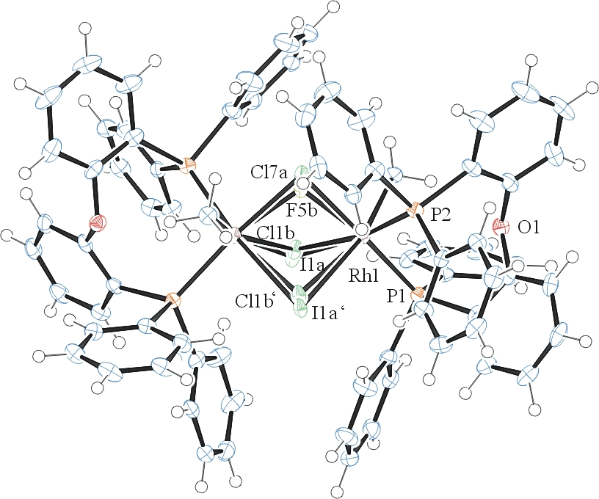

Figure 1. ORTEP of the structure with thermal ellipsoids at the 50% probability level. Anions and solvent omitted for clarity.

Table 1: Crystallographic data for the structures provided.
Empirical formula C74 H62 Cl1.86 F0.62 I0.52 O2 P4 Rh2
Formula weight 1457.19
Temperature 100(2) K
Wavelength 0.71073 Å
Crystal system Monoclinic
Space group C 2/c
Unit cell dimensions a = 25.3513(16) Å α= 90°.
b = 22.6139(16) Å β= 124.761(4)°.
c = 18.0351(11) Å γ = 90°.
Volume 8494.2(10) Å3
Z 4
Density (calculated) 1.139 Mg/m3
Absorption coefficient 0.750 mm-1
F(000) 2948
Crystal size 0.69 x 0.06 x 0.06 mm3
Theta range for data collection 1.46 to 25.60°.
Index ranges -30<=h<=30, -27<=k<=27, -21<=l<=21
Reflections collected 58527
Independent reflections 7917 [R(int) = 0.0526]
Completeness to theta = 25.00° 99.9 %
Max. and min. transmission 0.9564 and 0.6257
Refinement method Full-matrix least-squares on F2
Data / restraints / parameters 7917 / 1 / 391
Goodness-of-fit on F2 1.037
Final R indices [I>2sigma(I)] R1 = 0.0346, wR2 = 0.0790
R indices (all data) R1 = 0.0465, wR2 = 0.0823
Largest diff. peak and hole 0.651 and -0.526 e.Å-3

Bruker (2007) APEX2 (Version 2.1-4), SAINT (version 7.34A), SADABS (version 2007/4), BrukerAXS Inc, Madison, Wisconsin, USA.
(a) Altomare A, Burla C, Camalli M, Cascarano G L, Giacovazzo C, Guagliardi A, Moliterni AGG, Polidori G, Spagna R. (1999) SIR97: a new tool for crystal structure determination and refinement Journal of Applied Crystallography, 32, 115-119. (b) Altomare A, Cascarano G L, Giacovazzo C, Guagliardi A. (1993) Completion and refinement of crystal structures with SIR 92. Journal of Applied Crystallography, 26, 343-350.
Sheldrick GM. (1997) SHELXL-97, Program for the Refinement of Crystal Structures. University of Göttingen, Germany.
Mackay, S.; Edwards, C.; Henderson, A.; Gilmore, C.; Stewart, N.; Shankland, K.; Donald, A. (1997) MaXus: a computer program for the solution and refinement of crystal structures from diffraction data. University of Glasgow, Scotland,.
Waasmaier, D.; Kirfel, A. (1995) New Analytical Scattering Factor Functions for Free Atoms and Ions. Acta Crystallographica A., 51, 416-430.
A. Spek, J. Appl. Cryst. (2003), 36, 7-13; P. van der Sluis & A. L. Spek, Acta Cryst. (1990). A46, 194-201.
Farrugia LJ. (1997) Ortep-3 for Windows. Journal of Applied Crystallography, 30, 565

