Crystal Structure Report for Stefan Stoll
by Maike Blakely & Werner Kaminsky
Sample Submitted by Donald Mannikko
ID – VOTPP
X-ray Crystallography Laboratory
University of Washington
28. July 2026

Data Collection started: 7/3/2017
Documentation finished: 7/5/2017

Data backup accessibly through http:
URL: http://cad4.cpac.washington.edu/structures

W.Kaminsky: tel. (206) 543 7585
(x-ray lab): tel. (206) 543 0210
Email: kaminsky@chem.washington.edu

Understanding crystallographic information is not trivial. If you discuss a structure in a publication, please let the crystallographers proof-read the final draft of that manuscript before you submit it.
For many structures it is true that crystallography is an intellectual performance (like synthesis or elucidation of mechanisms) and not a routine job. In these cases, particularly when the structures contribute significantly to the content of the publication, the crystallographers should be co-authors. Do not think this is not necessary because you pay for structures.
A red prism, measuring 0.47 x 0.30 x 0.25 mm³ was mounted on a loop with oil. Data was collected at -173ºC on a Bruker APEX II single crystal X-ray diffractometer, Mo-radiation.

Crystal-to-detector distance was 40 mm and exposure time was 10 seconds per frame for all sets. The scan width was 0.5º. Data collection was 98.4% complete to 25º in ϑ. A total of 23264 reflections were collected covering the indices, -17<=h<=17, -17<=k<=17, -12<=l<=12. 1116 reflections were symmetry independent and the R_{int} = 0.0673 indicated that the data was of average quality. Indexing and unit cell refinement indicated a body centered tetragonal lattice. The space group was found to be I 4/m (No. 87).

The data was integrated and scaled using SAINT, SADABS within the APEX2 software package by Bruker.

Solution by direct methods (SHELXS, SIR97) produced a complete heavy atom phasing model consistent with the proposed structure. The structure was completed by difference Fourier synthesis with SHELXL97., Scattering factors are from Waasmair and Kirfel. Hydrogen atoms were placed in geometrically idealised positions and constrained to ride on their parent atoms with C---H distances in the range 0.95-1.00 Angstrom. Isotropic thermal parameters U_{eq} were fixed such that they were 1.2U_{eq} of their parent atom Ueq for CH's and 1.5U_{eq} of their parent atom U_{eq} in case of methyl groups. All non-hydrogen atoms were refined anisotropically by full-matrix least-squares. A small amount of merohedral twinning [1.7(2) %] via two-fold rotation about [1 1 0] was observed.

The V=O is disordered to either side of the porphyrin plane. The molecule inhabits the crystallographic symmetry (4/m, C_{4h}). Atom coordinates were enumerated and transformed to match those of the published structure. While the older structure, collected at room temperature, can be confirmed, the redetermination is performed at 100K and shows improvements in R1, completeness of data and higher scattering angles.

The structure is of high quality and ready for publication. Table 1 summarizes the data collection details. Figure 1 shows an ORTEP of the asymmetric unit.

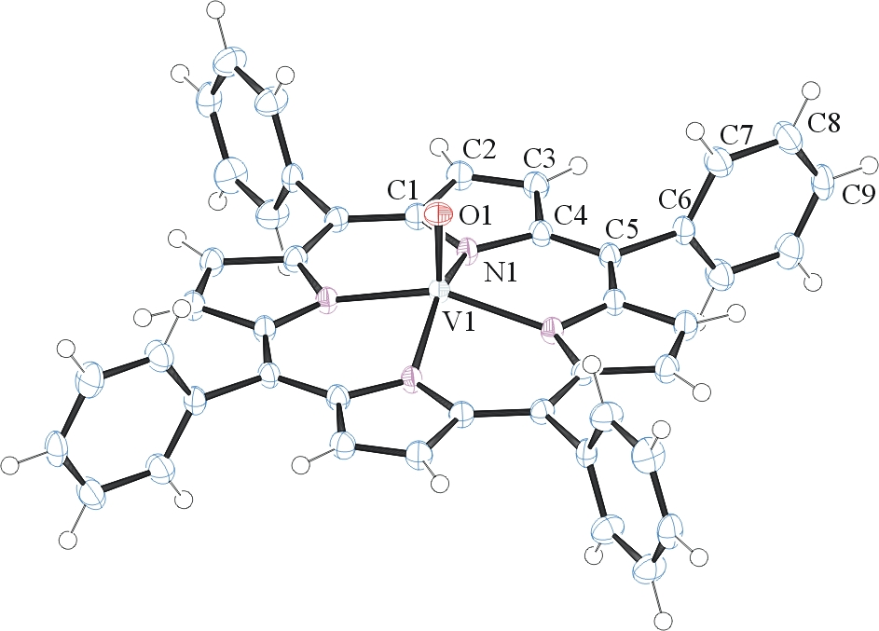
Figure 1. ORTEP of the structure with thermal ellipsoids at the 50% probability level. Disorder omitted for clarity.

Table 1: Crystallographic data for the structures provided.
Empirical formula C44 H28 N4 O V
Formula weight 679.64
Temperature 100(2) K
Wavelength 0.71073 Å
Crystal system Tetragonal
Space group I 4/m
Unit cell dimensions a = 13.322(4) Å α= 90°.
b = 13.322(4) Å β= 90°.
c = 9.665(4) Å γ = 90°.
Volume 1715.2(14) Å3
Z 2
Density (calculated) 1.316 Mg/m3
Absorption coefficient 0.330 mm-1
F(000) 702
Crystal size 0.470 x 0.300 x 0.250 mm3
Theta range for data collection 2.162 to 28.423°.
Index ranges -17<=h<=17, -17<=k<=17, -12<=l<=12
Reflections collected 23264
Independent reflections 1116 [R(int) = 0.0673]
Completeness to theta = 25.000° 98.4 %
Absorption correction Semi-empirical from equivalents
Max. and min. transmission 0.9457 and 0.7640
Refinement method Full-matrix least-squares on F2
Data / restraints / parameters 1116 / 0 / 74
Goodness-of-fit on F2 1.120
Final R indices [I>2sigma(I)] R1 = 0.0688, wR2 = 0.1534
R indices (all data) R1 = 0.0750, wR2 = 0.1562
Extinction coefficient n/a
Largest diff. peak and hole 0.307 and -0.506 e.Å-3

Bruker (2007) APEX2 (Version 2.1-4), SAINT (version 7.34A), SADABS (version 2007/4), BrukerAXS Inc, Madison, Wisconsin, USA.
(a) Altomare A, Burla C, Camalli M, Cascarano G L, Giacovazzo C, Guagliardi A, Moliterni AGG, Polidori G, Spagna R. (1999) SIR97: a new tool for crystal structure determination and refinement Journal of Applied Crystallography, 32, 115-119. (b) Altomare A, Cascarano G L, Giacovazzo C, Guagliardi A. (1993) Completion and refinement of crystal structures with SIR 92. Journal of Applied Crystallography, 26, 343-350.
(a) Sheldrick GM. (1997) SHELXL-97, Program for the Refinement of Crystal Structures. University of Göttingen, Germany. (b) Sheldrick GM. (2013) Crystal structure refinement with SHELXL. Acta Cryst. (2015). C71, 3-8.
Mackay, S.; Edwards, C.; Henderson, A.; Gilmore, C.; Stewart, N.; Shankland, K.; Donald, A. (1997) MaXus: a computer program for the solution and refinement of crystal structures from diffraction data. University of Glasgow, Scotland,.
Waasmaier, D.; Kirfel, A. (1995) New Analytical Scattering Factor Functions for Free Atoms and Ions. Acta Crystallographica A., 51, 416-430.
MICHAEL G. B. DREW, PHILIP C. H. MITCHELL and CARLOS E. SCOTT: Crystal and Molecular Structure of three Oxovanadium(IV) Porphyrins: Oxovanadium Tetraphenylporphyrin( I), Oxovanadium(IV) Etioporphyrin( II) and the 1: 2 Adduct of (II) with 1,4-Dihydroxybenzene(II1). Hydrogen Bonding Involving the VO Group. Relevance to Catalytic Demetallisation. Inorganica Chimica Acta, 82 (1984) 63-68.
Farrugia LJ. (1997) Ortep-3 for Windows. Journal of Applied Crystallography, 30, 565

