Crystal Structure Report for K. Goldberg
by Sarah Flowers and Werner Kaminsky
Sample Submitted by Wilson Bailey
ID – WDB_3_115
X-ray Crystallography Laboratory
University of Washington
31. July 2026

Data Collection started: 12/15/14
Documentation finished: 12/17/14

Data backup accessibly through http:
URL: http://cad4.cpac.washington.edu/structures
Username: xray-user
Password: hkl-data

W.Kaminsky: tel. (206) 543 7585
(x-ray lab): tel. (206) 543 0210
Email: kaminsky@chem.washington.edu

Understanding crystallographic information is not trivial. If you discuss a structure in a publication, please let the crystallographers proof-read the final draft of that manuscript before you submit it.
For many structures it is true that crystallography is an intellectual performance (like synthesis or elucidation of mechanisms) and not a routine job. In these cases, particularly when the structures contribute significantly to the content of the publication, the crystallographers should be co-authors. Do not think this is not necessary because you pay for structures. Even I have to pay for my own structures for my research.
A bright yellow clear, quasi kite shaped, prism measuring 0.33 x 0.18 x 0.075 mm³ with a small imperfection in the middle was mounted on a loop with oil. Data was collected at -173ºC on a Bruker APEX II single crystal X-ray diffractometer, Mo-radiation.

Crystal-to-detector distance was 40.00 mm and exposure time was 3 seconds per frame for all sets. The scan width was 0.5º. Data collection was 100.0 % complete to 25º in ϑ. A total of 97,372 reflections were collected covering the indices, h = -18 to 18, k = -15 to 15, l = -25 to 25. 7,543 reflections were symmetry independent and the R_{int} = 0.0356 indicated that the data was better than average quality (0.07). Indexing and unit cell refinement indicated a monoclinic lattice. The space group was found to be P 2₁/n (No.14).

The data was integrated and scaled using SAINT, SADABS within the APEX2 software package by Bruker.

Solution by direct methods (SHELXS, SIR97) produced a complete heavy atom phasing model consistent with the proposed structure. The structure was completed by difference Fourier synthesis with SHELXL97., Scattering factors are from Waasmair and Kirfel. Hydrogen atoms were placed in geometrically idealised positions and constrained to ride on their parent atoms with C---H distances in the range 0.95-1.00 Angstrom. Isotropic thermal parameters U_{eq} were fixed such that they were 1.2U_{eq} of their parent atom Ueq for CH's and 1.5U_{eq} of their parent atom U_{eq} in case of methyl groups. All non-hydrogen atoms were refined anisotropically by full-matrix least-squares.

This structure features a Pt dimer bridged by two potassium atoms.
The structure is of high quality and ready for publication. Table 1 summarizes the data
Figure 1 shows an ORTEP⁶ of the asymmetric unit.

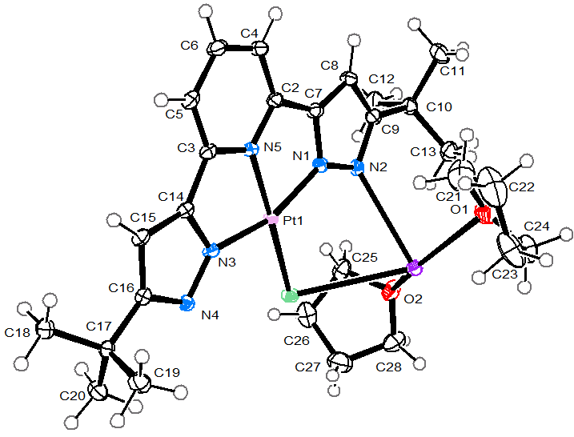

Figure 1. ORTEP of the structure with thermal ellipsoids at the 50% probability level. Solvent omitted for clarity.

Table 1. Crystal data and structure refinement for wdb_3_115_0ma.
Identification code wdb_3_115_0ma
Empirical formula C27 H39 Cl K N5 O2 Pt
Formula weight 735.27
Temperature 100(2) K
Wavelength 0.71073 Å
Crystal system Monoclinic
Space group P 2₁/n
Unit cell dimensions a = 14.1029(7) Å α= 90°.
b = 11.6863(6) Å β= 105.028(3)°.
c = 18.8823(9) Å γ = 90°.
Volume 3005.6(3) Å3
Z 4
Density (calculated) 1.625 Mg/m3
Absorption coefficient 4.928 mm-1
F(000) 1464
Crystal size 0.33 x 0.18 x 0.08 mm3
Theta range for data collection 2.07 to 28.41°.
Index ranges -18<=h<=18, -15<=k<=15, -25<=l<=25
Reflections collected 97372
Independent reflections 7543 [R(int) = 0.0356]
Completeness to theta = 25.00° 100.0 %
Absorption correction Semi-empirical from equivalents
Max. and min. transmission 0.6939 and 0.2932
Refinement method Full-matrix least-squares on F2
Data / restraints / parameters 7543 / 0 / 334
Goodness-of-fit on F2 1.033
Final R indices [I>2sigma(I)] R1 = 0.0164, wR2 = 0.0354
R indices (all data) R1 = 0.0223, wR2 = 0.0373
Largest diff. peak and hole 0.679 and -0.922 e.Å-3

Bruker (2007) APEX2 (Version 2.1-4), SAINT (version 7.34A), SADABS (version 2007/4), BrukerAXS Inc, Madison, Wisconsin, USA.
(a) Altomare A, Burla C, Camalli M, Cascarano G L, Giacovazzo C, Guagliardi A, Moliterni AGG, Polidori G, Spagna R. (1999) SIR97: a new tool for crystal structure determination and refinement Journal of Applied Crystallography, 32, 115-119. (b) Altomare A, Cascarano G L, Giacovazzo C, Guagliardi A. (1993) Completion and refinement of crystal structures with SIR 92. Journal of Applied Crystallography, 26, 343-350.
Sheldrick GM. (1997) SHELXL-97, Program for the Refinement of Crystal Structures. University of Göttingen, Germany.
Mackay, S.; Edwards, C.; Henderson, A.; Gilmore, C.; Stewart, N.; Shankland, K.; Donald, A. (1997) MaXus: a computer program for the solution and refinement of crystal structures from diffraction data. University of Glasgow, Scotland,.
Waasmaier, D.; Kirfel, A. (1995) New Analytical Scattering Factor Functions for Free Atoms and Ions. Acta Crystallographica A., 51, 416-430. 6 P. v.d. Sluis & A.L. Spek, BYPASS: an effective method for the refinement of crystal structures containing disordered solvent regions. Acta Cryst. A46, (1990), 194-201.

