Crystal Structure Report for Karen Goldberg
by Maike Blakely & Werner Kaminsky
Sample Submitted by Zuzana Culakova
ID – ZC_II_116
X-ray Crystallography Laboratory
University of Washington
31. July 2026

Data Collection started: 01/11/2018
Documentation finished: 01/18/2018

Data backup accessibly through http:
URL: http://cad4.cpac.washington.edu/structures

W.Kaminsky: tel. (206) 543 7585
(x-ray lab): tel. (206) 543 0210
Email: kaminsky@chem.washington.edu

Understanding crystallographic information is not trivial. If you discuss a structure in a publication, please let the crystallographers proof-read the final draft of that manuscript before you submit it.
For many structures it is true that crystallography is an intellectual performance (like synthesis or elucidation of mechanisms) and not a routine job. In these cases, particularly when the structures contribute significantly to the content of the publication, the crystallographers should be co-authors. Do not think this is not necessary because you pay for structures.
A colorless prism, measuring 0.57 x 0.14 x 0.14 mm³ was mounted on a loop with oil. Data was collected at -173ºC on a Bruker APEX II single crystal X-ray diffractometer, Mo-radiation.

Crystal-to-detector distance was 40 mm and exposure time was 5 seconds per frame for all sets. The scan width was 0.5º. Data collection was 99.9% complete to 25º in ϑ. A total of 26729 reflections were collected covering the indices, -11<=h<=11, -19<=k<=19, -27<=l<=28. 7167 reflections were symmetry independent and the R_{int} = 0.0252 indicated that the data was better than average (0.07). Indexing and unit cell refinement indicated a primitive monoclinic lattice. The space group was found to be Pmc2₁ (No. 26).

The data was integrated and scaled using SAINT, SADABS within the APEX2 software package by Bruker.

Solution by direct methods (SHELXS, SIR97) produced a complete heavy atom phasing model consistent with the proposed structure. The structure was completed by difference Fourier synthesis with SHELXL97., Scattering factors are from Waasmair and Kirfel. Hydrogen atoms were placed in geometrically idealised positions and constrained to ride on their parent atoms with C---H distances in the range 0.95-1.00 Angstrom. Isotropic thermal parameters U_{eq} were fixed such that they were 1.2U_{eq} of their parent atom Ueq for CH's and 1.5U_{eq} of their parent atom U_{eq} in case of methyl groups. All non-hydrogen atoms were refined anisotropically by full-matrix least-squares.

The crystal was enantiomorphicly twinned, quasi racemic (left-right 1:1). This produces a pseudo-symmetry, which makes it seem like there is a center of symmetry. If that were the case though the triflate ion would have to be disordered, which should also show in the non-centrosymmetric solution, which it does not.

The structure is of high quality and ready for publication. Table 1 summarizes the data collection details. Figure 1 shows an ORTEP of the asymmetric unit.

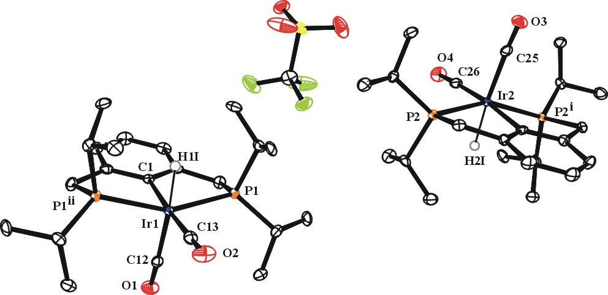

Figure 1. ORTEP of the structure with thermal ellipsoids at the 50% probability level. Hydrogen atoms omitted for clarity except for the hydrides.
Table 1: Crystallographic data for the structures provided.
Empirical formula C23 H36 F3 Ir O5 P2 S
Formula weight 735.72
Temperature 100(2) K
Wavelength 0.71073 Å
Crystal system Orthorhombic
Space group Pmc2₁
Unit cell dimensions a = 8.9556(7) Å α= 90°.
b = 14.9968(11) Å β= 90°.
c = 21.0354(17) Å γ = 90°.
Volume 2825.2(4) Å3
Z 4
Density (calculated) 1.730 Mg/m3
Absorption coefficient 4.963 mm-1
F(000) 1456
Crystal size 0.57 x 0.14 x 0.14 mm3
Theta range for data collection 1.936 to 28.302°.
Index ranges -11<=h<=11, -19<=k<=19, -27<=l<=38
Reflections collected 26729
Independent reflections 7167 [R(int) = 0.0252]
Completeness to theta = 25.00° 99.9 %
Max. and min. transmission 0.5752 and 0.7457
Refinement method Full-matrix least-squares on F2
Data / restraints / parameters 7167/ 1 / 350
Goodness-of-fit on F2 1.035
Final R indices [I>2sigma(I)] R1 = 0.0155, wR2 = 0.0340
R indices (all data) R1 = 0.0164, wR2 = 0.0344
Largest diff. peak and hole 0.440 and -0.370 e.Å-3

Bruker (2007) APEX2 (Version 2.1-4), SAINT (version 7.34A), SADABS (version 2007/4), BrukerAXS Inc, Madison, Wisconsin, USA.
(a) Altomare A, Burla C, Camalli M, Cascarano G L, Giacovazzo C, Guagliardi A, Moliterni AGG, Polidori G, Spagna R. (1999) SIR97: a new tool for crystal structure determination and refinement Journal of Applied Crystallography, 32, 115-119. (b) Altomare A, Cascarano G L, Giacovazzo C, Guagliardi A. (1993) Completion and refinement of crystal structures with SIR 92. Journal of Applied Crystallography, 26, 343-350.
(a) Sheldrick GM. (1997) SHELXL-97, Program for the Refinement of Crystal Structures. University of Göttingen, Germany. (b) Sheldrick GM. (2013) Crystal structure refinement with SHELXL. Acta Cryst. (2015). C71, 3-8.
Mackay, S.; Edwards, C.; Henderson, A.; Gilmore, C.; Stewart, N.; Shankland, K.; Donald, A. (1997) MaXus: a computer program for the solution and refinement of crystal structures from diffraction data. University of Glasgow, Scotland,.
Waasmaier, D.; Kirfel, A. (1995) New Analytical Scattering Factor Functions for Free Atoms and Ions. Acta Crystallographica A., 51, 416-430.
Farrugia LJ. (1997) Ortep-3 for Windows. Journal of Applied Crystallography, 30, 565

