Crystal Structure Report for K Goldberg
by Werner Kaminsky
Sample Submitted by Zuzana Culakova
ID – ZC_II_155
X-ray Crystallography Laboratory
University of Washington
28. July 2026

Data Collection started: 9/5/2017
Documentation finished: 9/12/2017

Data backup accessibly through http:
URL: http://cad4.cpac.washington.edu/structures

W.Kaminsky: tel. (206) 543 7585
(x-ray lab): tel. (206) 543 0210
Email: kaminsky@chem.washington.edu

Understanding crystallographic information is not trivial. If you discuss a structure in a publication, please let the crystallographers proof-read the final draft of that manuscript before you submit it.
For many structures it is true that crystallography is an intellectual performance (like synthesis or elucidation of mechanisms) and not a routine job. In these cases, particularly when the structures contribute significantly to the content of the publication, the crystallographers should be co-authors. Do not think this is not necessary because you pay for structures.
A colorless plate, measuring 0.14 x 0.07 x 0.02 mm³ was mounted on a loop with oil. Data was collected at -173ºC on a Bruker APEX II single crystal X-ray diffractometer, Mo-radiation.

Crystal-to-detector distance was 40 mm and exposure time was 20 seconds per frame for all sets. The scan width was 0.5º. Data collection was 99.2 % complete to 25º in ϑ. A total of 18541 reflections were collected covering the indices, -19<=h<=18, -18<=k<=18, 0<=l<=28. 9613 reflections were symmetry independent and the R_{int} = 0.1744 indicated twinning problems (see below). Indexing and unit cell refinement indicated a primitive monoclinic lattice. The space group was found to be P 2/a (No. 13).

The data appeared twinned (CELL_NOW) and after multi-domain integration (SAINT, SADABS within the APEX2 software package by Bruker) the data was merged utilizing twinabs.

Solution by direct methods (SHELXS, SIR97) produced a complete heavy atom phasing model consistent with the proposed structure. The structure was completed by difference Fourier synthesis with SHELXL97., Scattering factors are from Waasmair and Kirfel. Hydrogen atoms were placed in geometrically idealised positions and constrained to ride on their parent atoms with C---H distances in the range 0.95-1.00 Angstrom. Isotropic thermal parameters U_{eq} were fixed such that they were 1.2U_{eq} of their parent atom Ueq for CH's and 1.5U_{eq} of their parent atom U_{eq} in case of methyl groups. All non-hydrogen atoms were refined anisotropically by full-matrix least-squares.

The crystal plates exhibited striations albeit uniform extinction, which indicates a two-fold twin operation perpendicular to the b-axis, however, despite utilizing one such twin relation during integration of the data, it appeared possible that more twin axes may exist. Thus, the twinning was not completely resolved. In addition, a NTf₂ molecule and DCM appeared heavily disordered. The Ir-complexes are bridged via a chloride and the hydrides are constructed at known average distance

The structure is of mediocre quality and only for study purposes: publication may be difficult due to the unresolved twinning problems. Table 1 summarizes the data collection details. Figure 1 shows an ORTEP of the asymmetric unit.

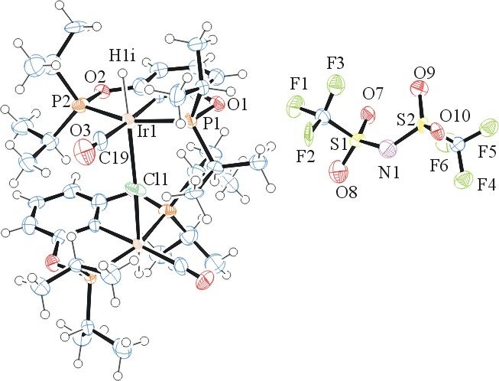
Figure 1. ORTEP of the structure with thermal ellipsoids at the 50% probability level. Disorder and solvent omitted for clarity.

Table 1: Crystallographic data for the structures provided.
Empirical formula C162 H260 Cl8 F24 Ir8 N4 O40 P16 S8
Formula weight 5932.92
Temperature 100(2) K
Wavelength 0.71073 Å
Crystal system Monoclinic
Space group P2/a
Unit cell dimensions a = 15.804(3) Å α= 90°.
b = 14.983(2) Å β= 101.160(4)°.
c = 23.597(3) Å γ = 90°.
Volume 5482.1(14) Å3
Z 1
Density (calculated) 1.797 Mg/m3
Absorption coefficient 5.211 mm-1
F(000) 2916
Crystal size 0.14 x 0.07 x 0.02 mm3
Theta range for data collection 1.359 to 25.350°.
Index ranges -19<=h<=18, -18<=k<=18, 0<=l<=28
Reflections collected 18541
Independent reflections 9613 [R(int) = 0.1714]
Completeness to theta = 25.000° 99.2 %
Refinement method Full-matrix least-squares on F2
Data / restraints / parameters 9613 / 559 / 726
Goodness-of-fit on F2 1.173
Final R indices [I>2sigma(I)] R1 = 0.1511, wR2 = 0.2579
R indices (all data) R1 = 0.1910, wR2 = 0.2817
Largest diff. peak and hole 6.926 and -7.158 e.Å-3

Sheldrick, G. M. (2005). CELL_NOW. University of Goettingen, Germany.
Bruker (2007) APEX2 (Version 2.1-4), SAINT (version 7.34A), SADABS (version 2007/4), BrukerAXS Inc, Madison, Wisconsin, USA.
Sheldrick, G. M. (2007). TWINABS. University of Goettingen, Germany.
(a) Altomare A, Burla C, Camalli M, Cascarano G L, Giacovazzo C, Guagliardi A, Moliterni AGG, Polidori G, Spagna R. (1999) SIR97: a new tool for crystal structure determination and refinement Journal of Applied Crystallography, 32, 115-119. (b) Altomare A, Cascarano G L, Giacovazzo C, Guagliardi A. (1993) Completion and refinement of crystal structures with SIR 92. Journal of Applied Crystallography, 26, 343-350.
(a) Sheldrick GM. (1997) SHELXL-97, Program for the Refinement of Crystal Structures. University of Göttingen, Germany. (b) Sheldrick GM. (2013) Crystal structure refinement with SHELXL. Acta Cryst. (2015). C71, 3-8.
Mackay, S.; Edwards, C.; Henderson, A.; Gilmore, C.; Stewart, N.; Shankland, K.; Donald, A. (1997) MaXus: a computer program for the solution and refinement of crystal structures from diffraction data. University of Glasgow, Scotland,.
Waasmaier, D.; Kirfel, A. (1995) New Analytical Scattering Factor Functions for Free Atoms and Ions. Acta Crystallographica A., 51, 416-430.
Farrugia LJ. (1997) Ortep-3 for Windows. Journal of Applied Crystallography, 30, 565

