Crystal Structure Report for Zhong Lin
by Werner Kaminsky
Sample Submitted by Xiaodong Xu
ID – Zhong_1_original
X-ray Crystallography Laboratory
University of Washington
28. July 2026

Data Collection started: 5/22/2019
Documentation finished: 7/9/2019

Data backup accessibly through http:
URL: http://cad4.cpac.washington.edu/structures

W.Kaminsky: tel. (206) 543 7585
(x-ray lab): tel. (206) 543 0210
Email: kaminsky@chem.washington.edu

Understanding crystallographic information is not trivial. If you discuss a structure in a publication, please let the crystallographers proof-read the final draft of that manuscript before you submit it.
For many structures it is true that crystallography is an intellectual performance (like synthesis or elucidation of mechanisms) and not a routine job. In these cases, particularly when the structures contribute significantly to the content of the publication, the crystallographers should be co-authors. Do not think this is not necessary because you pay for structures.
A metallic black plate, measuring 0.370 x 0.150 x 0.002 mm³ was mounted on a loop with oil. Data was collected at -173ºC on a Bruker APEX II single crystal X-ray diffractometer, Mo-radiation.

Crystal-to-detector distance was 40 mm and exposure time was 3 seconds per frame for all sets. The scan width was 0.5º. Data collection was 97.8% complete to 25º in ϑ. A total of 1713 merged reflections were collected covering the indices, -8<=h<=8, -8<=k<=8, -24<=l<=24. 346 reflections were symmetry independent and the elevated R_{int} = 0.1136 relates to an unfavorable sample shape and possible tiny bend of the crystal plate. Indexing and unit cell refinement indicated a R-centered trigonal lattice in hexagonal setting. The space group was found to be R‾3 (No. 148).

The data was integrated and scaled using SAINT, SADABS within the APEX2 software package by Bruker.

Solution by direct methods (SHELXT or SIR97) produced a complete heavy atom phasing model consistent with the proposed structure. The structure was refined with SHELXL., Scattering factors are from Waasmair and Kirfel. All atoms were treated anisotropically by full-matrix least-squares.

The structure indicates a little disorder or twinning. Because the amount of residual electron density was small, a twin law was not derivable, instead, a second V-I atom pair at 4.5% of the total content was included which overlaps with the main component.

The structure is of high quality and ready for publication. Table 1 summarizes the data collection details. Figure 1 shows an ORTEP of the asymmetric unit.

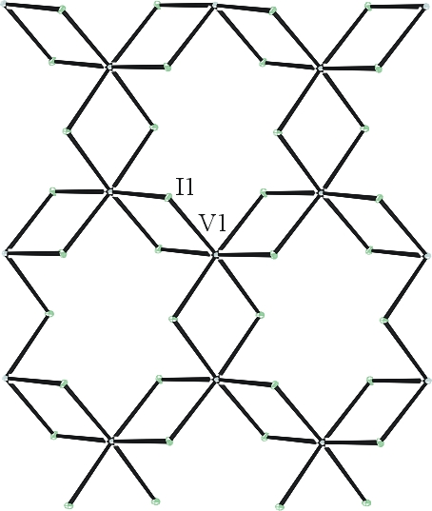

Figure 1. ORTEP of an extended 2-D polimeric structure with thermal ellipsoids at the 50% probability level. Disorder omitted for clarity.

Table 1: Crystallographic data for the structures provided.
Empirical formula I6 V2
Formula weight 863.28
Temperature 100(2) K
Wavelength 0.71073 Å
Crystal system Trigonal
Space group R -3 :H
Unit cell dimensions a = 6.9040(3) Å α= 90°.
b = 6.9040(3) Å β= 90°.
c = 19.8244(18) Å γ = 120°.
Volume 818.34(10) Å3
Z 3
Density (calculated) 5.255 Mg/m3
Absorption coefficient 18.616 mm-1
F(000) 1092
Crystal size 0.370 x 0.150 x 0.010 mm3
Theta range for data collection 3.559 to 25.479°.
Index ranges -8<=h<=8, -8<=k<=8, -24<=l<=24
Reflections collected 1713
Independent reflections 346 [R(int) = 0.1136]
Completeness to theta = 25.000° 97.8 %
Refinement method Full-matrix least-squares on F2
Data / restraints / parameters 346 / 0 / 17
Goodness-of-fit on F2 1.181
Final R indices [I>2sigma(I)] R1 = 0.0292, wR2 = 0.0695
R indices (all data) R1 = 0.0306, wR2 = 0.0709
Largest diff. peak and hole 1.422 and -1.682 e.Å-3

Bruker (2007) APEX2 (Version 2.1-4), SAINT (version 7.34A), SADABS (version 2007/4), BrukerAXS Inc, Madison, Wisconsin, USA.
Sheldrick GM. (2015) SHELXT - Integrated space-group and crystal-structure determination. Acta Cryst. A71, 3-8.
(a) Altomare A, Burla C, Camalli M, Cascarano G L, Giacovazzo C, Guagliardi A, Moliterni AGG, Polidori G, Spagna R. (1999) SIR97: a new tool for crystal structure determination and refinement Journal of Applied Crystallography, 32, 115-119. (b) Altomare A, Cascarano G L, Giacovazzo C, Guagliardi A. (1993) Completion and refinement of crystal structures with SIR 92. Journal of Applied Crystallography, 26, 343-350.
(a) Sheldrick GM. (1997) SHELXL-97, Program for the Refinement of Crystal Structures. University of Göttingen, Germany. (b) Sheldrick GM. (2015) Crystal structure refinement with SHELXL. Acta Cryst. (2015). C71, 3–8
Mackay, S.; Edwards, C.; Henderson, A.; Gilmore, C.; Stewart, N.; Shankland, K.; Donald, A. (1997) MaXus: a computer program for the solution and refinement of crystal structures from diffraction data. University of Glasgow, Scotland,.
Farrugia LJ. (1997) Ortep-3 for Windows. Journal of Applied Crystallography, 30, 565

