Crystal Structure Report for A Jen
by Werner Kaminsky
Sample Submitted by ZongLong Zhu
ID – Zhu_Pb_RT
X-ray Crystallography Laboratory
University of Washington
28. July 2026

Data Collection started: 9/13/2016
Documentation finished: 9/15/2016

Data backup accessibly through http:
URL: http://cad4.cpac.washington.edu/structures

W.Kaminsky: tel. (206) 543 7585
(x-ray lab): tel. (206) 543 0210
Email: kaminsky@chem.washington.edu

Understanding crystallographic information is not trivial. If you discuss a structure in a publication, please let the crystallographers proof-read the final draft of that manuscript before you submit it.
For many structures it is true that crystallography is an intellectual performance (like synthesis or elucidation of mechanisms) and not a routine job. In these cases, particularly when the structures contribute significantly to the content of the publication, the crystallographers should be co-authors. Do not think this is not necessary because you pay for structures.
A black, lustrous piece, measuring 0.09 x 0.03 x 0.02 mm³ was mounted on a loop with oil. Data was collected at 22ºC on a Bruker APEX II single crystal X-ray diffractometer, Mo-radiation.

Crystal-to-detector distance was 40 mm and exposure time was 10 seconds per frame for all sets. The scan width was 0.5º. Data collection was 100% complete to 25º in ϑ. A total of 21139 reflections were collected covering the indices, -11<=h<=11, -11<=k<=11, -16<=l<=16. 703 reflections were symmetry independent and the R_{int} = 0.0570 indicated that the data was of good quality (0.07). Indexing and unit cell refinement indicated a body-centered tetragonal lattice. The space group was found to be I -4 c 2 (No.120).

The data was integrated and scaled using SAINT, SADABS within the APEX2 software package by Bruker.

Solution by direct methods (SHELXS, SIR97) produced a complete heavy atom phasing model consistent with the proposed structure. The structure was completed by difference Fourier synthesis with SHELXL97., Scattering factors are from Waasmair and Kirfel. Hydrogen atoms were placed in geometrically idealised positions and constrained to ride on their parent atoms with C---H distances in the range 0.95-1.00 Angstrom. Isotropic thermal parameters U_{eq} were fixed such that they were 1.2U_{eq} of their parent atom Ueq for CH's and 1.5U_{eq} of their parent atom U_{eq} in case of methyl groups. All non-hydrogen atoms were refined anisotropically by full-matrix least-squares.

The choice to collect data at room temperature (RT) resulted from observing 4-fold split peak intensities when trying to determining the structure at 100K. In fact, the RT data indicated already a 9% amount of merohedral twinning via matrix (-½ -½ -½,-½ -½ ½, -1 1 0) in addition to 90-degree rotation twinning about the c-axis, which mimics a pseudo-cubic symmetry and 4-fold disordered CH3NH3 occupying suitably large voids in the structure. One of the iodines is disordered over two slightly displaced locations. The phase transition thus most likely is of the type disorder (RT) order (low T). Attempts to solve the data at LT and determine the type of transition have failed so far (to complete this task would require extra funding for this time consuming exercise).

The structure is of high quality and ready for publication. Table 1 summarizes the data collection details. Figure 1 shows an ORTEP of the asymmetric unit.

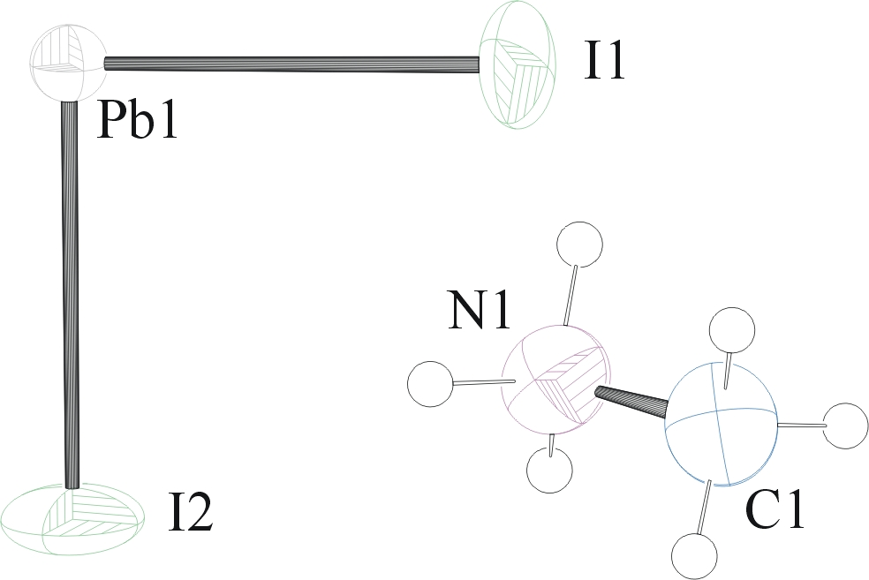
Figure 1. ORTEP of the asymmetric unit with thermal ellipsoids at the 50% probability level. Disorder of I1 and the CH₃NH₃ is introduced by the lattice symmetry.

Table 1: Crystallographic data for the structures provided.
Empirical formula C H6 I3 N Pb
Formula weight 619.96
Temperature 295(2) K
Wavelength 0.71073 Å
Crystal system Tetragonal
Space group I -4 c 2
Unit cell dimensions a = 8.871(5) Å α= 90°.
b = 8.871(5) Å β= 90°.
c = 12.657(7) Å γ = 90°.
Volume 996.0(10) Å3
Z 4
Density (calculated) 4.134 Mg/m3
Absorption coefficient 26.154 mm-1
F(000) 1040
Crystal size 0.09 x 0.03 x 0.02 mm3
Theta range for data collection 2.80 to 28.45°.
Index ranges -11<=h<=11, -11<=k<=11, -16<=l<=16
Reflections collected 21139
Independent reflections 703 [R(int) = 0.0570]
Completeness to theta = 25.00° 100.0 %
Max. and min. transmission 0.6228 and 0.2018
Refinement method Full-matrix least-squares on F2
Data / restraints / parameters 703 / 18 / 36
Goodness-of-fit on F2 1.219
Final R indices [I>2sigma(I)] R1 = 0.0226, wR2 = 0.0517
R indices (all data) R1 = 0.0271, wR2 = 0.0539
Absolute structure parameter 0.3(2)
Extinction coefficient 0.00099(6)
Largest diff. peak and hole 0.899 and -0.868 e.Å-3

Bruker (2007) APEX2 (Version 2.1-4), SAINT (version 7.34A), SADABS (version 2007/4), BrukerAXS Inc, Madison, Wisconsin, USA.
(a) Altomare A, Burla C, Camalli M, Cascarano G L, Giacovazzo C, Guagliardi A, Moliterni AGG, Polidori G, Spagna R. (1999) SIR97: a new tool for crystal structure determination and refinement Journal of Applied Crystallography, 32, 115-119. (b) Altomare A, Cascarano G L, Giacovazzo C, Guagliardi A. (1993) Completion and refinement of crystal structures with SIR 92. Journal of Applied Crystallography, 26, 343-350.
(a) Sheldrick GM. (1997) SHELXL-97, Program for the Refinement of Crystal Structures. University of Göttingen, Germany. (b) Sheldrick GM. (2013) Crystal structure refinement with SHELXL. Acta Cryst. (2015). C71, 3-8.
Mackay, S.; Edwards, C.; Henderson, A.; Gilmore, C.; Stewart, N.; Shankland, K.; Donald, A. (1997) MaXus: a computer program for the solution and refinement of crystal structures from diffraction data. University of Glasgow, Scotland,.
Waasmaier, D.; Kirfel, A. (1995) New Analytical Scattering Factor Functions for Free Atoms and Ions. Acta Crystallographica A., 51, 416-430.
Farrugia LJ. (1997) Ortep-3 for Windows. Journal of Applied Crystallography, 30, 565

