Crystal Structure Report for M. Larsen
by Werner Kaminsky
Sample ID – CCB1_91
X-ray Crystallography Laboratory
University of Washington
31. July 2026

Data Collection started: 7/24/2024
Documentation finished: 7/29/2024

Data backup accessibly through http:
URL: http://cad4.cpac.washington.edu/structures

W.Kaminsky: tel. (206) 543 7585
(x-ray lab): tel. (206) 543 0210
Email: kaminsky@chem.washington.edu

Understanding crystallographic information is not trivial. If you discuss a structure in a publication, please let the crystallographers proof-read the final draft of that manuscript before you submit it.
For many structures it is true that crystallography is an intellectual performance (like synthesis or elucidation of mechanisms) and not a routine job. In these cases, particularly when the structures contribute significantly to the content of the publication, the crystallographers should be co-authors. Do not think this is not necessary because you pay for structures.
A colorless shard, measuring 0.10 x 0.07 x 0.01 mm³ was mounted on a loop with oil. Data was collected at -173ºC on a Bruker APEX II single crystal X-ray diffractometer, Mo-radiation, equipped with a Miracol X-ray optical collimator.

Crystal-to-detector distance was 40 mm and exposure time was 120 seconds per frame for all sets. The scan width was 1º. Data collection was 96.0% complete to 24.404º in ϑ. A total of 3099 merged reflections were collected covering the indices, -13<=h<=13, -8<=k<=8, -13<=l<=14. 1537 reflections were symmetry independent and the R_{int} = 0.1725 indicated that the data was of lower than average quality (0.07) due to twinning. Indexing and unit cell refinement indicated a primitive monoclinic lattice. The space group was found to be x xx (No.xx).

The data appeared multiply twinned 1) via 180 degrees approximately about (1 0 0), 2) 7 degrees rotation about [-0.37 -0.47 1] (CELL_NOW) and after multi-domain integration (SAINT, SADABS within the APEX2 software package by Bruker) the data was merged utilizing twinabs.

Solution by direct methods (SHELXT or SIR97) produced a complete heavy atom phasing model consistent with the proposed structure. The structure was completed by difference Fourier synthesis with SHELXL. Scattering factors are from Waasmair and Kirfel. Hydrogen atoms were placed in geometrically idealised positions and constrained to ride on their parent atoms with C---H distances in the range 0.95-1.00 Angstrom. Isotropic thermal parameters U_{eq} were fixed such that they were 1.2U_{eq} of their parent atom Ueq for CH's and 1.5U_{eq} of their parent atom U_{eq} in case of methyl groups. All non-hydrogen atoms were refined anisotropically by full-matrix least-squares.

In addition to the above twiinin and due to the similarity in length of the a and b axis, a pseudo merohedral twin was applied to the refinement with twin matrix (0 0 1, 0 -1 0, 1 0 0). With so many twin components, the data could only be of limited quality.

The structure is of high quality and ready for publication. Table 1 summarizes the data collection details. Figure 1 shows an ORTEP of the asymmetric unit.

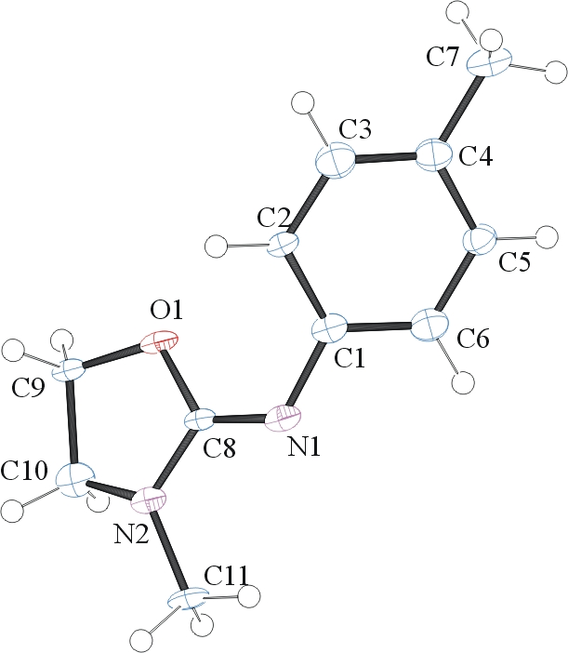
Figure 1. ORTEP of the structure with thermal ellipsoids at the 50% probability level.

Table 1: Crystallographic data for the structures provided.
Empirical formula C11 H14 N2 O
Formula weight 190.24
Temperature 100(2) K
Wavelength 0.71073 Å
Crystal system Monoclinic
Space group P 2₁/n
Unit cell dimensions a = 12.008(5) Å α= 90°.
b = 7.222(3) Å β= 111.702(17)°.
c = 12.070(5) Å γ = 90°.
Volume 972.6(7) Å3
Z 4
Density (calculated) 1.299 Mg/m3
Absorption coefficient 0.085 mm-1
F(000) 408
Crystal size 0.100 x 0.070 x 0.010 mm3
Theta range for data collection 1.816 to 24.404°.
Index ranges -13<=h<=13, -8<=k<=8, -13<=l<=14
Reflections collected 3099
Independent reflections 1537 [R(int) = 0.1725]
Completeness to theta = 24.404° 96.0 %
Refinement method Full-matrix least-squares on F2
Data / restraints / parameters 1537 / 84 / 130
Goodness-of-fit on F2 1.050
Final R indices [I>2sigma(I)] R1 = 0.1705, wR2 = 0.3474
R indices (all data) R1 = 0.2323, wR2 = 0.3796
Largest diff. peak and hole 0.771 and -0.591 e.Å-3

Sheldrick, G. M. (2005). CELL_NOW. University of Goettingen, Germany.
Bruker (2007) APEX2 (Version 2.1-4), SAINT (version 7.34A), SADABS (version 2007/4), BrukerAXS Inc, Madison, Wisconsin, USA.
Sheldrick, G. M. (2007). TWINABS. University of Goettingen, Germany.
(a) Sheldrick GM. (2008) A short history of SHELX. Acta Cryst. A64, 112-122. (b) Sheldrick GM. (2015) SHELXT - Integrated space-group and crystal-structure determination. Acta Cryst. A71, 3-8.
(a) Altomare A, Burla C, Camalli M, Cascarano G L, Giacovazzo C, Guagliardi A, Moliterni AGG, Polidori G, Spagna R. (1999) SIR97: a new tool for crystal structure determination and refinement Journal of Applied Crystallography, 32, 115-119. (b) Altomare A, Cascarano G L, Giacovazzo C, Guagliardi A. (1993) Completion and refinement of crystal structures with SIR 92. Journal of Applied Crystallography, 26, 343-350.
(a) Sheldrick GM. (1997) SHELXL-97, Program for the Refinement of Crystal Structures. University of Göttingen, Germany. (b) Sheldrick GM. (2015) Crystal structure refinement with SHELXL. Acta Cryst. C71, 3–8
Waasmaier, D.; Kirfel, A. (1995) New Analytical Scattering Factor Functions for Free Atoms and Ions. Acta Crystallographica A., 51, 416-430.
Farrugia LJ. (1997) Ortep-3 for Windows. Journal of Applied Crystallography, 30, 565

