Crystal Structure Report for D. Reed
by Werner Kaminsky
Sample Submitted by Caroline Christ
ID – CGC_I_17_CG
X-ray Crystallography Laboratory
University of Washington
29. July 2026

Data Collection started: 6/25/2025
Documentation finished: 7/04/2025

Data backup accessibly through http:
URL: http://cad4.cpac.washington.edu/structures

W.Kaminsky: tel. (206) 543 7585
(x-ray lab): tel. (206) 543 0210
Email: kaminsky@chem.washington.edu

Understanding crystallographic information is not trivial. If you discuss a structure in a publication, please let the crystallographers proof-read the final draft of that manuscript before you submit it.
For many structures it is true that crystallography is an intellectual performance (like synthesis or elucidation of mechanisms) and not a routine job. In these cases, particularly when the structures contribute significantly to the content of the publication, the crystallographers should be co-authors. Do not think this is not necessary because you pay for structures.
A green needle, measuring 0.22 x 0.05 x 0.04 mm³ was mounted on a loop with oil. Data was collected at -173ºC on a Bruker APEX II single crystal X-ray diffractometer, Mo-radiation, equipped with a Miracol X-ray optical collimator.

Crystal-to-detector distance was 40 mm and exposure time was 60 seconds per frame for all sets. The scan width was 0.75º. Data collection was xx.x% complete to 25º in ϑ. A total of 52766 merged reflections were collected covering the indices, -46<=h<=38, -42<=k<=42, -30<=l<=30. 26849 reflections were symmetry independent and the R_{int} = 0.0.1538 indicated that the data was week (see below). Indexing and unit cell refinement indicated a C-centered monoclinic lattice. The space group was found to be C 2/m (No.12).

The data was integrated and scaled using SAINT, SADABS within the APEX2 software package by Bruker.

Solution by direct methods (SHELXT or SIR97) produced a complete heavy atom phasing model consistent with the proposed structure. The structure was completed by difference Fourier synthesis with SHELXL. Scattering factors are from Waasmair and Kirfel. Hydrogen atoms were placed in geometrically idealised positions and constrained to ride on their parent atoms with C---H distances in the range 0.95-1.00 Angstrom. Isotropic thermal parameters U_{eq} were fixed such that they were 1.2U_{eq} of their parent atom Ueq for CH's and 1.5U_{eq} of their parent atom U_{eq} in case of methyl groups. All non-hydrogen atoms were refined anisotropically by full-matrix least-squares.

Large amount of ligand disorder as well as solvent disorder caused diffraction intensiteas at larger bragg angles to intrinsically fall below diffuse background scattering, similar to the diffraction pattern of a hot crystal even though the collection temperature was 110K.

The big molecule contains mirror symmetry. The with some of the copper atoms of the complex coordinated two waters, two DMA, and 20 ethyl alcohols, some of which disordered. In addition, voids are solvent filled, the contribution of which to the diffraction pattern was removed with SQUEEZE.

The structure is may be published with the explanation given above. Table 1 summarizes the data collection details. Figure 1 shows an ORTEP of the asymmetric unit.

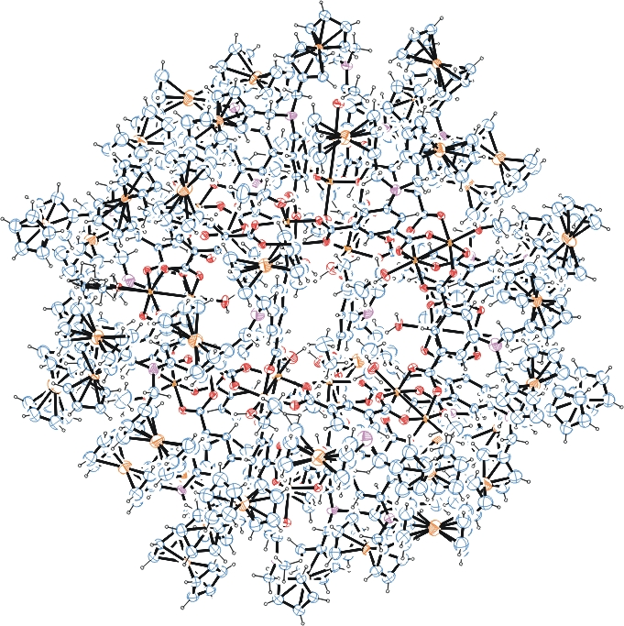
Figure 1. ORTEP of the structure with thermal ellipsoids at the 15% probability level

Table 1: Crystallographic data for the structures provided.
Empirical formula C768 H742 Cu24 Fe48 N26 O120
Formula weight 16461.59
Temperature 110(2) K
Wavelength 0.71073 Å
Crystal system Monoclinic
Space group C 2/m
Unit cell dimensions a = 46.684(2) Å α= 90°.
b = 42.584(2) Å β= 123.346(3)°.
c = 30.3769(14) Å γ = 90°.
Volume 50447(4) Å3
Z 2
Density (calculated) 1.084 Mg/m3
Absorption coefficient 1.211 mm-1
F(000) 16872
Crystal size 0.220 x 0.050 x 0.040 mm3
Theta range for data collection 0.708 to 20.816°.
Index ranges -46<=h<=38, -42<=k<=42, 0<=l<=30
Reflections collected 52766
Independent reflections 26849 [R(int) = 0.1538]
Completeness to theta = 20.816° 99.8 %
Refinement method Full-matrix least-squares on F2
Data / restraints / parameters 26849 / 11562 / 2342
Goodness-of-fit on F2 1.135
Final R indices [I>2sigma(I)] R1 = 0.1475, wR2 = 0.3861
R indices (all data) R1 = 0.2806, wR2 = 0.4337
Largest diff. peak and hole 1.829 and -1.199 e.Å-3

Bruker (2007) APEX2 (Version 2.1-4), SAINT (version 7.34A), SADABS (version 2007/4), BrukerAXS Inc, Madison, Wisconsin, USA.
(a) Sheldrick GM. (2008) A short history of SHELX. Acta Cryst. A64, 112-122. (b) Sheldrick GM. (2015) SHELXT - Integrated space-group and crystal-structure determination. Acta Cryst. A71, 3-8.
(a) Altomare A, Burla C, Camalli M, Cascarano G L, Giacovazzo C, Guagliardi A, Moliterni AGG, Polidori G, Spagna R. (1999) SIR97: a new tool for crystal structure determination and refinement Journal of Applied Crystallography, 32, 115-119. (b) Altomare A, Cascarano G L, Giacovazzo C, Guagliardi A. (1993) Completion and refinement of crystal structures with SIR 92. Journal of Applied Crystallography, 26, 343-350.
(a) Sheldrick GM. (1997) SHELXL-97, Program for the Refinement of Crystal Structures. University of Göttingen, Germany. (b) Sheldrick GM. (2015) Crystal structure refinement with SHELXL. Acta Cryst. C71, 3–8
Waasmaier, D.; Kirfel, A. (1995) New Analytical Scattering Factor Functions for Free Atoms and Ions. Acta Crystallographica A., 51, 416-430.
(a) A. Spek, J. Appl. Cryst. (2003), 36, 7-13; (b) P. van der Sluis & A. L. Spek, Acta Cryst. (1990). A46, 194-201. (c) Spek, A. L. (2009). Acta. Cryst. D65, 148-155.
Farrugia LJ. (1997) Ortep-3 for Windows. Journal of Applied Crystallography, 30, 565

