Crystal Structure Report for B. Carlson by Werner Kaminsky
Sample Submitted by Brenden Carlson
ID – cnbiphphen_b
X-ray Crystallography Laboratory
University of Washington
31. July 2026

Data Collection started: 2/3/2015
Documentation finished: 2/6/2015

Data backup accessibly through http:
URL: http://cad4.cpac.washington.edu/structures

W.Kaminsky: tel. (206) 543 7585
(x-ray lab): tel. (206) 543 0210
Email: kaminsky@chem.washington.edu

Understanding crystallographic information is not trivial. If you discuss a structure in a publication, please let the crystallographers proof-read the final draft of that manuscript before you submit it.
For many structures it is true that crystallography is an intellectual performance (like synthesis or elucidation of mechanisms) and not a routine job. In these cases, particularly when the structures contribute significantly to the content of the publication, the crystallographers should be co-authors. Do not think this is not necessary because you pay for structures. Even I have to pay for my own structures for my research.
A colorless plate, measuring 0.50 x 0.24 x 0.10 mm³ was mounted on a loop with oil. Data was collected at 25ºC on a Nonius Kappa CCD FR590 single crystal X-ray diffractometer, Mo-radiation.

Crystal-to-detector distance was 30 mm and exposure time was 60 seconds per degree for all sets. The scan width was 2º. Data collection was 96.9% complete to 25º in ϑ. A total of 5359 merged reflections were collected covering the indices, h = -27 to 28, k = -12 to 13, l = -15 to 15. 2949 reflections were symmetry independent and the R_{int} = 0.0543 indicated that the data was better than average quality (0.07). Indexing and unit cell refinement indicated a C-centered monoclinic lattice. The space group was found to be C 2/c (No. 15).

The data was integrated and scaled using hkl-SCALEPACK. This program applies a multiplicative correction factor (S) to the observed intensities (I) and has the following form:

S is calculated from the scale and the B factor determined for each frame and is then applied to I to give the corrected intensity (I_{corr}).

Solution by direct methods (SHELXS, SIR97) produced a complete heavy atom phasing model consistent with the proposed structure. The structure was completed by difference Fourier synthesis with SHELXL97., Scattering factors are from Waasmair and Kirfel. Hydrogen atoms were placed in geometrically idealised positions and constrained to ride on their parent atoms with C---H distances in the range 0.95-1.00 Angstrom. Isotropic thermal parameters U_{eq} were fixed such that they were 1.2U_{eq} of their parent atom Ueq for CH's and 1.5U_{eq} of their parent atom U_{eq} in case of methyl groups. All non-hydrogen atoms were refined anisotropically by full-matrix least-squares.

Phenyl C13 – C18 is disordered via a rotation about C13-C16, C19 N2. The chloroform is disordered with the two orientations about the C-H group produced via the two-fold rotation of the space group which reproduces one molecular ‘arm’ out of the other as indicated in Fig. 1.

The material undergoes a structural order-disorder phase transition upon cooling which resolves the disorder, but causes two twin domains to appear, related by a 4.9 degree rotation about ca. (0.25 1 0). The low-temperature symmetry is P2₁/n, where a and c are exchanged, thus the high phase space group in the same orientation is A 2/a, with similar lattice parameters. Chloroform solvent stays disordered.
The structure is of high quality and ready for publication. Table 1 summarizes the data collection details. Figure 1 shows an ORTEP of the asymmetric unit.

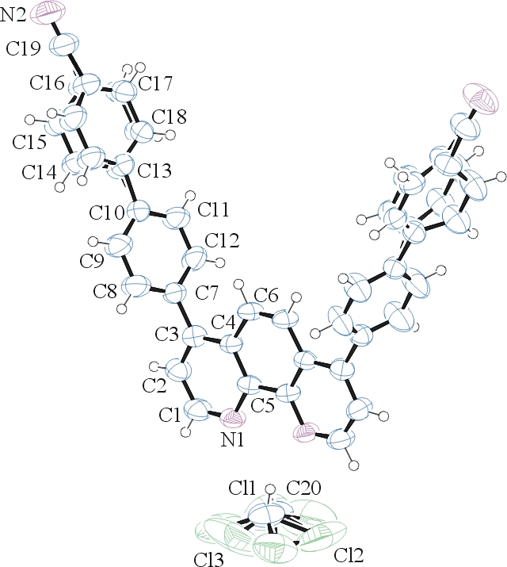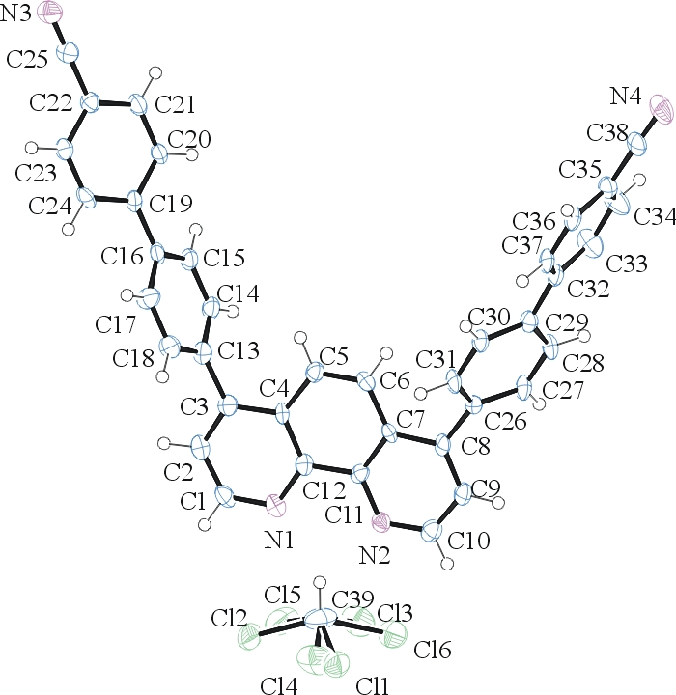
Figure 1. ORTEP of the structure with thermal ellipsoids at the 50% probability level. Left: structure in C 2/c at 295K, on the right, structure at 90K in P2₁/c.

Table 1: Crystallographic data for the structures provided.
Empirical formula C39 H23 Cl3 N4
Formula weight 653.96
Temperature 298(2) K
Wavelength 0.71073 Å
Crystal system Monoclinic
Space group C 2/c
Unit cell dimensions a = 23.486(3) Å α= 90°.
b = 10.9899(11) Å β= 97.508(7)°.
c = 12.9603(9) Å γ = 90°.
Volume 3316.4(6) Å3
Z 4
Density (calculated) 1.310 Mg/m3
Absorption coefficient 0.311 mm-1
F(000) 1344
Crystal size 0.50 x 0.24 x 0.10 mm3
Theta range for data collection 3.42 to 25.35°.
Index ranges -27<=h<=28, -12<=k<=13, -15<=l<=15
Reflections collected 5359
Independent reflections 2949 [R(int) = 0.0543]
Completeness to theta = 25.00° 96.9 %
Max. and min. transmission 0.9696 and 0.8602
Refinement method Full-matrix least-squares on F2
Data / restraints / parameters 2949 / 6 / 222
Goodness-of-fit on F2 1.023
Final R indices [I>2sigma(I)] R1 = 0.0640, wR2 = 0.1541
R indices (all data) R1 = 0.1348, wR2 = 0.1877
Extinction coefficient 0.0051(11)
Largest diff. peak and hole 0.192 and -0.225 e.Å-3

Otwinowsky, Z.; Minor, W. In: Methods in Enzymology; Carter, C. W., Jr., Sweet, R. M., Eds.; Academic Press: New York, 1997, 276, 307-326.
(a) Altomare, A.; Burla, C.; Camalli M.; Cascarano L.; Giacovazzo C.; Guagliardi A.; Moliterni A.G.G.; Polidori G.; Spagna R. J. Appl. Cryst. 1999, 32, 115-119; (b) Altomare, A., Cascarano, G., Giacovazzo, C., Guagliardi, A., J. Appl. Cryst. 1993, 26, 343.
Sheldrick, G. M. SHELXL-97: Program for the Refinement of Crystal Structures 1997 University of Gottingen, Germany.
Mackay, S.; Edwards, C.; Henderson, A.; Gilmore, C.; Stewart, N.; Shankland, K.; Donald, A.; MaXus: a computer program for the solution and refinement of crystal structures from diffraction data. University of Glasgow, Scotland, 1997.
Waasmaier, D.; Kirfel, A. Acta Crystallogr. A. 1995, 51, 416.
Farrugia, L. J. Appl. Cryst. 1997, 30, 565

