Crystal Structure Report for Alex Jen
And Sei-Hum Jang
by Werner Kaminsky
Sample Submitted by Francis Lin
ID – francis_31B
X-ray Crystallography Laboratory
University of Washington
31. July 2026

Data Collection started: 1/8/2021
Documentation finished: 1/16/2021

Data backup accessibly through http:
URL: http://cad4.cpac.washington.edu/structures

W.Kaminsky: tel. (206) 543 7585
(x-ray lab): tel. (206) 543 0210
Email: kaminsky@chem.washington.edu

Understanding crystallographic information is not trivial. If you discuss a structure in a publication, please let the crystallographers proof-read the final draft of that manuscript before you submit it.
For many structures it is true that crystallography is an intellectual performance (like synthesis or elucidation of mechanisms) and not a routine job. In these cases, particularly when the structures contribute significantly to the content of the publication, the crystallographers should be co-authors. Do not think this is not necessary because you pay for structures.
A black prism, measuring 0.30 x 0.20 x 0.05 mm³ was mounted on a loop with oil. Data was collected at -173ºC on a Bruker APEX II single crystal X-ray diffractometer, Mo-radiation.

Crystal-to-detector distance was 40 mm and exposure time was 120 seconds per frame for all sets. The scan width was 0.5º. Data collection was 99.1% complete to 25º in ϑ. A total of 63167 merged reflections were collected covering the indices, -16<=h<=16, -27<=k<=27, -37<=l<=37. 32596 reflections were symmetry independent and the R_{int} = 0.1749 indicated that the data was of sufficient quality. Indexing and unit cell refinement indicated a triclinic lattice. Transformation to a pseudo C-centered monoclinic did not solove. The space group was found to be P‾1 (No. 2).

The data was integrated and scaled using SAINT, SADABS within the APEX2 software package by Bruker.

Solution by direct methods (SHELXS, SIR97) produced a complete heavy atom phasing model consistent with the proposed structure. The structure was completed by difference Fourier synthesis with SHELXL97., Scattering factors are from Waasmair and Kirfel. Hydrogen atoms were placed in geometrically idealised positions and constrained to ride on their parent atoms with C---H distances in the range 0.95-1.00 Angstrom. Isotropic thermal parameters U_{eq} were fixed such that they were 1.2U_{eq} of their parent atom Ueq for CH's and 1.5U_{eq} of their parent atom U_{eq} in case of methyl groups. All non-hydrogen atoms were refined anisotropically by full-matrix least-squares.

The contribution of some disordered solvent to the diffraction pattern was removed with SQUEEZE. Almost all sidechains showed disorder requiring extensive application of restraints.

The structure is of sufficient quality for publication. Table 1 summarizes the data collection details. Figure 1 shows an ORTEP of the asymmetric unit.

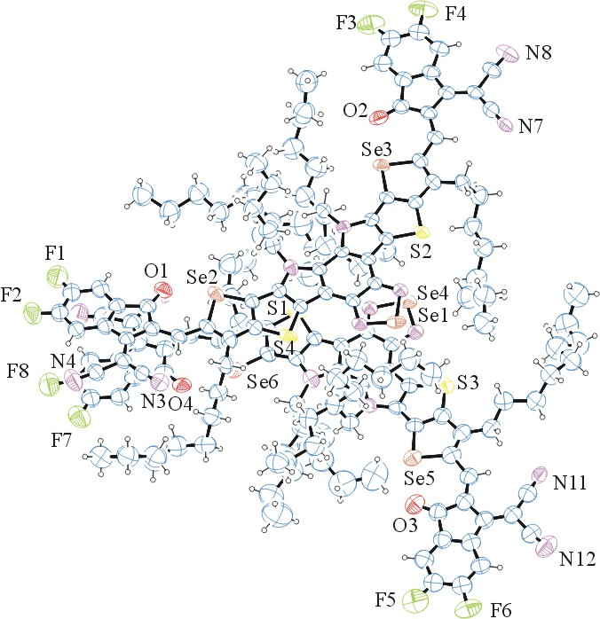
Figure 1. ORTEP of the structure with thermal ellipsoids at the 30% probability level. Disorder and SQUEEZED solvent omitted for clarity.

Table 1: Crystallographic data for the structures provided.
Empirical formula C172 H188 F8 N16 O4 S4 Se6
Formula weight 3297.37
Temperature 100(2) K
Wavelength 0.71073 Å
Crystal system Triclinic
Space group P -1
Unit cell dimensions a = 13.6210(11) Å α= 69.978(5)°.
b = 23.393(2) Å β= 85.612(5)°.
c = 31.325(3) Å γ = 83.465(5)°.
Volume 9309.6(15) Å3
Z 2
Density (calculated) 1.176 Mg/m3
Absorption coefficient 1.283 mm-1
F(000) 3408
Crystal size 0.300 x 0.200 x 0.050 mm3
Theta range for data collection 1.385 to 25.027°.
Index ranges -16<=h<=16, -27<=k<=27, -37<=l<=37
Reflections collected 63167
Independent reflections 32596 [R(int) = 0.1749]
Completeness to theta = 25.000° 99.1 %
Refinement method Full-matrix least-squares on F2
Data / restraints / parameters 32596 / 3758 / 2071
Goodness-of-fit on F2 1.063
Final R indices [I>2sigma(I)] R1 = 0.1760, wR2 = 0.3593
R indices (all data) R1 = 0.3624, wR2 = 0.4536
Largest diff. peak and hole 1.317 and -0.690 e.Å-3

Bruker (2007) APEX2 (Version 2.1-4), SAINT (version 7.34A), SADABS (version 2007/4), BrukerAXS Inc, Madison, Wisconsin, USA.
(a) Altomare A, Burla C, Camalli M, Cascarano G L, Giacovazzo C, Guagliardi A, Moliterni AGG, Polidori G, Spagna R. (1999) SIR97: a new tool for crystal structure determination and refinement Journal of Applied Crystallography, 32, 115-119. (b) Altomare A, Cascarano G L, Giacovazzo C, Guagliardi A. (1993) Completion and refinement of crystal structures with SIR 92. Journal of Applied Crystallography, 26, 343-350.
(a) Sheldrick GM. (1997) SHELXL-97, Program for the Refinement of Crystal Structures. University of Göttingen, Germany. (b) Sheldrick GM. (2013) Crystal structure refinement with SHELXL. Acta Cryst. (2015). C71, 3-8.
Mackay, S.; Edwards, C.; Henderson, A.; Gilmore, C.; Stewart, N.; Shankland, K.; Donald, A. (1997) MaXus: a computer program for the solution and refinement of crystal structures from diffraction data. University of Glasgow, Scotland,.
Waasmaier, D.; Kirfel, A. (1995) New Analytical Scattering Factor Functions for Free Atoms and Ions. Acta Crystallographica A., 51, 416-430.
(a) A. Spek, J. Appl. Cryst. (2003), 36, 7-13; (b) P. van der Sluis & A. L. Spek, Acta Cryst. (1990). A46, 194-201. (c) Spek, A. L. (2009). Acta. Cryst. D65, 148-155.
Farrugia LJ. (1997) Ortep-3 for Windows. Journal of Applied Crystallography, 30, 565

