Crystal Structure Report for B. Cossairt
by Sarah Flowers & Werner Kaminsky
Sample Submitted by Dylan Gary
ID – dg_052615
X-ray Crystallography Laboratory
University of Washington
31. July 2026

Data backup accessibly through http:
URL: http://cad4.cpac.washington.edu/structures

Data Collection started: 5/26/2015
Documentation finished: 7/24/2015

W.Kaminsky: tel. (206) 543 7585
(x-ray lab): tel. (206) 543 0210
Email: kaminsky@chem.washington.edu

Understanding crystallographic information is not trivial. If you discuss a structure in a publication, please let the crystallographers proof-read the final draft of that manuscript before you submit it.
For many structures it is true that crystallography is an intellectual performance (like synthesis or elucidation of mechanisms) and not a routine job. In these cases, particularly when the structures contribute significantly to the content of the publication, the crystallographers should be co-authors. Do not think this is not necessary because you pay for structures. Even I have to pay for my own structures for my research.
A yellow piece, measuring 0.19 x 0.15 x 0.15 mm³ was mounted on a loop with oil. Data was collected at -173ºC on a Bruker APEX II single crystal X-ray diffractometer, Mo-radiation.

Crystal-to-detector distance was 60 mm and exposure time was 60 seconds per frame for all sets. The scan width was 0.5º. Data collection was 99.7 % complete to 25º in ϑ. A total of 254930 reflections were collected covering the indices, h = -28 to 28, k = -29 to 29, l = -51 to 51. 80008 reflections were symmetry independent and the R_{int} = 0.0708 indicated that the data was of average quality. Indexing and unit cell refinement indicated a triclinic lattice. The space group was found to be P‾1 (No. 2).

The data was integrated and scaled using SAINT, SADABS within the APEX2 software package by Bruker.

Solution by direct methods (SHELXS, SIR97) produced a complete heavy atom phasing model consistent with the proposed structure. The structure was completed by difference Fourier synthesis with SHELXL97., Scattering factors are from Waasmair and Kirfel. Hydrogen atoms were placed in geometrically idealised positions and constrained to ride on their parent atoms with C---H distances in the range 0.95-1.00 Angstrom. Isotropic thermal parameters U_{eq} were fixed such that they were 1.2U_{eq} of their parent atom Ueq for CH's and 1.5U_{eq} of their parent atom U_{eq} in case of methyl groups. All non-hydrogen atoms were refined anisotropically by full-matrix least-squares.

Solvent analysis discovered two two distinct voids filled with diethylether and related contribution to the diffraction pattern was removed with SQEEZE

With the size of the molecule comes implicitely the possibility of disorder, which may have contributed to larger than expected positive as well as negative rest electron densities around the indium atoms, estimated to about 2% which also leeds to an increased R1 value. Possible is also some chemical inhomogeneity due to the inclusion of water by exposure to ambient humidity, the process of which was difficult to monitor for completion. Some disorder of the phenyls was treated explicitly as some inter molecular ‘squeezing’ occurs. As a result of the large molecular size (11.7 kD) and strong scattering of the In-P-cluster, carbon atoms were weekly represented in the data, requiring DELU (In-O-C) and ISOR (O, C) restraints. In addition, the general geometry of the organic molecules was linked via SAME commands. The structure is of high quality and ready for publication. Table 1 summarizes the data collection details.

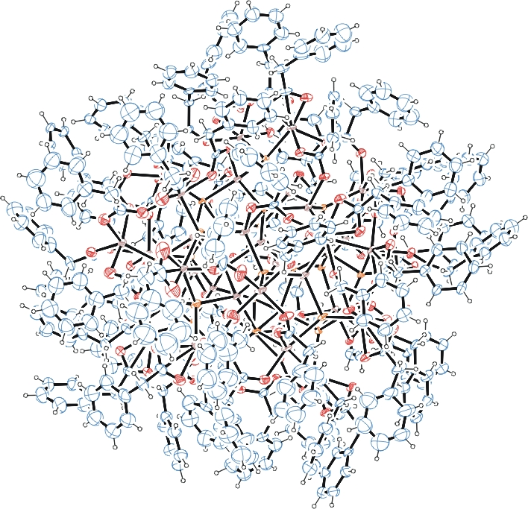

Figure 1. ORTEP of the structure with thermal ellipsoids at the 25% probability level. Disorder omitted for clarity.

Table 1: Crystallographic data for the structures provided.
Empirical formula C408 H359 In37 O103 P20
Formula weight 11777.67
Temperature 100(2) K
Wavelength 0.71073 Å
Crystal system Triclinic
Space group P -1
Unit cell dimensions a = 23.5228(11) Å α= 84.905(3)°.
b = 24.1862(12) Å β= 88.006(3)°.
c = 43.0370(19) Å γ = 63.079(3)°.
Volume 21744.9(18) Å3
Z 2
Density (calculated) 1.799 Mg/m3
Absorption coefficient 2.067 mm-1
F(000) 11488
Crystal size 0.190 x 0.150 x 0.150 mm3
Theta range for data collection 1.634 to 25.472°.
Index ranges -28<=h<=28, -29<=k<=29, -51<=l<=51
Reflections collected 254930
Independent reflections 80008 [R(int) = 0.0708]
Completeness to theta = 25.000° 99.7 %
Absorption correction Semi-empirical from equivalents
Max. and min. transmission 0.7468 and 0.6948
Refinement method Full-matrix least-squares on F2
Data / restraints / parameters 80008 / 34585 / 4771
Goodness-of-fit on F2 1.205
Final R indices [I>2sigma(I)] R1 = 0.1283, wR2 = 0.3359
R indices (all data) R1 = 0.1935, wR2 = 0.3771
Largest diff. peak and hole 7.109 and -1.973 e.Å-3

Bruker (2007) APEX2 (Version 2.1-4), SAINT (version 7.34A), SADABS (version 2007/4), BrukerAXS Inc, Madison, Wisconsin, USA.
(a) Altomare A, Burla C, Camalli M, Cascarano G L, Giacovazzo C, Guagliardi A, Moliterni AGG, Polidori G, Spagna R. (1999) SIR97: a new tool for crystal structure determination and refinement Journal of Applied Crystallography, 32, 115-119. (b) Altomare A, Cascarano G L, Giacovazzo C, Guagliardi A. (1993) Completion and refinement of crystal structures with SIR 92. Journal of Applied Crystallography, 26, 343-350.
Sheldrick GM. (1997) SHELXL-97, Program for the Refinement of Crystal Structures. University of Göttingen, Germany.
Mackay, S.; Edwards, C.; Henderson, A.; Gilmore, C.; Stewart, N.; Shankland, K.; Donald, A. (1997) MaXus: a computer program for the solution and refinement of crystal structures from diffraction data. University of Glasgow, Scotland,.
Waasmaier, D.; Kirfel, A. (1995) New Analytical Scattering Factor Functions for Free Atoms and Ions. Acta Crystallographica A., 51, 416-430.
A. Spek, J. Appl. Cryst. (2003), 36, 7-13; P. van der Sluis & A. L. Spek, Acta Cryst. (1990). A46, 194-201.
Farrugia LJ. (1997) Ortep-3 for Windows. Journal of Applied Crystallography, 30, 565

