Crystal Structure Report for B Cossairt
by Sarah Flowers and Werner Kaminsky
Sample Submitted by David Ung
ID – du1_12
X-ray Crystallography Laboratory
University of Washington
30. July 2026

Data Collection started: 3/18/2015
Documentation finished: 3/20/2015

Data backup accessibly through http:
URL: http://cad4.cpac.washington.edu/structures

W.Kaminsky: tel. (206) 543 7585
(x-ray lab): tel. (206) 543 0210
Email: kaminsky@chem.washington.edu

Understanding crystallographic information is not trivial. If you discuss a structure in a publication, please let the crystallographers proof-read the final draft of that manuscript before you submit it.
For many structures it is true that crystallography is an intellectual performance (like synthesis or elucidation of mechanisms) and not a routine job. In these cases, particularly when the structures contribute significantly to the content of the publication, the crystallographers should be co-authors. Do not think this is not necessary because you pay for structures. Even I have to pay for my own structures for my research.
A yellow piece, measuring 0.15 x 0.13 x 0.08 mm³ was mounted on a loop with oil. Data was collected at -183ºC on a Bruker APEX II single crystal X-ray diffractometer, Mo-radiation.

Crystal-to-detector distance was 40 mm and exposure time was 30 seconds per frame for all sets. The scan width was 0.5º. Data collection was 99.2% complete to 25º in ϑ. A total of 21623 reflections were collected covering the indices, h = -16 to 16, k = -10 to 11, l = -19 to 19. 3598 reflections were symmetry independent and the R_{int} = 0.1143 indicated that the data was of modest quality. Indexing and unit cell refinement indicated a primitive orthorhombic lattice. The space group was found to be P c a 2₁ (No.29).

The data was integrated and scaled using SAINT, SADABS within the APEX2 software package by Bruker.

Solution by direct methods (SHELXS, SIR97) produced a complete heavy atom phasing model consistent with the proposed structure. The structure was completed by difference Fourier synthesis with SHELXL97., Scattering factors are from Waasmair and Kirfel. Hydrogen atoms were placed in geometrically idealised positions and constrained to ride on their parent atoms with C---H distances in the range 0.95-1.00 Angstrom. Isotropic thermal parameters U_{eq} were fixed such that they were 1.2U_{eq} of their parent atom Ueq for CH's and 1.5U_{eq} of their parent atom U_{eq} in case of methyl groups. All non-hydrogen atoms were refined anisotropically by full-matrix least-squares.

This structure is non-chiral – non-centrosymmetric, with a Flack Enantiopure parameter refined to 0.05(2).

The structure is of high quality and ready for publication. Table 1 summarizes the data collection details. Figure 1 shows an ORTEP of the asymmetric unit.

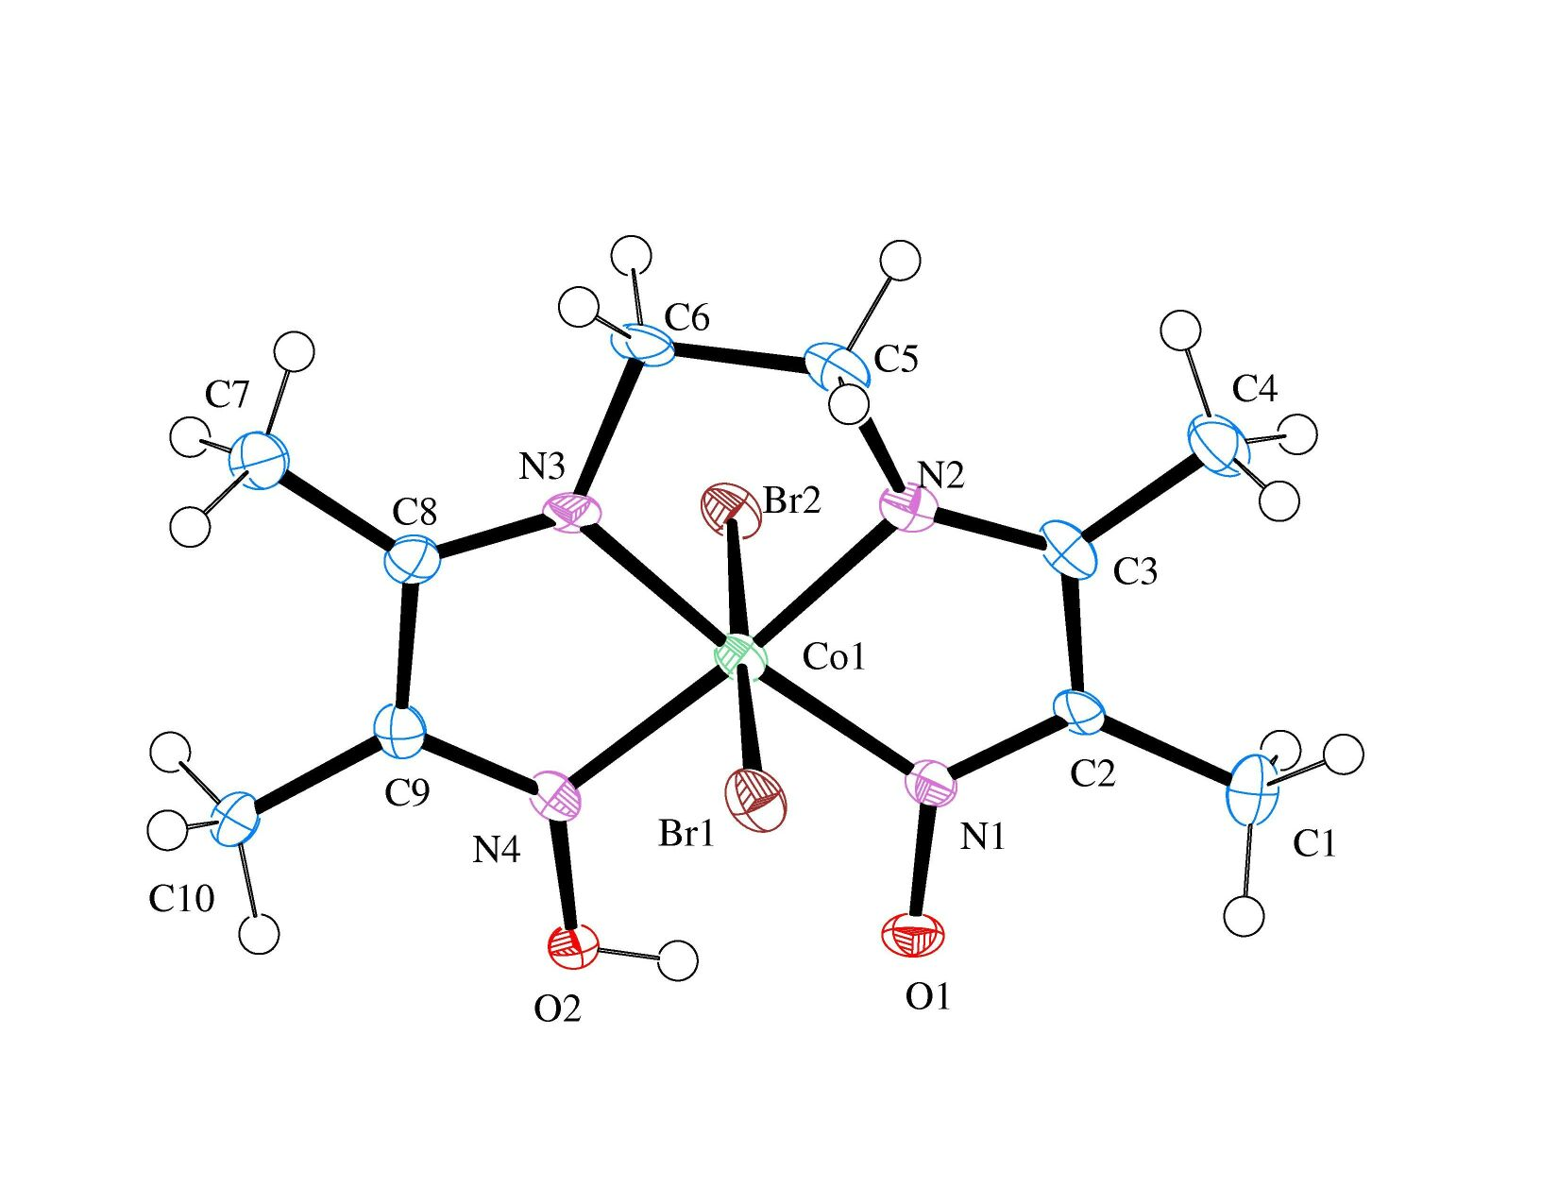

Figure 1. ORTEP of the structure with thermal ellipsoids at the 50% probability level.

Table 1: Crystallographic data for the structures provided.
Empirical formula C10 H17 Br2 Co N4 O2
Formula weight 444.03
Temperature 90(2) K
Wavelength 0.71073 Å
Crystal system Orthorhombic
Space group P c a 2₁
Unit cell dimensions a = 12.244(2) Å α= 90°.
b = 8.3081(13) Å β= 90°.
c = 14.502(2) Å γ = 90°.
Volume 1475.2(4) Å3
Z 4
Density (calculated) 1.999 Mg/m3
Absorption coefficient 6.583 mm-1
F(000) 872
Crystal size 0.15 x 0.13 x 0.08 mm3
Theta range for data collection 2.45 to 28.29°.
Index ranges -16<=h<=16, -10<=k<=11, -19<=l<=19
Reflections collected 21623
Independent reflections 3598 [R(int) = 0.1132]
Completeness to theta = 25.00° 99.2 %
Max. and min. transmission 0.6210 and 0.4384
Refinement method Full-matrix least-squares on F2
Data / restraints / parameters 3598 / 46 / 179
Goodness-of-fit on F2 1.033
Final R indices [I>2sigma(I)] R1 = 0.0613, wR2 = 0.1207
R indices (all data) R1 = 0.1014, wR2 = 0.1355
Absolute structure parameter 0.05(2)
Extinction coefficient 0.0073(7)
Largest diff. peak and hole 1.267 and -1.461 e.Å-3

Bruker (2007) APEX2 (Version 2.1-4), SAINT (version 7.34A), SADABS (version 2007/4), BrukerAXS Inc, Madison, Wisconsin, USA.
(a) Altomare A, Burla C, Camalli M, Cascarano G L, Giacovazzo C, Guagliardi A, Moliterni AGG, Polidori G, Spagna R. (1999) SIR97: a new tool for crystal structure determination and refinement Journal of Applied Crystallography, 32, 115-119. (b) Altomare A, Cascarano G L, Giacovazzo C, Guagliardi A. (1993) Completion and refinement of crystal structures with SIR 92. Journal of Applied Crystallography, 26, 343-350.
Sheldrick GM. (1997) SHELXL-97, Program for the Refinement of Crystal Structures. University of Göttingen, Germany.
Mackay, S.; Edwards, C.; Henderson, A.; Gilmore, C.; Stewart, N.; Shankland, K.; Donald, A. (1997) MaXus: a computer program for the solution and refinement of crystal structures from diffraction data. University of Glasgow, Scotland,.
Waasmaier, D.; Kirfel, A. (1995) New Analytical Scattering Factor Functions for Free Atoms and Ions. Acta Crystallographica A., 51, 416-430.
Claborn, K., Isborn, C., Kaminsky, W., Kahr, B.: Optical rotation of achiral compounds. Angewandte Chemie 47 (2008) 5706-5717.
Farrugia LJ. (1997) Ortep-3 for Windows. Journal of Applied Crystallography, 30, 565

