Crystal Structure Report for A. Velian
by Paige Gannon & Werner Kaminsky
Sample Submitted by Jon Kephart
ID – JAK726
X-ray Crystallography Laboratory
University of Washington
31. July 2026

Data Collection started: 2/14/2022
Documentation finished: 2/23/2022

Data backup accessibly through http:
URL: http://cad4.cpac.washington.edu/structures

W.Kaminsky: tel. (206) 543 7585
(x-ray lab): tel. (206) 543 0210
Email: kaminsky@chem.washington.edu

Understanding crystallographic information is not trivial. If you discuss a structure in a publication, please let the crystallographers proof-read the final draft of that manuscript before you submit it.
For many structures it is true that crystallography is an intellectual performance (like synthesis or elucidation of mechanisms) and not a routine job. In these cases, particularly when the structures contribute significantly to the content of the publication, the crystallographers should be co-authors. Do not think this is not necessary because you pay for structures.
A black prism, measuring 0.22 x 0.10 x 0.07 mm³ was mounted on a loop with oil. Data was collected at -173ºC on a Bruker APEX II single crystal X-ray diffractometer, Mo-radiation, equipped with a Miracol X-ray optical collimator.

Crystal-to-detector distance was 40 mm and exposure time was 60 seconds per frame for all sets. The scan width was 1º. Data collection was 100% complete to 25º in ϑ. A total of 55679 reflections were collected covering the indices, -16<=h<=16, -25<=k<=25, -33<=l<=33. 27844 reflections were symmetry independent and the R_{int} = 0.3858 indicated that the crystal did not scatter well to higher theta angles. Indexing and unit cell refinement indicated a triclinic lattice. The space group was found to be P‾1 (No. 2).

The data was integrated and scaled using SAINT, SADABS within the APEX2 software package by Bruker.

Solution by direct methods (SHELXT or SIR97) produced a complete heavy atom phasing model consistent with the proposed structure. The structure was completed by difference Fourier synthesis with SHELXL., Scattering factors are from Waasmair and Kirfel. Hydrogen atoms were placed in geometrically idealised positions and constrained to ride on their parent atoms with C---H distances in the range 0.95-1.00 Angstrom. Isotropic thermal parameters U_{eq} were fixed such that they were 1.2U_{eq} of their parent atom Ueq for CH's and 1.5U_{eq} of their parent atom U_{eq} in case of methyl groups. All non-hydrogen atoms were refined anisotropically by full-matrix least-squares.

The structure is of 1-dim polymeric character with C114 binding to the potassium of the K(18-crown-6) which in turn coordinates with oxygen from one of the CrNTs. The contribution of disordered mostly THF solvent to the diffraction pattern was removed with SQUEEZE
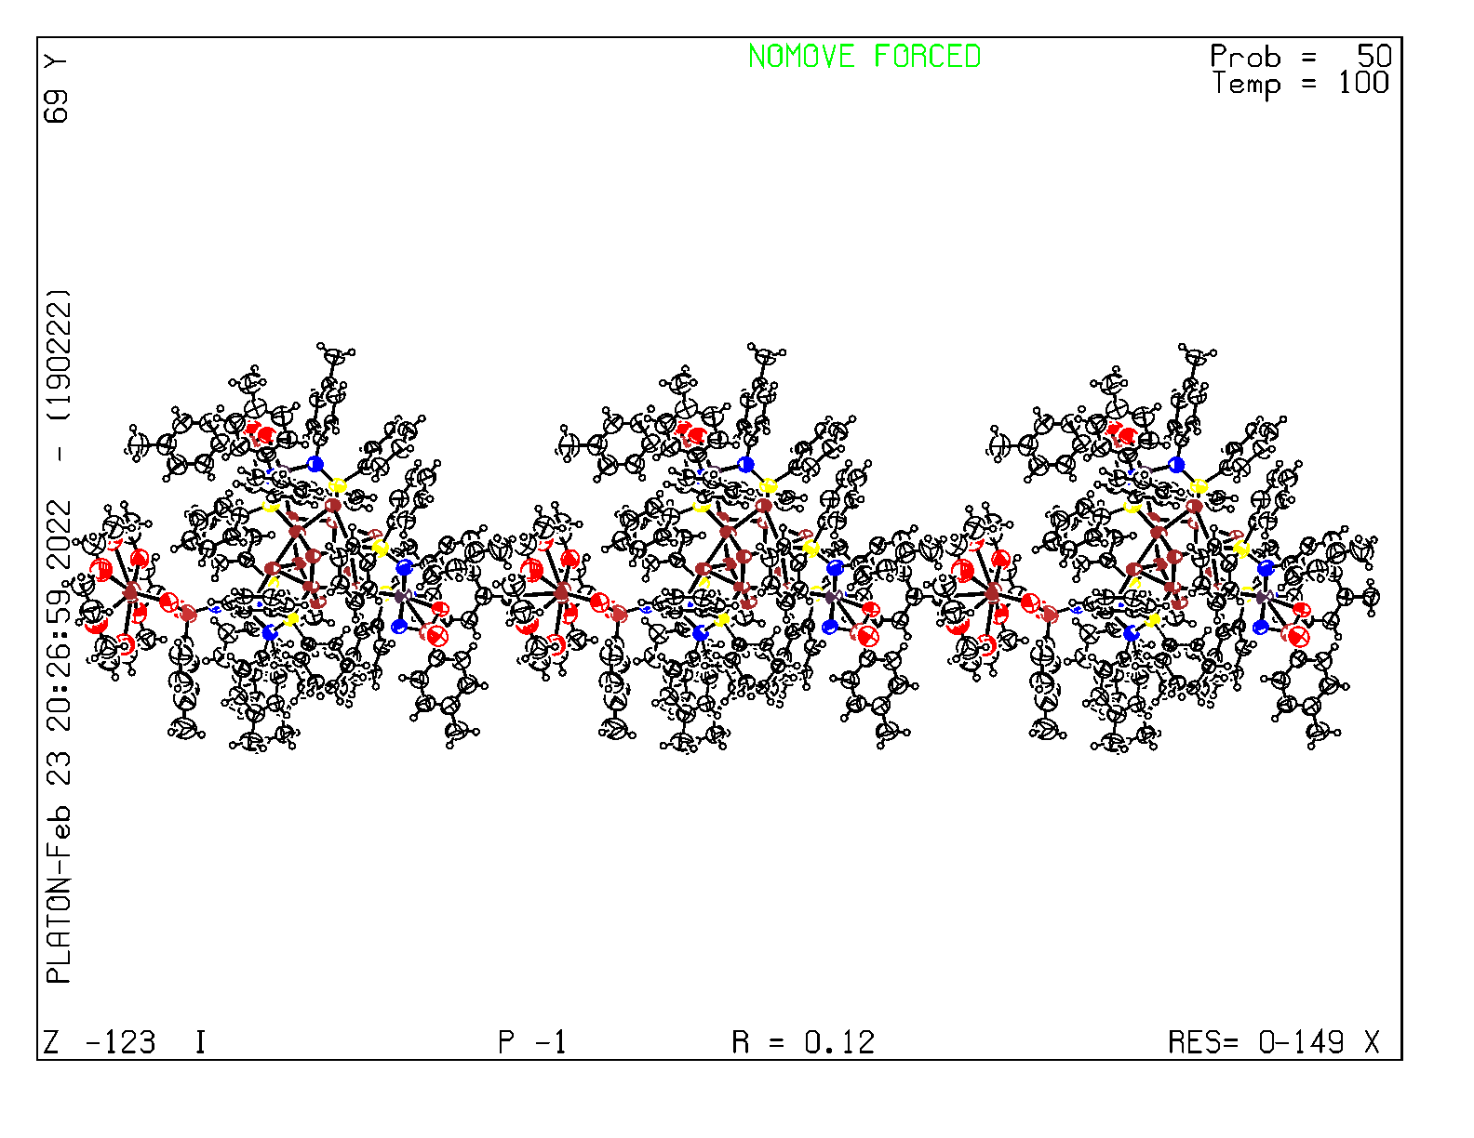
Since the data was weak, a few restraints were needed, including DELU for P, C, N, O, ISOR for C, N, O, FLAT for two toluenes, DFIX for two too close C in the crown, and two hydrogen atoms, as well as an EADP for C1, C101 of disordered phenylgroup. Another toluene in the vicinity of the crown is disordered as well. The structure is of rather moderate quality but may be publishable. Table 1 summarizes the data collection details. Figure 1 shows an ORTEP of the asymmetric unit.
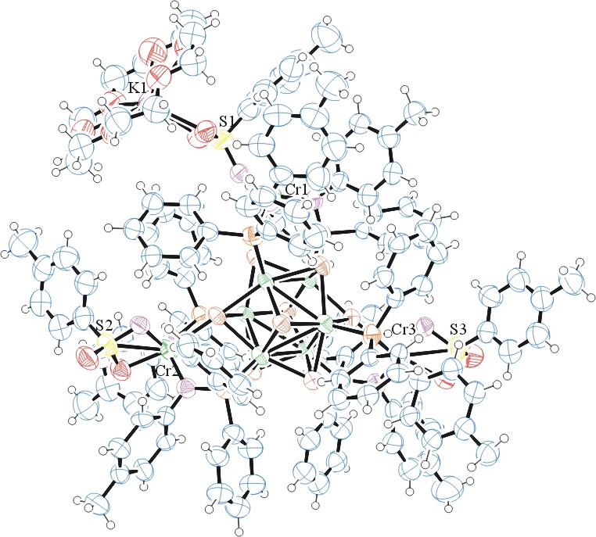

Figure 1. ORTEP of the asymmetric unit with thermal ellipsoids at the 50% probability level. Disorder and solvent omitted for clarity.

Table 1: Crystallographic data for the structures provided.
Empirical formula C147 H146 Co6 Cr3 K N9 O12 P6 S3 Se8
Formula weight 3693.08
Temperature 100(2) K
Wavelength 0.71073 Å
Crystal system Triclinic
Space group P -1
Unit cell dimensions a = 13.5208(13) Å α= 92.559(7)°.
b = 21.561(2) Å β= 98.400(7)°.
c = 28.037(3) Å γ = 101.903(6)°.
Volume 7888.0(14) Å3
Z 2
Density (calculated) 1.555 Mg/m3
Absorption coefficient 2.843 mm-1
F(000) 3700
Crystal size 0.220 x 0.100 x 0.070 mm3
Theta range for data collection 1.170 to 25.027°.
Index ranges -16<=h<=16, -25<=k<=25, -33<=l<=33
Reflections collected 55679
Independent reflections 27844 [R(int) = 0.3858]
Completeness to theta = 25.000° 100.0 %
Refinement method Full-matrix least-squares on F2
Data / restraints / parameters 27844 / 2658 / 1599
Goodness-of-fit on F2 0.940
Final R indices [I>2sigma(I)] R1 = 0.1243, wR2 = 0.2855
R indices (all data) R1 = 0.3593, wR2 = 0.4045
Largest diff. peak and hole 1.361 and -1.152 e.Å-3

Bruker (2007) APEX2 (Version 2.1-4), SAINT (version 7.34A), SADABS (version 2007/4), BrukerAXS Inc, Madison, Wisconsin, USA.
Sheldrick GM. (2015) SHELXT - Integrated space-group and crystal-structure determination. Acta Cryst. A71, 3-8.
(a) Altomare A, Burla C, Camalli M, Cascarano G L, Giacovazzo C, Guagliardi A, Moliterni AGG, Polidori G, Spagna R. (1999) SIR97: a new tool for crystal structure determination and refinement Journal of Applied Crystallography, 32, 115-119. (b) Altomare A, Cascarano G L, Giacovazzo C, Guagliardi A. (1993) Completion and refinement of crystal structures with SIR 92. Journal of Applied Crystallography, 26, 343-350.
’Sheldrick : A short history of SHELX . Acta Cryst. (2008), A64, 112-122
Mackay, S.; Edwards, C.; Henderson, A.; Gilmore, C.; Stewart, N.; Shankland, K.; Donald, A. (1997) MaXus: a computer program for the solution and refinement of crystal structures from diffraction data. University of Glasgow, Scotland,.
Waasmaier, D.; Kirfel, A. (1995) New Analytical Scattering Factor Functions for Free Atoms and Ions. Acta Crystallographica A., 51, 416-430.
(a) A. Spek, J. Appl. Cryst. (2003), 36, 7-13; (b) P. van der Sluis & A. L. Spek, Acta Cryst. (1990). A46, 194-201. (c) Spek, A. L. (2009). Acta. Cryst. D65, 148-155.
Farrugia LJ. (1997) Ortep-3 for Windows. Journal of Applied Crystallography, 30, 565

