Crystal Structure Report for M Heinekey
by Louise Guard
Sample Submitted by Louise Guard
ID – LG01b (tBuPCPIrHCOPyBF4)
X-ray Crystallography Laboratory
University of Washington
28. July 2026

Data Collection started: 12/9/2015
Documentation finished: 8/30/2016

Data backup accessibly through http:
URL: http://cad4.cpac.washington.edu/structures

W.Kaminsky: tel. (206) 543 7585
(x-ray lab): tel. (206) 543 0210
Email: kaminsky@chem.washington.edu

Understanding crystallographic information is not trivial. If you discuss a structure in a publication, please let the crystallographers proof-read the final draft of that manuscript before you submit it.
For many structures it is true that crystallography is an intellectual performance (like synthesis or elucidation of mechanisms) and not a routine job. In these cases, particularly when the structures contribute significantly to the content of the publication, the crystallographers should be co-authors. Do not think this is not necessary because you pay for structures.
A colorless plate, measuring 0.40 x 0.30 x 0.03 mm³ was mounted on a loop with oil. Data was collected at -173ºC on a Bruker APEX II single crystal X-ray diffractometer, Mo-radiation.

Crystal-to-detector distance was 40 mm and exposure time was 10 seconds per frame for all sets. The scan width was 0.5º. Data collection was 99.5% complete to 25º in ϑ. A total of 156408 reflections were collected covering the indices, -17<=h<=17, -19<=k<=19, -26<=l<=26. 17805 reflections were symmetry independent and the R_{int} = 0.0693 indicated that the data was of average quality. Indexing and unit cell refinement indicated a triclinic lattice. The space group was found to be P‾1 (No. 2).

The data was integrated and scaled using SAINT, SADABS within the APEX2 software package by Bruker.

The structure was solved by direct methods with XS, using Olex2, producing a complete heavy atom phasing model consistent with the proposed structure. The structure was completed by difference Fourier synthesis with SHELXL97. Scattering factors are from Waasmair and Kirfel. Hydrogen atoms were placed in geometrically idealised positions and constrained to ride on their parent atoms with C---H distances in the range 0.95-1.00 Angstrom. Isotropic thermal parameters U_{eq} were fixed such that they were 1.2U_{eq} of their parent atom Ueq for CH's and 1.5U_{eq} of their parent atom U_{eq} in case of methyl groups. All non-hydrogen atoms were refined anisotropically by full-matrix least-squares.

The structure shows two independent molecules in the assymmetric unit with two BF4⁻ anions and two CH₂Cl₂ solvent molecules.

The structure is of high quality and ready for publication. Table 1 summarizes the data collection details. Figure 1 shows an ORTEP of the asymmetric unit.

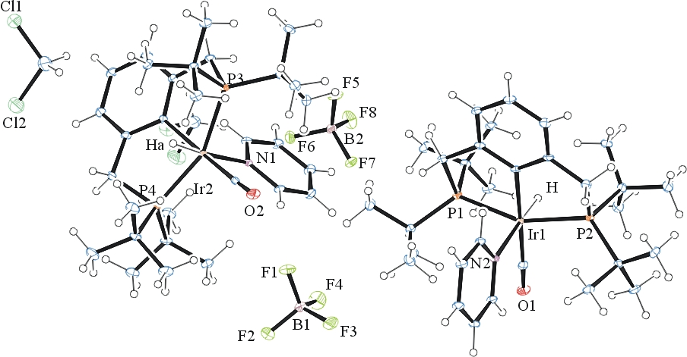
Figure 1. ORTEP of the structure with thermal ellipsoids at the 35% probability level.

Table 1: Crystallographic data for the structures provided.
Empirical formula C31 H51 B Cl2 F4 Ir N O P2
Formula weight 865.58
Temperature 100(2) K
Wavelength 0.71073 Å
Crystal system Triclinic
Space group P -1
Unit cell dimensions a = 12.9175(9) Å α= 109.001(4)°.
b = 14.7329(10) Å β= 96.628(4)°.
c = 20.1421(14) Å γ = 90.772(4)°.
Volume 3594.9(4) Å3
Z 4
Density (calculated) 1.599 Mg/m3
Absorption coefficient 3.998 mm-1
F(000) 1736
Crystal size 0.40 x 0.30 x 0.03 mm3
Theta range for data collection 1.46 to 28.43°.
Index ranges -17<=h<=17, -19<=k<=19, -26<=l<=26
Reflections collected 156408
Independent reflections 17805 [R(int) = 0.0693]
Completeness to theta = 25.00° 99.5 %
Max. and min. transmission 0.8895 and 0.2977
Refinement method Full-matrix least-squares on F2
Data / restraints / parameters 17805 / 1 / 807
Goodness-of-fit on F2 1.032
Final R indices [I>2sigma(I)] R1 = 0.0344, wR2 = 0.0725
R indices (all data) R1 = 0.0545, wR2 = 0.0820
Largest diff. peak and hole 2.329 and -2.142 e.Å-3

Bruker (2007) APEX2 (Version 2.1-4), SAINT (version 7.34A), SADABS (version 2007/4), BrukerAXS Inc, Madison, Wisconsin, USA.
Sheldrick, G. M. Acta Crystallogr. Sect. A 2008, 64, 112-122.
Dolomanov, O. V.; Bourhis, L. J.; Gildea, R. J.; Howard, J. A. K.; Puschmann, H. "OLEX2: a complete structure solution, refinement and analysis program." J. Appl. Cryst. 2009, 42, 339- 341.
(a) Sheldrick, G. M. SHELXL-97, Program for the Refinement of Crystal Structures. University of Göttingen, Germany, 1997.
Waasmaier, D.; Kirfel, A. (1995) New Analytical Scattering Factor Functions for Free Atoms and Ions. Acta Crystallographica A., 51, 416-430.
Farrugia LJ. (1997) Ortep-3 for Windows. Journal of Applied Crystallography, 30, 565

