Crystal Structure Report for
Rupam Dinda
by Werner Kaminsky
ID – MM_15
X-ray Crystallography Laboratory
University of Washington
31. July 2026

Data Collection started: 7/27/2017
Documentation finished: 7/31/2017

Data backup accessibly through http:
URL: http://cad4.cpac.washington.edu/structures

W.Kaminsky: tel. (206) 543 7585
(x-ray lab): tel. (206) 543 0210
Email: kaminsky@chem.washington.edu

Understanding crystallographic information is not trivial. If you discuss a structure in a publication, please let the crystallographers proof-read the final draft of that manuscript before you submit it.
For many structures it is true that crystallography is an intellectual performance (like synthesis or elucidation of mechanisms) and not a routine job. In these cases, particularly when the structures contribute significantly to the content of the publication, the crystallographers should be co-authors. Do not think this is not necessary because you pay for structures.
A light brown prism, measuring 0.20 x 0.09 x 0.05 mm³ was mounted on a loop with oil. Data was collected at -143ºC on a Nonius Kappa CCD FR590 single crystal X-ray diffractometer, Mo-radiation.

Crystal-to-detector distance was 30 mm and exposure time was 60 seconds per degree for all sets. The scan width was 2º. Data collection was 99.9% complete to 25.3º and 94.3% complete to 25º in ϑ. A total of 25427 partial and complete reflections were collected, covering the indices, -16<=h<=16, -12<=k<=13, -18<=l<=18. 12420 reflections were symmetry independent with an alevated R_{int} = 0.1532 which reflects a rather small sample size. Indexing and unit cell refinement indicated a primitive monoclinic lattice. The space group was found to be P 2₁/c (No. 14).

The data was integrated and scaled using hkl-SCALEPACK. This program applies a multiplicative correction factor (S) to the observed intensities (I) and has the following form:

S is calculated from the scale and the B factor determined for each frame and is then applied to I to give the corrected intensity (I_{corr}).

Solution by direct methods (SHELXS, SIR97) produced a complete heavy atom phasing model consistent with the proposed structure. The structure was completed by difference Fourier synthesis with SHELXL97., Scattering factors are from Waasmair and Kirfel. Hydrogen atoms were placed in geometrically idealised positions and constrained to ride on their parent atoms with C---H distances in the range 0.95-1.00 Angstrom. Isotropic thermal parameters U_{eq} were fixed such that they were 1.2U_{eq} of their parent atom Ueq for CH's and 1.5U_{eq} of their parent atom U_{eq} in case of methyl groups. All non-hydrogen atoms were refined anisotropically by full-matrix least-squares.

The structure is of high quality and ready for publication. Table 1 summarizes the data collection details. Figure 1 shows an ORTEP of the asymmetric unit.

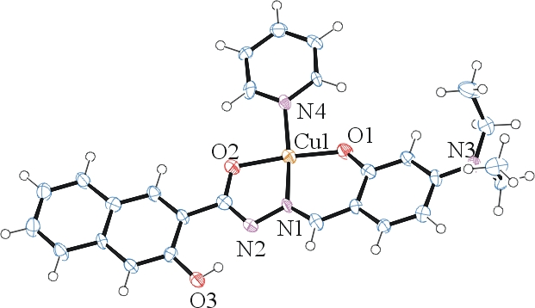 Figure 1. ORTEP of the structure with thermal ellipsoids at the 50% probability level.

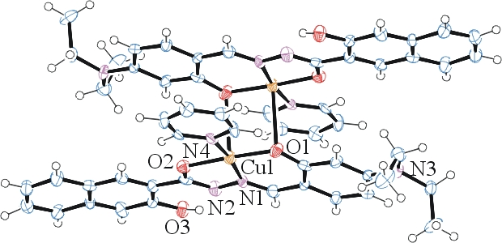
Figure 2. Dimeric packing pattern via Cu1 – O1 interactions perpendicular to the molecular planes.

Table 1: Crystallographic data for the structures provided.
Empirical formula C54 H52 Cu2 N8 O6
Formula weight 1036.11
Temperature 130(2) K
Wavelength 0.71073 Å
Crystal system Monoclinic
Space group P 2₁/c
Unit cell dimensions a = 14.0290(17) Å α= 90°.
b = 11.4323(14) Å β= 108.441(8)°.
c = 15.227(3) Å γ = 90°.
Volume 2316.8(6) Å3
Z 2
Density (calculated) 1.485 Mg/m3
Absorption coefficient 0.981 mm-1
F(000) 1076
Crystal size 0.200 x 0.090 x 0.050 mm3
Theta range for data collection 2.979 to 25.348°.
Index ranges -16<=h<=16, -12<=k<=13, -18<=l<=18
Reflections collected 7264
Independent reflections 4192 [R(int) = 0.1532]
Completeness to theta = 25.000° 99.0 %
Refinement method Full-matrix least-squares on F2
Data / restraints / parameters 4192 / 0 / 319
Goodness-of-fit on F2 0.884
Final R indices [I>2sigma(I)] R1 = 0.0618, wR2 = 0.1052
R indices (all data) R1 = 0.1990, wR2 = 0.1481
Largest diff. peak and hole 0.608 and -0.827 e.Å-3

Otwinowsky, Z.; Minor, W. In: Methods in Enzymology; Carter, C. W., Jr., Sweet, R. M., Eds.; Academic Press: New York, 1997, 276, 307-326.
(a) Altomare, A.; Burla, C.; Camalli M.; Cascarano L.; Giacovazzo C.; Guagliardi A.; Moliterni A.G.G.; Polidori G.; Spagna R. J. Appl. Cryst. 1999, 32, 115-119; (b) Altomare, A., Cascarano, G., Giacovazzo, C., Guagliardi, A., J. Appl. Cryst. 1993, 26, 343.
(a) Sheldrick GM. (1997) SHELXL-97, Program for the Refinement of Crystal Structures. University of Göttingen, Germany. (b) Sheldrick GM. (2013) Crystal structure refinement with SHELXL. Acta Cryst. (2015). C71, 3-8.
Mackay, S.; Edwards, C.; Henderson, A.; Gilmore, C.; Stewart, N.; Shankland, K.; Donald, A.; MaXus: a computer program for the solution and refinement of crystal structures from diffraction data. University of Glasgow, Scotland, 1997.
Waasmaier, D.; Kirfel, A. Acta Crystallogr. A. 1995, 51, 416.
Farrugia, L. J. Appl. Cryst. 1997, 30, 565

