Crystal Structure Report for B. Cossairt
by Werner Kaminsky
Sample Submitted by Betsy Flowers
ID – mn_solvento_b
X-ray Crystallography Laboratory
University of Washington
29. July 2026

Data Collection started: 4/13/2016
Documentation finished: 4/20/2016

Data backup accessibly through http:
URL: http://cad4.cpac.washington.edu/structures

W.Kaminsky: tel. (206) 543 7585
(x-ray lab): tel. (206) 543 0210
Email: kaminsky@chem.washington.edu

Understanding crystallographic information is not trivial. If you discuss a structure in a publication, please let the crystallographers proof-read the final draft of that manuscript before you submit it.
For many structures it is true that crystallography is an intellectual performance (like synthesis or elucidation of mechanisms) and not a routine job. In these cases, particularly when the structures contribute significantly to the content of the publication, the crystallographers should be co-authors. Do not think this is not necessary because you pay for structures.
An orange prism, measuring 0.08 x 0.06 x 0.03 mm³ was mounted on a loop with oil. Data was collected at -173ºC on a Bruker APEX II single crystal X-ray diffractometer, Mo-radiation.

Crystal-to-detector distance was 40 mm and exposure time was 20 seconds per frame for all sets. The scan width was 0.5. Data collection was 100% complete to 25º in ϑ. A total of 87904 reflections were collected covering the indices, -33<=h<=33, -14<=k<=14, -29<=l<=29. 7191 reflections were symmetry independent and the R_{int} = 0.1021 reflects that the sample was small. Indexing and unit cell refinement indicated a C-centered monoclinic lattice. The space group was found to be C 2/c (No. 15).

The data was integrated and scaled using SAINT, SADABS within the APEX2 software package by Bruker.

Solution by direct methods (SHELXS, SIR97) produced a complete heavy atom phasing model consistent with the proposed structure. The structure was completed by difference Fourier synthesis with SHELXL97., Scattering factors are from Waasmair and Kirfel. Hydrogen atoms were placed in geometrically idealised positions and constrained to ride on their parent atoms with C---H distances in the range 0.95-1.00 Angstrom. Isotropic thermal parameters U_{eq} were fixed such that they were 1.2U_{eq} of their parent atom Ueq for CH's and 1.5U_{eq} of their parent atom U_{eq} in case of methyl groups. All non-hydrogen atoms were refined anisotropically by full-matrix least-squares.

Two Ru-complexes are connected via a chemically disordered bridge consisting of 85% NO₂⁻ and 15% PF₄⁻. The latter being disordered via two-fold rotation symmetry. Accordingly, a CH₂Cl₂ solvent appeared three-fold disordered. The remaining -3 charge of the dimer is balanced by 3 PF₆⁻ anions. The high degree of disorder required application of several positional restraints as well as restraints of displacement parameters of the disordered moieties.

The structure is of high quality and ready for publication. Table 1 summarizes the data collection details. Figure 1 shows an ORTEP of the asymmetric unit.
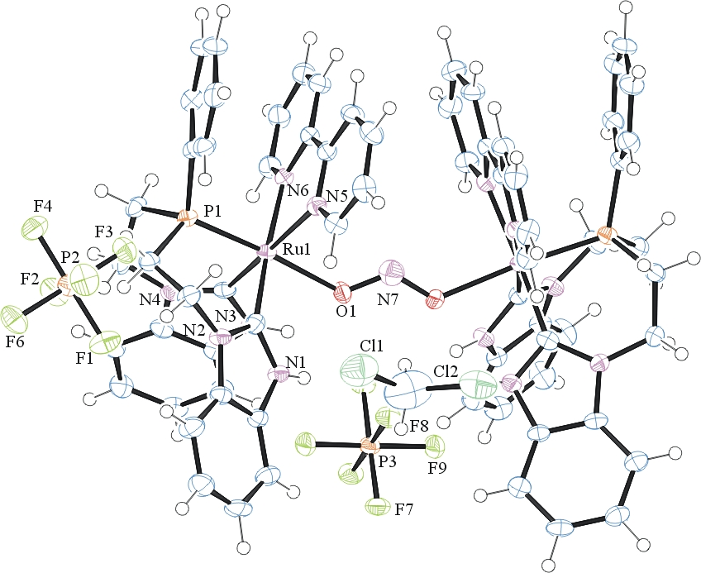
Figure 1. ORTEP of the structure with thermal ellipsoids at the 50% probability level. Disorder omitted for clarity (maior component shown).

Table 1: Crystallographic data for the structures provided.
Empirical formula C70 H66 Cl4 F18.60 N12.85 O1.70 P5.15 Ru2
Formula weight 1971.28
Temperature 100(2) K
Wavelength 0.71073 Å
Crystal system Monoclinic
Space group C 2/c
Unit cell dimensions a = 27.497(3) Å α= 90°.
b = 12.3149(10) Å β= 110.168(8)°.
c = 24.593(3) Å γ = 90°.
Volume 7817.1(15) Å3
Z 4
Density (calculated) 1.675 Mg/m3
Absorption coefficient 0.727 mm-1
F(000) 3960.8
Crystal size 0.08 x 0.06 x 0.03 mm3
Theta range for data collection 1.58 to 25.45°.
Index ranges -33<=h<=33, -14<=k<=14, -29<=l<=29
Reflections collected 87904
Independent reflections 7191 [R(int) = 0.1021]
Completeness to theta = 25.00° 100.0 %
Max. and min. transmission 0.9785 and 0.9441
Refinement method Full-matrix least-squares on F2
Data / restraints / parameters 7191 / 55 / 570
Goodness-of-fit on F2 1.007
Final R indices [I>2sigma(I)] R1 = 0.0433, wR2 = 0.0872
R indices (all data) R1 = 0.0814, wR2 = 0.1017
Largest diff. peak and hole 0.884 and -0.754 e.Å-3

Bruker (2007) APEX2 (Version 2.1-4), SAINT (version 7.34A), SADABS (version 2007/4), BrukerAXS Inc, Madison, Wisconsin, USA.
(a) Altomare A, Burla C, Camalli M, Cascarano G L, Giacovazzo C, Guagliardi A, Moliterni AGG, Polidori G, Spagna R. (1999) SIR97: a new tool for crystal structure determination and refinement Journal of Applied Crystallography, 32, 115-119. (b) Altomare A, Cascarano G L, Giacovazzo C, Guagliardi A. (1993) Completion and refinement of crystal structures with SIR 92. Journal of Applied Crystallography, 26, 343-350.
(a) Sheldrick GM. (1997) SHELXL-97, Program for the Refinement of Crystal Structures. University of Göttingen, Germany. (b) Sheldrick GM. (2013) Crystal structure refinement with SHELXL. Acta Cryst. (2015). C71, 3-8.
Mackay, S.; Edwards, C.; Henderson, A.; Gilmore, C.; Stewart, N.; Shankland, K.; Donald, A. (1997) MaXus: a computer program for the solution and refinement of crystal structures from diffraction data. University of Glasgow, Scotland,.
Waasmaier, D.; Kirfel, A. (1995) New Analytical Scattering Factor Functions for Free Atoms and Ions. Acta Crystallographica A., 51, 416-430.
Farrugia LJ. (1997) Ortep-3 for Windows. Journal of Applied Crystallography, 30, 565

