Crystal Structure Report for B. Cossairt
by Dylan Rogers & Werner Kaminsky
Sample Submitted by Andrew Ritchhart
ID – rubpycooh
X-ray Crystallography Laboratory
University of Washington
28. July 2026

Data Collection started: 1/27/2020
Documentation finished: 2/6/2020

Data backup accessibly through http:
URL: http://cad4.cpac.washington.edu/structures

W.Kaminsky: tel. (206) 543 7585
(x-ray lab): tel. (206) 543 0210
Email: kaminsky@chem.washington.edu

Understanding crystallographic information is not trivial. If you discuss a structure in a publication, please let the crystallographers proof-read the final draft of that manuscript before you submit it.
For many structures it is true that crystallography is an intellectual performance (like synthesis or elucidation of mechanisms) and not a routine job. In these cases, particularly when the structures contribute significantly to the content of the publication, the crystallographers should be co-authors. Do not think this is not necessary because you pay for structures.
A red prism, measuring 0.16 x 0.09 x 0.08 mm³ was mounted on a loop with oil. Data was collected at -173ºC on a Bruker APEX II single crystal X-ray diffractometer, Mo-radiation.

Crystal-to-detector distance was 40 mm and exposure time was 30 seconds per frame for all sets. The scan width was 0.5º. Data collection was 99.9% complete to 25º in ϑ. A total of 11013 merged reflections were collected covering the indices, -11<=h<=11, -15<=k<=15, -42<=l<=42. 5561 reflections were symmetry independent and the R_{int} = 0.0392 indicated that the data was of better than average quality (0.07). Indexing and unit cell refinement indicated a primitive tetragonal lattice. The space group was found to be P 4₂/n (No. 86).

The data was integrated and scaled using SAINT, SADABS within the APEX2 software package by Bruker.

Solution by direct methods (SHELXT or SIR97) produced a complete heavy atom phasing model consistent with the proposed structure. The structure was completed by difference Fourier synthesis with SHELXL., Scattering factors are from Waasmair and Kirfel. Hydrogen atoms were placed in geometrically idealised positions and constrained to ride on their parent atoms with C---H distances in the range 0.95-1.00 Angstrom. Isotropic thermal parameters U_{eq} were fixed such that they were 1.2U_{eq} of their parent atom Ueq for CH's and 1.5U_{eq} of their parent atom U_{eq} in case of methyl groups. All non-hydrogen atoms were refined anisotropically by full-matrix least-squares.

The asymmetric cell contains half of the complex which is completed by symmetry. The disordered oxygen hydrogen bond to chlorine (O1B-H1B-Cl2) or to those of a symmetry related complex (O2A-H2A-O2B* and vice versa); *: 1-x, 2-y, 1-z. Accordingly, the two chlorines accompanying the complex are distributed over four locations.

The contribution of disordered solvent to the diffraction pattern was removed with SQUEEZE

The structure is of high quality and ready for publication. Table 1 summarizes the data collection details. Figure 1 shows an ORTEP of the asymmetric unit.

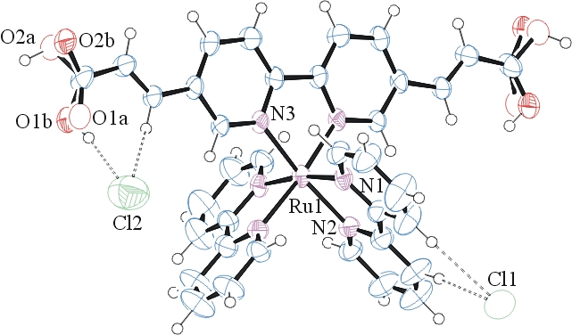
Figure 1. ORTEP of the structure with thermal ellipsoids at the 50% probability level. Solvent SQUEEZEd.

Table 1: Crystallographic data for the structures provided.
Empirical formula C36 H28 Cl2 N6 O4 Ru
Formula weight 780.61
Temperature 100(2) K
Wavelength 0.71073 Å
Crystal system Tetragonal
Space group P 42/n
Unit cell dimensions a = 11.7526(5) Å α= 90°.
b = 11.7526(5) Å β= 90°.
c = 32.1926(16) Å γ = 90°.
Volume 4446.6(4) Å3
Z 4
Density (calculated) 1.166 Mg/m3
Absorption coefficient 0.511 mm-1
F(000) 1584
Crystal size 0.160 x 0.090 x 0.080 mm3
Theta range for data collection 1.845 to 28.343°.
Index ranges -11<=h<=11, -15<=k<=15, -42<=l<=42
Reflections collected 11013
Independent reflections 5561 [R(int) = 0.0392]
Completeness to theta = 25.000° 99.9 %
Refinement method Full-matrix least-squares on F2
Data / restraints / parameters 5561 / 31 / 239
Goodness-of-fit on F2 1.145
Final R indices [I>2sigma(I)] R1 = 0.0794, wR2 = 0.1772
R indices (all data) R1 = 0.1186, wR2 = 0.1921
Largest diff. peak and hole 1.382 and -0.892 e.Å-3

Bruker (2007) APEX2 (Version 2.1-4), SAINT (version 7.34A), SADABS (version 2007/4), BrukerAXS Inc, Madison, Wisconsin, USA.
Sheldrick GM. (2015) SHELXT - Integrated space-group and crystal-structure determination. Acta Cryst. A71, 3-8.
(a) Altomare A, Burla C, Camalli M, Cascarano G L, Giacovazzo C, Guagliardi A, Moliterni AGG, Polidori G, Spagna R. (1999) SIR97: a new tool for crystal structure determination and refinement Journal of Applied Crystallography, 32, 115-119. (b) Altomare A, Cascarano G L, Giacovazzo C, Guagliardi A. (1993) Completion and refinement of crystal structures with SIR 92. Journal of Applied Crystallography, 26, 343-350.
(a) Sheldrick GM. (1997) SHELXL-97, Program for the Refinement of Crystal Structures. University of Göttingen, Germany. (b) Sheldrick GM. (2015) Crystal structure refinement with SHELXL. Acta Cryst. (2015). C71, 3–8
Mackay, S.; Edwards, C.; Henderson, A.; Gilmore, C.; Stewart, N.; Shankland, K.; Donald, A. (1997) MaXus: a computer program for the solution and refinement of crystal structures from diffraction data. University of Glasgow, Scotland,.
Waasmaier, D.; Kirfel, A. (1995) New Analytical Scattering Factor Functions for Free Atoms and Ions. Acta Crystallographica A., 51, 416-430.
(a) A. Spek, J. Appl. Cryst. (2003), 36, 7-13; (b) P. van der Sluis & A. L. Spek, Acta Cryst. (1990). A46, 194-201. (c) Spek, A. L. (2009). Acta. Cryst. D65, 148-155.
Farrugia LJ. (1997) Ortep-3 for Windows. Journal of Applied Crystallography, 30, 565

