Crystal Structure Report for B. Cossairt
by Sarah Flowers & Werner Kaminsky
Sample Submitted by Sarah Flowers
ID – SEF2_142
X-ray Crystallography Laboratory
University of Washington
31. July 2026

Data Collection started: 04/25/16
Documentation finished: 05/31/16

Data backup accessibly through http:
URL: http://cad4.cpac.washington.edu/structures

W.Kaminsky: tel. (206) 543 7585
(x-ray lab): tel. (206) 543 0210
Email: kaminsky@chem.washington.edu

Understanding crystallographic information is not trivial. If you discuss a structure in a publication, please let the crystallographers proof-read the final draft of that manuscript before you submit it.
For many structures it is true that crystallography is an intellectual performance (like synthesis or elucidation of mechanisms) and not a routine job. In these cases, particularly when the structures contribute significantly to the content of the publication, the crystallographers should be co-authors. Do not think this is not necessary because you pay for structures.
A clear yellow hexagonal prism, measuring 0.15 x 0.10 x 0.08 mm³ was mounted on a loop with oil. Data was collected at -173ºC on a Bruker APEX II single crystal X-ray diffractometer, Mo-radiation.

Crystal-to-detector distance was 40.00 mm and exposure time was 10 seconds per frame for all sets. The scan width was 0.5º. Data collection was 99.5% complete to 25º in ϑ. A total of 160,385 reflections were collected covering the indices, h = -33 to 33, k = -14 to 14, l = -29 to 29. 7,297 reflections were symmetry independent and the R_{int} = 0.0668 indicated that the data was better than average quality (0.07). Indexing and unit cell refinement indicated a monoclinic C lattice. The space group was found to be C 2/c (No. 15).

The data was integrated and scaled using SAINT, SADABS within the APEX2 software package by Bruker.

Solution by direct methods (SHELXS, SIR97) produced a complete heavy atom phasing model consistent with the proposed structure. The structure was completed by difference Fourier synthesis with SHELXL97., Scattering factors are from Waasmair and Kirfel. Hydrogen atoms were placed in geometrically idealised positions and constrained to ride on their parent atoms with C---H distances in the range 0.95-1.00 Angstrom. Isotropic thermal parameters U_{eq} were fixed such that they were 1.2U_{eq} of their parent atom Ueq for CH's and 1.5U_{eq} of their parent atom U_{eq} in case of methyl groups. All non-hydrogen atoms were refined anisotropically by full-matrix least-squares.

The structure contains a Ruthenium dimer the Ruthenium centers are connected by on OCCH3O moiety. The structure also contains 3 PF₆ anions. Void analysis revealed disordered dichloromethane molecules occupying voids centered at 4 locations within the unit cell: (0.25, 0.25, 1.0); (0.75, 0.25, 0.5); (0.25, 0.75, 0.5); and (0.75, 0.75, 1.0). The contribution to the diffraction pattern of this disordered solvent was removed with SQEEZE.

The structure is of high quality and ready for publication. Table 1 summarizes the data collection details. Figure 1 shows an ORTEP of the asymmetric unit.
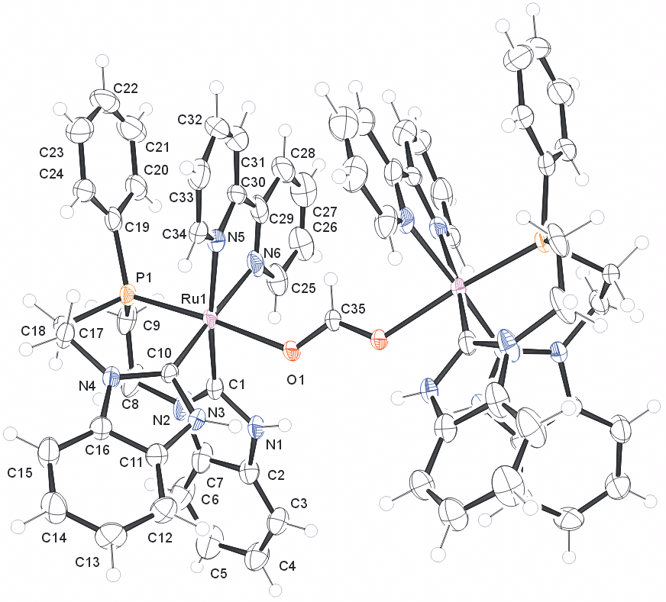

Figure 1. ORTEP of the structure with thermal ellipsoids at the 50% probability level. Counter ions (3 PF₆ ions) and disordered dichloromethane molecules were removed for clarity.

Table 1: Crystallographic data for the structures provided.
Identification code ru_occh3o_0m
Empirical formula C70 H65 F18 N12 O2 P5 Ru2
Formula weight 1805.33
Temperature 100(2) K
Wavelength 0.71073 Å
Crystal system Monoclinic
Space group C 2/c
Unit cell dimensions a = 27.611(3) Å α= 90°.
b = 12.3872(15) Å β= 110.157(6)°.
c = 24.567(2) Å γ = 90°.
Volume 7887.9(15) Å3
Z 4
Density (calculated) 1.520 Mg/m3
Absorption coefficient 0.578 mm-1
F(000) 3640
Crystal size 0.08 x 0.05 x 0.01 mm3
Theta range for data collection 1.57 to 25.42°.
Index ranges -33<=h<=33, -14<=k<=14, -29<=l<=29
Reflections collected 73766
Independent reflections 7258 [R(int) = 0.1428]
Completeness to theta = 25.00° 100.0 %
Absorption correction Semi-empirical from equivalents
Max. and min. transmission 0.9942 and 0.9552
Refinement method Full-matrix least-squares on F2
Data / restraints / parameters 7258 / 8 / 505
Goodness-of-fit on F2 1.003
Final R indices [I>2sigma(I)] R1 = 0.0605, wR2 = 0.1217
R indices (all data) R1 = 0.1123, wR2 = 0.1369
Largest diff. peak and hole 0.991 and -0.729 e.Å-3

Bruker (2007) APEX2 (Version 2.1-4), SAINT (version 7.34A), SADABS (version 2007/4), BrukerAXS Inc, Madison, Wisconsin, USA.
(a) Altomare A, Burla C, Camalli M, Cascarano G L, Giacovazzo C, Guagliardi A, Moliterni AGG, Polidori G, Spagna R. (1999) SIR97: a new tool for crystal structure determination and refinement Journal of Applied Crystallography, 32, 115-119. (b) Altomare A, Cascarano G L, Giacovazzo C, Guagliardi A. (1993) Completion and refinement of crystal structures with SIR 92. Journal of Applied Crystallography, 26, 343-350.
(a) Sheldrick GM. (1997) SHELXL-97, Program for the Refinement of Crystal Structures. University of Göttingen, Germany. (b) Sheldrick GM. (2013) Crystal structure refinement with SHELXL. Acta Cryst. (2015). C71, 3-8.
Mackay, S.; Edwards, C.; Henderson, A.; Gilmore, C.; Stewart, N.; Shankland, K.; Donald, A. (1997) MaXus: a computer program for the solution and refinement of crystal structures from diffraction data. University of Glasgow, Scotland,.
Waasmaier, D.; Kirfel, A. (1995) New Analytical Scattering Factor Functions for Free Atoms and Ions. Acta Crystallographica A., 51, 416-430.
A. Spek, J. Appl. Cryst. (2003), 36, 7-13; P. van der Sluis & A. L. Spek, Acta Cryst. (1990). A46, 194-201.
7 Farrugia LJ. (1997) Ortep-3 for Windows. Journal of Applied Crystallography, 30, 565

