Crystal Structure Report for B. Cossairt
by Sarah Flowers & Werner Kaminsky
Sample Submitted by Sarah Flowers
ID – SEF3_14
X-ray Crystallography Laboratory
University of Washington
28. July 2026

Data Collection started: 03/16/2017
Documentation finished: 07/11/2017

Data backup accessibly through http:
URL: http://cad4.cpac.washington.edu/structures

W.Kaminsky: tel. (206) 543 7585
(x-ray lab): tel. (206) 543 0210
Email: kaminsky@chem.washington.edu

Understanding crystallographic information is not trivial. If you discuss a structure in a publication, please let the crystallographers proof-read the final draft of that manuscript before you submit it.
For many structures it is true that crystallography is an intellectual performance (like synthesis or elucidation of mechanisms) and not a routine job. In these cases, particularly when the structures contribute significantly to the content of the publication, the crystallographers should be co-authors. Do not think this is not necessary because you pay for structures.
A clear orange prism, measuring 0.045 x 0.09 x 0.03 mm³ was mounted on a loop with oil. Data was collected at -173ºC on a Bruker APEX II single crystal X-ray diffractometer, Mo-radiation.

Crystal-to-detector distance was 40.00 mm and exposure time was 240 seconds per frame for all sets. The scan width was 1.0º. Data collection was 99.8% complete to 25º in ϑ. A total of 71,162 reflections were collected covering the indices, h = -40 to 40, k = -40 to 40, l = -23 to 23. 7,953 reflections were symmetry independent and the R_{int} = 0.1708 indicated that the data was less than average quality (0.07). Indexing and unit cell refinement indicated a Trigonal R lattice. The space group was found to be R -3 (No. 148).

The data was integrated and scaled using SAINT, SADABS within the APEX2 software package by Bruker.

Solution by direct methods (SHELXS, SIR97) produced a complete heavy atom phasing model consistent with the proposed structure. The structure was completed by difference Fourier synthesis with SHELXL97., Scattering factors are from Waasmair and Kirfel. Hydrogen atoms were placed in geometrically idealised positions and constrained to ride on their parent atoms with C---H distances in the range 0.95-1.00 Angstrom. Isotropic thermal parameters U_{eq} were fixed such that they were 1.2U_{eq} of their parent atom Ueq for CH's and 1.5U_{eq} of their parent atom U_{eq} in case of methyl groups. All non-hydrogen atoms were refined anisotropically by full-matrix least-squares.

The structure contains a Ruthenium monomer half sandwich compound. Void analysis revealed disordered diethyl ether and dichloromethane molecules occupying voids centered at 3 locations within the unit cell: (0.00, 0.00, -0.02); (0.33, 0.67, 0.16); and (0.67, 0.33, 0.83). The contribution to the diffraction pattern of this disordered solvent was removed with SQEEZE.

The structure is of high quality and ready for publication. Table 1 summarizes the data collection details. Figure 1 shows an ORTEP of the asymmetric unit.
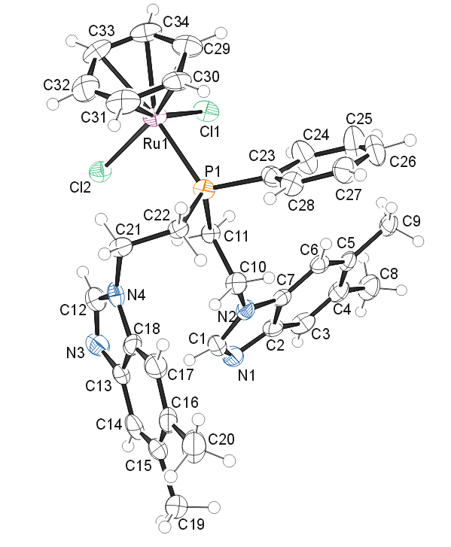

Figure 1. ORTEP of the structure with thermal ellipsoids at the 50% probability level.

Table 1: Crystallographic data for the structures provided.
Identification code sef3_14_0m
Empirical formula C34 H37 Cl2 N4 P Ru
Formula weight 704.62
Temperature 293(2) K
Wavelength 0.71073 Å
Crystal system Trigonal
Space group R -3
Unit cell dimensions a = 33.798(4) Å α= 90°.
b = 33.798(4) Å β= 90°.
c = 19.6172(17) Å γ = 120°.
Volume 19407(4) Å3
Z 18
Density (calculated) 1.085 Mg/m3
Absorption coefficient 0.547 mm-1
F(000) 6516
Crystal size 0.09 x 0.05 x 0.03 mm3
Theta range for data collection 1.25 to 25.43°.
Index ranges -40<=h<=40, -40<=k<=40, -23<=l<=23
Reflections collected 71162
Independent reflections 7953 [R(int) = 0.1708]
Completeness to theta = 25.00° 99.8 %
Absorption correction Semi-empirical from equivalents
Max. and min. transmission 0.9838 and 0.9524
Refinement method Full-matrix least-squares on F2
Data / restraints / parameters 7953 / 0 / 383
Goodness-of-fit on F2 0.964
Final R indices [I>2sigma(I)] R1 = 0.0662, wR2 = 0.1379
R indices (all data) R1 = 0.1388, wR2 = 0.1581
Largest diff. peak and hole 0.470 and -0.463 e.Å-3

Bruker (2007) APEX2 (Version 2.1-4), SAINT (version 7.34A), SADABS (version 2007/4), BrukerAXS Inc, Madison, Wisconsin, USA.
(a) Altomare A, Burla C, Camalli M, Cascarano G L, Giacovazzo C, Guagliardi A, Moliterni AGG, Polidori G, Spagna R. (1999) SIR97: a new tool for crystal structure determination and refinement Journal of Applied Crystallography, 32, 115-119. (b) Altomare A, Cascarano G L, Giacovazzo C, Guagliardi A. (1993) Completion and refinement of crystal structures with SIR 92. Journal of Applied Crystallography, 26, 343-350.
(a) Sheldrick GM. (1997) SHELXL-97, Program for the Refinement of Crystal Structures. University of Göttingen, Germany. (b) Sheldrick GM. (2013) Crystal structure refinement with SHELXL. Acta Cryst. (2015). C71, 3-8.
Mackay, S.; Edwards, C.; Henderson, A.; Gilmore, C.; Stewart, N.; Shankland, K.; Donald, A. (1997) MaXus: a computer program for the solution and refinement of crystal structures from diffraction data. University of Glasgow, Scotland,.
Waasmaier, D.; Kirfel, A. (1995) New Analytical Scattering Factor Functions for Free Atoms and Ions. Acta Crystallographica A., 51, 416-430.
A. Spek, J. Appl. Cryst. (2003), 36, 7-13; P. van der Sluis & A. L. Spek, Acta Cryst. (1990). A46, 194-201.
7 Farrugia LJ. (1997) Ortep-3 for Windows. Journal of Applied Crystallography, 30, 565

