Crystal Structure Report for A. Velian
by Paige M Gannon & Werner Kaminsky
Sample Submitted by
Sebastian Krajewski
ID – SMK343
X-ray Crystallography Laboratory
University of Washington
31. July 2026

Data Collection started: 8/17/2022
Documentation finished: 8/22/2022

Data backup accessibly through http:
URL: http://cad4.cpac.washington.edu/structures

W.Kaminsky: tel. (206) 543 7585
(x-ray lab): tel. (206) 543 0210
Email: kaminsky@chem.washington.edu

Understanding crystallographic information is not trivial. If you discuss a structure in a publication, please let the crystallographers proof-read the final draft of that manuscript before you submit it.
For many structures it is true that crystallography is an intellectual performance (like synthesis or elucidation of mechanisms) and not a routine job. In these cases, particularly when the structures contribute significantly to the content of the publication, the crystallographers should be co-authors. Do not think this is not necessary because you pay for structures.
A black plate, measuring 0.60 x 0.50 x 0.20 mm³ was mounted on a loop with oil. Data was collected at -173ºC on a Bruker APEX II single crystal X-ray diffractometer, Mo-radiation, equipped with a Miracol X-ray optical collimator.

Crystal-to-detector distance was 40 mm and exposure time was 10 seconds per frame for all sets. The scan width was 0.5º. Data collection was 99.3% complete to 25º in ϑ. A total of 15003 reflections were collected covering the indices, -13<=h<=13, -16<=k<=16, -16<=l<=16. 7610 reflections were symmetry independent and the R_{int} = 0.0496 indicated that the data was of better than average quality (0.07). Indexing and unit cell refinement indicated a triclinic lattice. The space group was found to be P‾1 (No. 2).

The data was integrated and scaled using SAINT, SADABS within the APEX2 software package by Bruker.

Solution by direct methods (SHELXT or SIR97) produced a complete heavy atom phasing model consistent with the proposed structure. The structure was completed by difference Fourier synthesis with SHELXL. Scattering factors are from Waasmair and Kirfel. Hydrogen atoms were placed in geometrically idealized positions and constrained to ride on their parent atoms with C---H distances in the range 0.95-1.00 Angstrom. Isotropic thermal parameters U_{se} were fixed such that they were 1.2U_{eq} of their parent atom Ueq for CH's and 1.5U_{eq} of their parent atom U_{eq} in case of methyl groups. All non-hydrogen atoms were refined anisotropically by full-matrix least-squares.

Data was collected to a resolution of 0.7, however, the best resolution limit where P-H bonds were stable at lowest error margin and rest electron density appeared to be small enough was found to be 0.8, where the weighting scheme was manually optimized for best results. The protons on P1 and P3 were refined with the isotropic thermal parameters set to 1.2 times the U_{eq} of the phosphorous. Phenyl disorder on P2 required to place the protons in optimized geometry at a P-H distance like that of the freely refined P1-H1 and P3-H3 distances. Three bad reflections were removed and the disordered phenyls C13B – C24B had their displacements parameters restraint with DELU and ISOR commands, and the geometry was made similar to that of C13 > C24 via SAME commands. Two overlapping pairs of disordered atoms were stabilized with EADP cards.

The structure is of high quality and ready for publication. Table 1 summarizes the data collection details. Figure 1 shows an ORTEP of the asymmetric unit.

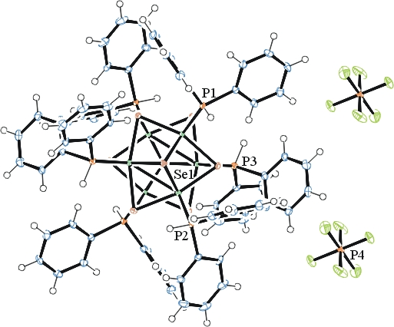
Figure 1. ORTEP of the extended structure with thermal ellipsoids at the 50% probability level. Disorder omitted for clarity.

Table 1: Crystallographic data for the structures provided.
Empirical formula C72 H66 Co6 F6 P7 Se8
Formula weight 2247.29
Temperature 100(2) K
Wavelength 0.71073 Å
Crystal system Triclinic
Space group P -1
Unit cell dimensions a = 10.7729(10) Å α= 89.200(4)°.
b = 13.0021(11) Å β= 82.754(4)°.
c = 13.5766(12) Å γ = 84.852(4)°.
Volume 1878.9(3) Å3
Z 1
Density (calculated) 1.986 Mg/m3
Absorption coefficient 5.375 mm-1
F(000) 1091
Crystal size 0.600 x 0.500 x 0.200 mm3
Theta range for data collection 1.573 to 26.372°.
Index ranges -13<=h<=13, -16<=k<=16, -16<=l<=16
Reflections collected 15003
Independent reflections 7610 [R(int) = 0.0496]
Completeness to theta = 25.000° 99.3 %
Refinement method Full-matrix least-squares on F2
Data / restraints / parameters 7610 / 127 / 532
Goodness-of-fit on F2 1.004
Final R indices [I>2sigma(I)] R1 = 0.0418, wR2 = 0.0924
R indices (all data) R1 = 0.0468, wR2 = 0.0963
Extinction coefficient 0.00042(10)
Largest diff. peak and hole 1.990 and -1.737 e.Å-3

Bruker (2007) APEX2 (Version 2.1-4), SAINT (version 7.34A), SADABS (version 2007/4), BrukerAXS Inc, Madison, Wisconsin, USA.
(a) Sheldrick GM. (2008) A short history of SHELX. Acta Cryst. A64, 112-122. (b) Sheldrick GM. (2015) SHELXT - Integrated space-group and crystal-structure determination. Acta Cryst. A71, 3-8.
(a) Altomare A, Burla C, Camalli M, Cascarano G L, Giacovazzo C, Guagliardi A, Moliterni AGG, Polidori G, Spagna R. (1999) SIR97: a new tool for crystal structure determination and refinement Journal of Applied Crystallography, 32, 115-119. (b) Altomare A, Cascarano G L, Giacovazzo C, Guagliardi A. (1993) Completion and refinement of crystal structures with SIR 92. Journal of Applied Crystallography, 26, 343-350.
(a) Sheldrick GM. (1997) SHELXL-97, Program for the Refinement of Crystal Structures. University of Göttingen, Germany. (b) Sheldrick GM. (2015) Crystal structure refinement with SHELXL. Acta Cryst. C71, 3–8
Waasmaier, D.; Kirfel, A. (1995) New Analytical Scattering Factor Functions for Free Atoms and Ions. Acta Crystallographica A., 51, 416-430.
Farrugia LJ. (1997) Ortep-3 for Windows. Journal of Applied Crystallography, 30, 565

