Crystal Structure Report for M Heinekey
by Werner Kaminsky
Data by Louise Guard
ID – tBuPOCOPCoIandNaBH4
X-ray Crystallography Laboratory
University of Washington
28. July 2026

Data Collection started: 1/11/2017
Documentation finished: 2/3/2017

Data backup accessibly through http:
URL: http://cad4.cpac.washington.edu/structures

W.Kaminsky: tel. (206) 543 7585
(x-ray lab): tel. (206) 543 0210
Email: kaminsky@chem.washington.edu

Understanding crystallographic information is not trivial. If you discuss a structure in a publication, please let the crystallographers proof-read the final draft of that manuscript before you submit it.
For many structures it is true that crystallography is an intellectual performance (like synthesis or elucidation of mechanisms) and not a routine job. In these cases, particularly when the structures contribute significantly to the content of the publication, the crystallographers should be co-authors. Do not think this is not necessary because you pay for structures.
A presumably black prism, measuring approx. 0.30 x 0.20 x 0.10 mm³ was mounted on a loop with oil. Data was collected at -173ºC on a Bruker APEX II single crystal X-ray diffractometer, Mo-radiation.

Crystal-to-detector distance was 40 mm and exposure time was 10 seconds per frame for all sets. The scan width was 0.5º. The data appeared twinned via 180 degrees about [1 0 0] and (0 1 1) (CELL_NOW) and after multi-domain integration (SAINT, SADABS within the APEX2 software package by Bruker) the data was merged utilizing twinabs. With that, data collection was 100% complete to 25º in ϑ. A total of 74316 reflections were collected covering the indices, -11<=h<=10, -16<=k<=16, 0<=l<=17. 6253 reflections were symmetry independent and the R_{int} = 0.0860 indicated that the data was of appropriate quality. Indexing and unit cell refinement indicated a triclinic lattice. The space group was found to be P‾1 (No. 2).

The data was integrated and scaled using SAINT, SADABS within the APEX2 software package by Bruker.

Solution by direct methods (SHELXS, SIR97) produced a complete heavy atom phasing model consistent with the proposed structure. The structure was completed by difference Fourier synthesis with SHELXL97., Scattering factors are from Waasmair and Kirfel. Hydrogen atoms were placed in geometrically idealised positions and constrained to ride on their parent atoms with C---H distances in the range 0.95-1.00 Angstrom. Isotropic thermal parameters U_{eq} were fixed such that they were 1.2U_{eq} of their parent atom Ueq for CH's and 1.5U_{eq} of their parent atom U_{eq} in case of methyl groups. All non-hydrogen atoms were refined anisotropically by full-matrix least-squares.

The structure is of high quality and ready for publication. Table 1 summarizes the data collection details. Figure 1 shows an ORTEP of the asymmetric unit.

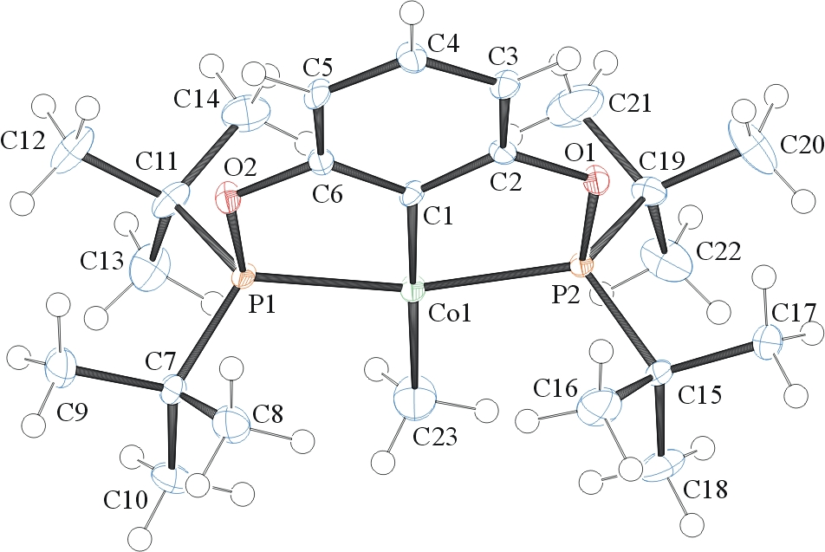
Figure 1. ORTEP of the structure with thermal ellipsoids at the 50% probability level.

Table 1: Crystallographic data for the structures provided.
Empirical formula C23 H42 Co O2 P2
Formula weight 471.43
Temperature 100(2) K
Wavelength 0.71073 Å
Crystal system Triclinic
Space group P -1
Unit cell dimensions a = 8.2366(7) Å α= 100.449(4)°.
b = 12.1780(10) Å β= 95.721(5)°.
c = 13.3921(11) Å γ = 104.843(4)°.
Volume 1261.76(18) Å3
Z 2
Density (calculated) 1.241 Mg/m3
Absorption coefficient 0.822 mm-1
F(000) 506
Crystal size 0.300 x 0.200 x 0.100 mm3
Theta range for data collection 1.565 to 28.416°.
Index ranges -11<=h<=10, -16<=k<=16, 0<=l<=17
Reflections collected 74316
Independent reflections 6253 [R(int) = 0.0860]
Completeness to theta = 25.000° 100.0 %
Absorption correction Semi-empirical from equivalents
Refinement method Full-matrix least-squares on F2
Data / restraints / parameters 6253 / 0 / 269
Goodness-of-fit on F2 1.073
Final R indices [I>2sigma(I)] R1 = 0.0600, wR2 = 0.1521
R indices (all data) R1 = 0.0729, wR2 = 0.1597
Largest diff. peak and hole 2.343 and -1.166 e.Å-3

Sheldrick, G. M. (2005). CELL_NOW. University of Goettingen, Germany.
Bruker (2007) APEX2 (Version 2.1-4), SAINT (version 7.34A), SADABS (version 2007/4), BrukerAXS Inc, Madison, Wisconsin, USA.
Sheldrick, G. M. (2007). TWINABS. University of Goettingen, Germany.
Bruker (2007) APEX2 (Version 2.1-4), SAINT (version 7.34A), SADABS (version 2007/4), BrukerAXS Inc, Madison, Wisconsin, USA.
(a) Altomare A, Burla C, Camalli M, Cascarano G L, Giacovazzo C, Guagliardi A, Moliterni AGG, Polidori G, Spagna R. (1999) SIR97: a new tool for crystal structure determination and refinement Journal of Applied Crystallography, 32, 115-119. (b) Altomare A, Cascarano G L, Giacovazzo C, Guagliardi A. (1993) Completion and refinement of crystal structures with SIR 92. Journal of Applied Crystallography, 26, 343-350.
(a) Sheldrick GM. (1997) SHELXL-97, Program for the Refinement of Crystal Structures. University of Göttingen, Germany. (b) Sheldrick GM. (2013) Crystal structure refinement with SHELXL. Acta Cryst. (2015). C71, 3-8.
Mackay, S.; Edwards, C.; Henderson, A.; Gilmore, C.; Stewart, N.; Shankland, K.; Donald, A. (1997) MaXus: a computer program for the solution and refinement of crystal structures from diffraction data. University of Glasgow, Scotland,.
Waasmaier, D.; Kirfel, A. (1995) New Analytical Scattering Factor Functions for Free Atoms and Ions. Acta Crystallographica A., 51, 416-430.
Farrugia LJ. (1997) Ortep-3 for Windows. Journal of Applied Crystallography, 30, 565

