Crystal Structure Report for A Jen
by Werner Kaminsky
Sample Submitted by Ting Zhao
ID – xyleneperov
X-ray Crystallography Laboratory
University of Washington
28. July 2026

Data Collection started: 1/28/2016
Documentation finished: 2/1/2016

Data backup accessibly through http:
URL: http://cad4.cpac.washington.edu/structures
Username: xray-user
Password: hkl-data

W.Kaminsky: tel. (206) 543 7585
(x-ray lab): tel. (206) 543 0210
Email: kaminsky@chem.washington.edu

Understanding crystallographic information is not trivial. If you discuss a structure in a publication, please let the crystallographers proof-read the final draft of that manuscript before you submit it.
For many structures it is true that crystallography is an intellectual performance (like synthesis or elucidation of mechanisms) and not a routine job. In these cases, particularly when the structures contribute significantly to the content of the publication, the crystallographers should be co-authors. Do not think this is not necessary because you pay for structures.
A colorless prism, measuring 0.50 x 0.04 x 0.03 mm³ was mounted on a loop with oil. Data was collected at -173ºC on a Bruker APEX II single crystal X-ray diffractometer, Mo-radiation.

Crystal-to-detector distance was 40 mm and exposure time was 10 seconds per frame for all sets. The scan width was 0.5º. Data collection was 100% complete to 25º in ϑ.

The data appeared twinned (CELL_NOW) and after multi-domain integration (SAINT, SADABS within the APEX2 software package by Bruker.) and merging (twinabs) a total of 5883 (merged) reflections covered the indices, -6<=h<=6, 0<=k<=25, -18<=l<=18. 2993 reflections were symmetry independent and the R_{int} = 0.0382 indicated that the data was excellent (average quality 0.07). Indexing and unit cell refinement indicated a primitive monoclinic lattice. The space group was found to be P 2₁/c (No.14).

Solution by direct methods (SHELXS, SIR97) produced a complete heavy atom phasing model consistent with the proposed structure. However, additional twinning was observed given by a 2-fold rotation about (0 0 1) which was resolved via a twin command within the shelx instruction file. The structure was completed by difference Fourier synthesis with SHELXL97., Scattering factors are from Waasmair and Kirfel. Hydrogen atoms were placed in geometrically idealised positions and constrained to ride on their parent atoms with C---H distances in the range 0.95-1.00 Angstrom. Isotropic thermal parameters U_{eq} were fixed such that they were 1.2U_{eq} of their parent atom Ueq for CH's and 1.5U_{eq} of their parent atom U_{eq} in case of methyl groups. All non-hydrogen atoms were refined anisotropically by full-matrix least-squares.

Half of the xylene is related to the other by symmetry. One water per xylene fills a void in the structure.

The structure is of high quality and ready for publication. Table 1 summarizes the data collection details. Figure 1 shows an ORTEP of the asymmetric unit.

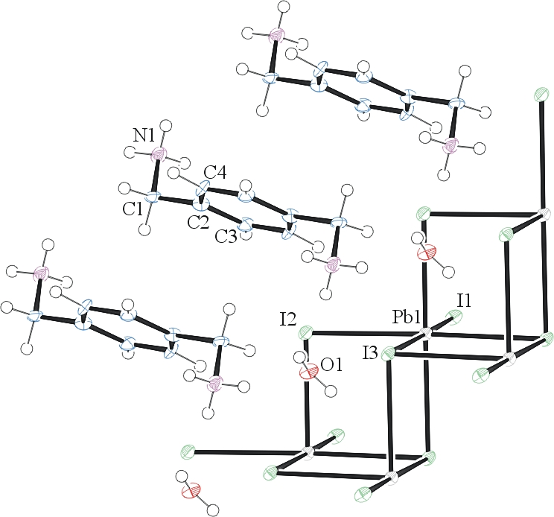
Figure 1. ORTEP of the structure with thermal ellipsoids at the 50% probability level.

Table 1: Crystallographic data for the structures provided.
Empirical formula C4 H9 I3 N O Pb
Formula weight 675.01
Temperature 100(2) K
Wavelength 0.71073 Å
Crystal system Monoclinic
Space group P 21/c
Unit cell dimensions a = 4.5590(4) Å α= 90°.
b = 18.9401(14) Å β= 99.654(4)°.
c = 13.8153(10) Å γ = 90°.
Volume 1176.03(16) Å3
Z 4
Density (calculated) 3.812 Mg/m3
Absorption coefficient 22.174 mm-1
F(000) 1156
Crystal size 0.50 x 0.04 x 0.03 mm3
Theta range for data collection 1.50 to 28.46°.
Index ranges -6<=h<=6, 0<=k<=25, -18<=l<=18
Reflections collected 5883
Independent reflections 2993 [R(int) = 0.0382]
Completeness to theta = 25.00° 100.0 %
Max. and min. transmission 0.9457 and 0.4806
Refinement method Full-matrix least-squares on F2
Data / restraints / parameters 2993 / 6 / 93
Goodness-of-fit on F2 1.119
Final R indices [I>2sigma(I)] R1 = 0.0380, wR2 = 0.0959
R indices (all data) R1 = 0.0406, wR2 = 0.0969
Extinction coefficient 0.00107(13)
Largest diff. peak and hole 3.011 and -3.992 e.Å-3

Sheldrick, G. M. (2005). CELL_NOW. University of Goettingen, Germany.
Bruker (2007) APEX2 (Version 2.1-4), SAINT (version 7.34A), SADABS (version 2007/4), BrukerAXS Inc, Madison, Wisconsin, USA.
Sheldrick, G. M. (2007). TWINABS. University of Goettingen, Germany.
(a) Altomare A, Burla C, Camalli M, Cascarano G L, Giacovazzo C, Guagliardi A, Moliterni AGG, Polidori G, Spagna R. (1999) SIR97: a new tool for crystal structure determination and refinement Journal of Applied Crystallography, 32, 115-119. (b) Altomare A, Cascarano G L, Giacovazzo C, Guagliardi A. (1993) Completion and refinement of crystal structures with SIR 92. Journal of Applied Crystallography, 26, 343-350.
(a) Sheldrick GM. (1997) SHELXL-97, Program for the Refinement of Crystal Structures. University of Göttingen, Germany. (b) Sheldrick GM. (2013) Crystal structure refinement with SHELXL. Acta Cryst. (2015). C71, 3-8.
Mackay, S.; Edwards, C.; Henderson, A.; Gilmore, C.; Stewart, N.; Shankland, K.; Donald, A. (1997) MaXus: a computer program for the solution and refinement of crystal structures from diffraction data. University of Glasgow, Scotland,.
Waasmaier, D.; Kirfel, A. (1995) New Analytical Scattering Factor Functions for Free Atoms and Ions. Acta Crystallographica A., 51, 416-430.
Farrugia LJ. (1997) Ortep-3 for Windows. Journal of Applied Crystallography, 30, 565

